NAME: ETAKEBO DESTINY OGAGA
MATRIC NO: 17/MHS01/123
DEPARTMENT: MEDICINE AND SURGERY
COURSE: GROSS ANATOMY OF HEAD AND NECK

ASSIGNMENT
WRITE AND ESSAY ON CAVERNOUS SINUS
DISCUSS THE WALLS OF THE NOSE

(1.) CAVERNOUS SINUS
The human brain is a highly vascular organ responsible for coordinating a myriad of processes throughout the body. Therefore, it is important that a pathway exists to return blood that enters the cranium to systemic circulation. The cavernous sinuses are one of several drainage pathways for the brain that sits in the middle. In addition to receiving venous drainage from the brain, it also receives tributaries from parts of the face.

The left and right cavernous sinuses communicate by through the anterior and posterior inter cavernous sinuses. The cavernous sinus drains to the superior and inferior petrosal sinuses, which then join the sigmoid sinus.

Structures of the cavernous sinus
The cavernous sinuses are 1 cm wide cavities that extend a distance of 2 cm from the most posterior aspect of the orbit to the petrous part of the temporal bone. They are bilaterally paired collections of venous plexuses that sit on either side of the sphenoid bone. Although they are not truly trabeculated cavities like the corpora cavernosa of the penis, the numerous plexuses, however, give the cavities their characteristic sponge-like appearance.

The cavernous sinus is roofed by an inner layer of dura mater that continues with the diaphragma sellae that covers the superior part of the pituitary gland. The roof of the sinus also has several other attachments. Anteriorly, it attaches to the anterior and middle clinoid processes, posteriorly it attaches to the tentorium (at its attachment to the posterior clinoid process). Part of the periosteum of the greater wing of the sphenoid bone forms the floor of the sinus. The body of the sphenoid acts as the medial wall of the sinus while the lateral wall is formed from the visceral part of the dura mater.

Source of the cavernous sinus

Middle cerebral vein, sphenoparietal sinus, superior ophthalmic vein, Inferior ophthalmic
The cavernous sinus is one of the dural venous sinuses of the head. It is a network of veins that sit in a cavity, approximately 1 x 2 cm in size in an adult. The carotid siphon of the internal carotid artery, and cranial nerves III, IV, V (branches V1 and V2) and VI all pass through this blood filled space.

Nearby structures
Above: optic tract, optic chiasma, internal carotid artery.
Inferiorly: Foramen lacerum and the junction of the body and greater wing of sphenoid bone.
Medially: Hypophysis cerebri or (pituitary gland) and sphenoidal air sinus.
Laterally: temporal lobe with uncus.
Anteriorly: superior orbital fissure and the apex of the orbit.
Posteriorly: apex of petrous temporal bone.

Venous connections
The cavernous sinus receives blood from:
Superior and inferior ophthalmic veins
Sphenoparietal sinus
Superficial middle cerebral veins
Inferior cerebral veins
Blood leaves the sinus via superior and inferior petrosal sinuses as well as via the emissary veins through the foramina of the skull (mostly through foramen ovale). There are also connections with the pterygoid plexus of veins via inferior ophthalmic vein, deep facial vein and emissary veins

Contents
The cavernous sinus contains the internal carotid artery and several cranial nerves. Abducens nerve (CN VI) traverses the sinus lateral to the internal carotid artery. The remainder of the cranial nerves pass through the lateral wall of the carotid sinus, and from superior to inferior they are:
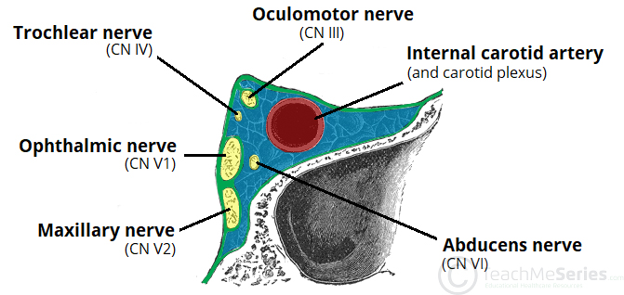

- Oculomotor nerve (CN III)
- Trochlear nerve (CN IV)
- Trigeminal nerve (CN V) - ophthalmic and maxillary divisions.
The contents of the cavernous sinus can be easily remembered with the mnemonic Oh, COAT, that stands for the Oculmotor nerve (III), Internal Carotid artery, Ophthalmic nerve (V1), Abducens nerve (VI), Trochlear nerve (IV).

Internal carotid artery
In addition to the thin walled veins that traverse the cavernous sinus, a lone arterial vessel also uses the area as a conduit. The internal carotid artery (a branch of the common carotid artery) – along with its postganglionic sympathetic plexus from the superior cervical ganglion – gains access to the cavernous sinus posteriorly.

As the petrous part of the internal carotid artery leaves the carotid canal, it curves vertically and superiorly above foramen lacerum to enter the cavernous sinus. Here the artery is also referred to as the cavernous part.

Within the sinus, the internal carotid artery travels anteriorly, in a horizontal manner until it reaches the anterior limit of the sinus. Here it curves vertically and superiorly to exit the sinus through its roof and become the cerebral part of the internal carotid artery. It is noteworthy that the cavernous part of the internal carotid artery is the only arterial vessel that is completely surrounded by venous networks. This fact is of great clinical significance, which will be discussed later.

Abducent nerve
There are also other non-vascular structures that utilize the cavernous sinus as a pathway to their points of supply. Five cranial nerves (CN) use this pathway to gain access to their points of innervations. The first to be discussed is the abducent nerve (CN VI). This motor nerve leave the pons and gains access through the posterior part of the sinus after passing of the apical potion of the petrous temporal bone. It has also been known to access the cavernous sinus by way of the petrosal sinus, adjacent to the clivus.

Within the cavernous sinus, it takes an inferolateral course, relative to the internal carotid artery. It exits the sinus by way of the superior orbital fissure to gain access to the orbit, where it innervates the lateral rectus muscle of the eyeball.

Oculomotor nerve
The other nerves travelling through the cavernous sinus do so between the endothelial lining and the dura mater of its lateral wall. The most superior of the four nerves in the lateral wall is the oculomotor nerve (CN III). At the posterior aspect of the roof of the cavernous sinus, the free and attached edges of tentorium cerebelli forms a space through which CN III enters the lateral wall of the sinus. It takes an anterior, inferomedial course (relative to the other nerves in the lateral wall) towards the anterior extremity of the sinus.

Here it bifurcates into its superior and inferior rami that pass through the superior orbital fissure. Along with sympathetic fibers from the internal carotid plexus, CN III provides motor supply to inferior oblique, levator palpebrae superioris, and the inferior, medial and superior recti muscles.

Trochlear nerve
The smallest of the cranial nerves, the trochlear nerve (CN IV), enters the posterior aspect of the cavernous sinus after leaving the posterior part of the brainstem and decussating with the same nerve from the opposite side. It continues anteriorly in the lateral wall of the cavernous sinus, inferior to CN III and passes through the superior orbital fissure at the anterior aspect of the sinus. Once in the orbit, CN IV has the responsibility of innervating the muscles of the eyeball that are responsible for inferolateral motions.

Trigeminal nerve
Finally, two of the three branches of the trigeminal nerve (CN V) pass through the cavernous sinus. Prior to entering the cavernous sinus, the proximal portion of the nerve lies in Meckel’s cave, where it forms the trigeminal ganglion. After leaving the cave, the mandibular division (CN V3) courses inferiorly to pass through foramen ovale (without entering the cavernous sinus).

The other two branches, the ophthalmic and the maxillary (CN V1 and CN V2, respectively), travel through the lateral wall of the sinus. Both take courses inferior to CN III and CN IV, however, CN V2 is the most inferior of them all. Both CN V branches in the sinus travels horizontally. CN V2 leaves the sinus via foramen rotundum, while the three branches of CN V1 exit the cranial fossa via the superior orbital fissure. CN V1 and CN V2 are purely sensory and supply specific regions of the face.

Function
Venous drainage
As a venous sinus, the cavernous sinus receives blood from the superior and inferior ophthalmic veins and from superficial cortical veins, and is connected to the basilar plexus of veins posteriorly. The cavernous sinus drains by two larger channels, the superior and inferior petrosal sinuses, ultimately into the internal jugular vein via the sigmoid sinus, also draining with emissary vein to pterygoid plexus.

Clinical significance
Carotid-cavernous fistula
Head trauma resulting in rupture of the cavernous part of the internal carotid artery can produce what is known as a carotid-cavernous fistula. A pulsating exophthalmos can result as the venous pressure in the sinus would increase and reverse the flow of blood in the ophthalmic veins.

Cavernous sinus thrombosis
The sinus also has communicating branches from the sin of the face. Particularly in the ‘danger area’ (at the nasolabial crease and at the crease between the ala of the nose and the cheek), an infection can spread to the cavernous sinus, which can result in a cavernous sinus thrombosis. This condition can result in internal strabismus (crossed eyes) if the CN VI is damaged, doubled vision while looking downward if CN IV was damaged, or ophthalmoplegia (paralysis or weakness in muscles of movement of the eye).

(2.) WALLS OF THE NOSE

External nose
The external nose is a visible component of the face, projecting over and allowing entrance into the nasal cavity. This article will discuss the anatomy of the external nose – its skeletal structure, muscles, blood supply and innervations.

Surface Appearance
The external nose is said to have a pyramidal shape. The nasal root is located superiorly, and is continuous with the forehead. The apex of the nose ends inferiorly in a rounded ‘tip’. Spanning between the root and apex is the dorsum of the nose.
Located immediately inferiorly to the apex are the nares; piriform openings into the vestibule of the nasal cavity. The nares are bounded medially by the nasal septum, and laterally by the ala nasi (the lateral cartilaginous wings of the nose).
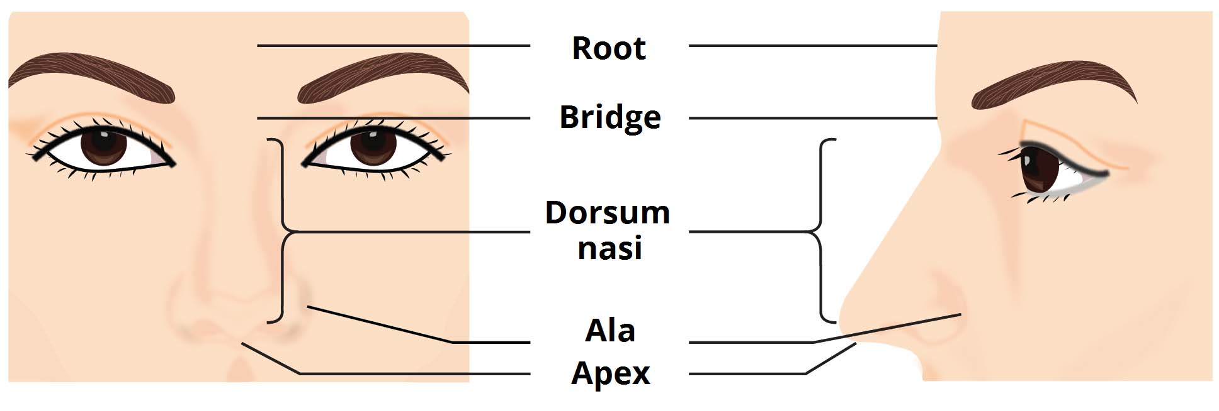
Surface appearance of the nose.

Skeletal Structure
The skeleton of the external nose is made of both bony and cartilaginous components:
Bony component – located superiorly, and is comprised of contributions from the nasal bones, maxillae and frontal bone.
Cartilaginous component – located inferiorly, and is comprised of the two lateral cartilages, two alar cartilages and one septal cartilage. There are also some smaller alar cartilages present.
Whilst the skin over the bony part of the nose is thin, that overlying the cartilaginous part is thicker with many sebaceous glands. This skin extends into the vestibule of the nose via the nares. Here there are hairs which function to filter air as it enters the respiratory system.
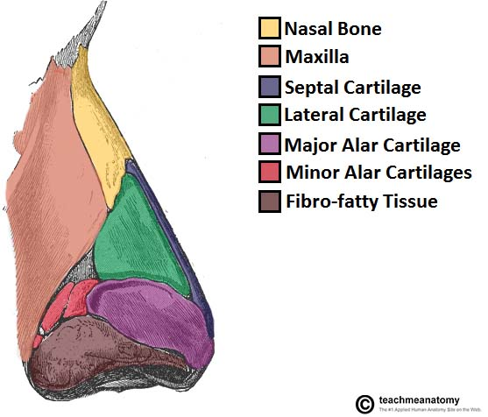
Lateral view of the external nasal skeleton
Muscles
A number of small muscles insert into the external nose, contributing to facial expression. All these muscles are innervated by branches of the facial nerve (CN VII).
The procerus muscle originates in the fascia overlying the nasal bone and lateral nasal cartilage, inserting into the inferior forehead. Contraction can depress the medial eyebrows, and wrinkles the skin of the superior dorsum.
The transverse portion of the nasalis muscle assists the procerus muscle in this action. Meanwhile the alar part of nasalis arises from the maxilla, inserting into the major alar cartilage. This allows the muscle to dilate the nares, “flaring” them. This action is assisted by the depressor septi nasi.

Vessels and Lymphatics
The skin of the external nose receives arterial supply from branches of the maxillary and ophthalmic arteries. The septum and alar cartilages receive additional supply from the angular artery and lateral nasal artery. These are both branches of the facial artery (derived from the external carotid artery).
Venous drainage is into the facial vein, and then in turn into the internal jugular vein.
Lymphatic drainage from the external nose is via superficial lymphatic vessels accompanying the facial vein. These vessels, like all lymphatic vessels of the head and neck, ultimately drain into the deep cervical lymph nodes.

Innervation
Sensory innervation of the external nose is derived from the trigeminal nerve (CN V). The external nasal nerve, a branch of the ophthalmic nerve (CN V₁), supplies the skin of the dorsum of nose, nasal alae and nasal vestibule. The lateral aspects of the nose are supplied by the infrorbital nerve, a branch of the maxillary nerve (CN v₂).
Motor innervation to the nasal muscles of facial expression is via the facial nerve (CN VII).

Nasalcavity
The nasal cavity is the most superior part of the respiratory tract. It extends from the vestibule of the nose to the nasopharynx, and has three divisions:
Vestibule – the area surrounding the anterior external opening to the nasal cavity.
Respiratory region – lined by a ciliated psudeostratified epithelium, interspersed with mucus-secreting goblet cells.
Olfactory region – located at the apex of the nasal cavity. It is lined by olfactory cells with olfactory receptors.
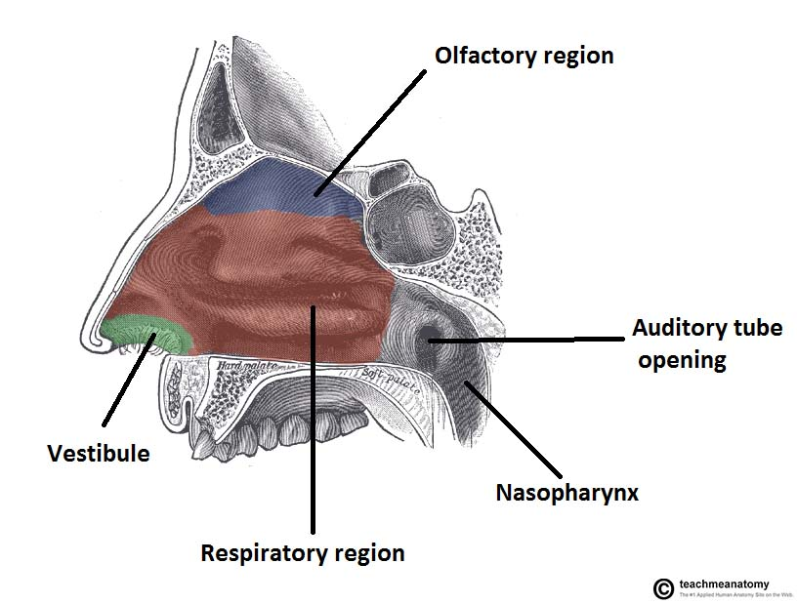
Sagittal section of the nasal cavity. Conchae are present on the lateral walls

Nasal Conchae
Projecting out of the lateral walls of the nasal cavity are curved shelves of bone. They are called conchae (or turbinates). The are three conchae – inferior, middle and superior.
They project into the nasal cavity, creating four pathways for the air to flow. These pathways are called meatuses:
Inferior meatus – between the inferior concha and floor of the nasal cavity.
Middle meatus – between the inferior and middle concha.
Superior meatus – between the middle and superior concha.
Spheno-ethmoidal recess – superiorly and posteriorly to the superior concha.
The function of the conchae is to increase the surface area of the nasal cavity – this increases the amount of inspired air that can come into contact with the cavity walls. They also disrupt the fast, laminar flow of the air, making it slow and turbulent. The air spends longer in the nasal cavity, so that it can be humidified.
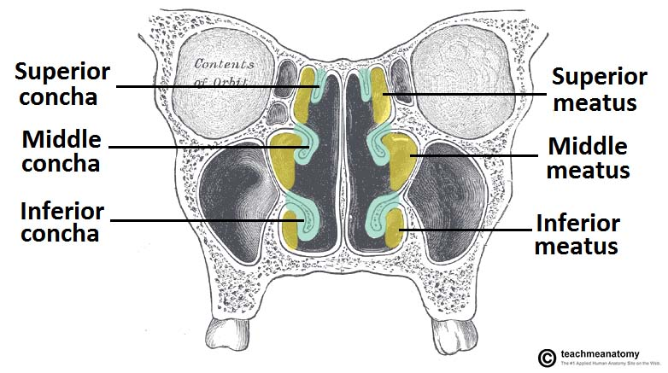
Coronal section of the anterior nasal cavity. The spheno-ethmoidal recess is located posteriorly,and not visible on this diagram.

Openings into the Nasal Cavity
One of the functions of the nose is to drain a variety of structures. Thus, there are many openings into the nasal cavity, by which drainage occurs.
The paranasal sinuses drain into the nasal cavity. The frontal, maxillary and anterior ethmoidal sinuses open into the middle meatus. The location of this opening is marked by the semilunar hiatus, a crescent-shaped groove on the lateral walls of the nasal cavity.
The middle ethmoidal sinuses empty out onto a structure called the ethmoidal bulla. This is a bulge in the lateral wall formed by the middle ethmoidal sinus itself. The posterior ethmoidal sinuses open out at the level of the superior meatus.
The only structure not to empty out onto the lateral walls of the nasal cavity is the sphenoid sinus. It drains onto the posterior roof.
In addition to the paranasal sinuses, other structures open into the nasal cavity:
Nasolacrimal duct – acts to drain tears from the eye. It opens into the inferior meatus.
Auditory (Eustachian) tube – opens into the nasopharynx at the level of the inferior meatus. It allows the middle ear to equalise with the atmospheric air pressure.

Gateways to the Nasal Cavity
As well as openings for the drainage of structures, nerves, vasculature and lymphatics need to be able to access the nasal cavity.
The cribriform plate is part of the ethmoid bone. It forms a portion of the roof of the nasal cavity. It contains very small perforations, allowing fibres of the olfactory nerve to enter and exit,
At the level of the superior meatus, the sphenopalatine foramen is located. This hole allows communication between the nasal cavity and the pterygopalatine fossa. The sphenopalatine artery, nasopalatine and superior nasal nerves pass through here.
The incisive canal is a pathway between the nasal cavity and the incisive fossa of the oral cavity. It transmits the nasopalatine nerve and greater palatine artery.
Vasculature
The nose has a very rich vascular supply – this allows it to effectively change humidity and temperature of inspired air. The nose receives blood from both the internal and external carotid arteries:
Internal carotid branches:
Anterior ethmoidal artery
Posterior ethmoidal artery
The ethmoidal arteries are branch of the ophthalmic artery. They descend into the nasal cavity through the cribriform plate
External carotid branches:
Sphenopalatine artery
Greater palatine artery
Superior labial artery
Lateral nasal arteries
In addition to the rich blood supply, these arteries form anastomoses with each other. This is particularly prevalent in the anterior portion of the nose .
The veins of the nose tend to follow the arteries. They drain into the pterygoid plexus, facial vein or cavernous sinus.
In some individuals, a few nasal veins join with the sagittal sinus (a dural venous sinus). This represents a potential pathway by which infection can spread from the nose into the cranial cavity.

Innervation
The innervation of the nose can be functionally divided into special and general innervation.
Special sensory innervation refers to the ability of the nose to smell. This is carried out by the olfactory nerves. The olfactory bulb, part of the brain, lies on the superior surface of the cribriform plate, above the nasal cavity. Branches of the olfactory nerve run through the cribriform plate to provide special sensory innervation to the nose.
General sensory innervation to the septum and lateral walls is delivered by the nasopalatine nerve (branch of maxillary nerve) and the nasociliary nerve (branch of the ophthalmic nerve). Innervation to the external skin of the nose is supplied by the trigeminal nerve.

Medialwall(nasalseptum):
The medial wall of the nasal cavity comprises the nasal septum, the septal catilage and various bones of the skull.
Nasal skeleton
The nasal septum is a structure consisting of both bony and cartilaginous components. The bony components are the:
perpendicular plate of the ethmoid superoinferiorly
the vomer posteroinferiorly
the crests of the maxillary bone anteroinferiorly
the crest of the palatine bone inferior to the vomer

Nasal septum (medial view)
Ethmoid bone
The medial wall of the nasal cavity is formed by both bony elements and cartilage. Posteriorly the perpendicular plate of the ethmoid bone forms the superoposterior part of the bony nasal septum and articulates superiorly with the cribriform plate. The posterior border articulates superiorly with the sphenoidal crest and with the vomer by its inferior border.
The cribriform plate is found in the midline on the anterior floor of the anterior cranial fossa. It can be descried as a thin bony plate of perforated bone through which the fibres of the olfactory nerve ascend and reach the entorhinal cortex. The plate is divided by the crista galae in the midline.

Maxillary bone
Further posteriorly than the ethmoid bone, the crest of both the maxilla and palatine bone complete the posterior septum. The anterior septum is formed entirely of the quadrangular cartilage which divides the cavity in the midline. The nasal septum can be deviated in some and is a sign of nasal trauma or abnormal growth
Bones, cartilages and mucosa of the medial wall of the nasal cavity.

Vomer
The vomer is an unpaired bone of the skull forms the inferior part of the septum. It is located in the mid sagittal plane and articulates with the ethmoid, both palatine bones and both maxillary bones.

Palatine bone
The horizontal plate of the palatine bone is a rectangular shaped bone that projects medially and forms a right angle with the perpendicular plate of the ethmoid. The nasal surface of the bone forms part of the inferior meatus of the nose, while the serrated anterior maxillary surface articulates with the maxilla. Laterally the bone articulates with the perpendicular plate, and superior portion of the plate forms the posterior part of the nasal cavity. The inferior surface of the plate is rough and provides attachment to the oral mucosa of the hard palate.

Nasal cartilage and associated structures
The septal cartilage is approximately 3-4mm thick. It divides the nasal cavity into two halves. The anteroinferior part of the cartilage has an expansion known as the ‘footplate’ which is 4-8mm wide. This foot plate lies in free contact with the membranous septum. The cartilage is expanded in other regions, namely the junction with the lateral nasal cartilage termed the posterior process. The cartilage is firmly adhered to the nasal bone by taut collagen fibres
The cartilage of the septum is also termed the ‘quadrangular cartilage’ due to its shape. The posterior nasal spine is a sharp pointed projection of the posterior border of the palatine bone. The musculus uvula gains its attachment here.
The pharyngeal tonsil is also known as the adenoid. It is a mass of lymphatic tissue located in the roof of the nasopharynx. The structure degrades with age and is almost entirely absent at puberty. The torus tubarius is also known as the tubar tonsil. It resides at the base of the cartilaginous section of the Eustachian tube.
The choana is an opening at the back of the nasal passage that empties into the nasopharynx, close to where the adenoids are. The passage way forms an outflow from the nasopharynx into the mouth and throat

Floor of the nasal cavity
Hard palate
The pharyngeal opening of the auditory tube can be described as a triangular opening surrounded by a raised, firm prominence known as the ‘torus’. The most medial end of the cartilage causes the elevation of the mucous membrane. The hard palate is a horizontal plate of bone formed by both the palatine process of the maxilla, which forms 75% of the hard palate, and the horizontal plate of the palatine bone, which forms the remaining 25%.
This bony structure has numerous perforations to allow for the passage of nutrient vessels. Its function is to form a separation between the nasopharynx and oropharynx. Insufficiency in this structure can cause difficulty with swallowing.

Soft palate
The soft palate is also referred to as the ‘velum’. This is a continuation of the hard palate posteriorly but has no bony structure. This structure is constituted of five muscles crucial for swallowing. These are the:
tensor veli palatini (innervated by the mandibular branch of the trigeminal nerve)
palatoglossus
the palatopharyngeus which has a crucial role in breathing
the levator veli palatini which elevates the soft palate to encompass the bolus of food
the musculus uvulae which move the uvula
The uvula has an essential role in human speech and works with the posterior part of the tongue to create ‘guttural’ sounds.

Thelateralwall:
The lateral wall of nasal cavity is contributed by the following bones: nasal, frontal process of maxilla, lacrimal, middle and superior nasal conchae of the labyrinth of ethmoid, inferior concha, perpendicular plate of the palatine and the medial pterygoid plate of the sphenoid. Bony wall is covered by mucous membrane and projects medially as curved plates of three nasal conchae
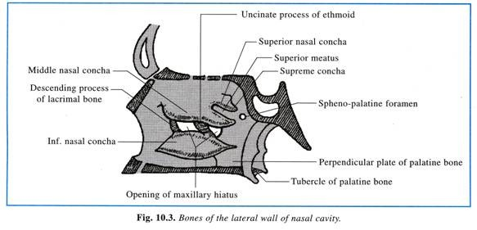
The inferior concha is a separate bone and presents a lower free margin, which extends horizontally backward and ends about 1.25 cm in front of the pharyngeal opening of the auditory tube. The space under cover of the inferior concha is known as the inferior meatus, which receives the termination of naso-lacrimal duct in its anterior part. The inferior meatus is continuous in front with the lateral wall of the vestibule of the nose.
The middle and superior conchae are parts of ethmoidal labyrinth. The free lower border of middle concha is mostly horizontal and lies on a level with the lower surface of the body of the sphenoid; the anterior part of lower border presents a short vertical limb.
The space under cover of the middle concha forms the middle meatus which presents in its lateral wall bulla ethmoidalis and hiatus semilunaris. The bulla ethmoidalis is bony bulging containing middle ethmoidal air sinuses which open into the middle meatus on or above the bulla. The hiatus semilunaris is a crescentic space between the bulla above and behind, and the uncinate process of ethmoid bone below and in front.
The floor of the hiatus receives the opening of maxillary sinus immediately below the bulla. A mucous diverticulum, ethmoidal infundibulum, extends upward from the anterior part of the hiatus through the ethmoidal labyrinth. The wall of the infundibulum receives anterior ethmoidal sinuses; the frontal sinus opens on the summit of the infundibulum directly or through the fronto-nasal duct.
Therefore the middle meatus receives the openings of the following paranasal sinuses —maxillary frontal, anterior and middle ethmoidal. Anteriorly the middle meatus is continuous with a depression known as the atrium which lies above the vestibule. The atrium is limited above by a mucous ridge, the agger nasi, which slopes downward and forward. The junction between the artrium and the vestibule forms a curved muco-cutaneous ridge known as the limen nasi.
The superior concha extends antero- posteriorly above the posterior half of the middle concha. The space under cover of the superior concha is known as the superior meatus into which posterior ethmoidal sinuses open. The area intervening between the superior concha and the nasal roof is termed the supreme meatus which is sometimes traversed by the highest concha. Above and behind the superior concha lies a depression, the spheno-ethmoidal recess, the posterior wall of which receives the opening of the sphenoidal sinus.

Arterial supply:
Similar to the nasal septum, the lateral wall is supplied by branches of ophthalmic, maxillary and facial arteries. The branches are arranged into four quadrants (Fig. 10.6):
(a) Antero-superior quadrant—by the anterior ethmoidal artery from ophthalmic;
(b) Antero-inferior quadrant—by the alar branch of facial and terminal branches of greater palatine arteries.
(c) Postero-superior quadrant—by the sphenopalatine branch of maxillary artery;
(d) Postero-inferior quadrant—by branches of greater palatine artery which pierce the perpendicular plate of palatine bone.

Venous drainage:
The veins form a plexus from which the blood drains into facial vein in front, retro-pharyngeal vein and pterygoid venous plexus behind, and into the inferior cerebral veins above.
Lymphatic drainage:
(a) From the anterior half of lateral wall, the lymphatics drain into the submandibular nodes;
(b) From its posterior half, drain into the retropharyngeal and upper deep cervical lymph nodes.

Nerve supply:
Sensory:
1. Sense of smell (special sensory)—from the olfactory zone is supplied by the olfactory nerves (Fig. 10.6).
2. Nerves of general sense from the rest of the lateral wall—These are derived from the trigeminal nerve and are distributed as follows :—
(a) Antero-superior quadrant—by the anterior ethmoidal nerve, from ophthalmic;
(b) Antero-inferior quadrant—by the anterior superior alveolar nerve, from maxillary;
(c) Postero-superior quadrant—by the posterior lateral nasal branches of pterygo-palatine ganglion, from maxillary;
(d) Postero-inferior quadrant—by the anterior palatine branches of the pterygo-palatine ganglion, from maxillary.
Secreto-motor—Postganglionic secreto-motor fibres for the nasal glands are derived from the pterygo-palatine ganglion, which receives preganglionic fibres from the superior salivatory nucleus of the facial nerve.
Vaso-motor—These are derived from the sympathetic system. The preganglionic fibres arise from the lateral horn cells of the upper 3 or 4 thoracic segments of the spinal cord, and the postganglionic fibres are derived from the superior cervical ganglion.

