Name: Winifred Naphtali Pella
Course: Gross Anatomy
Department: MBBS
Matric No. : 17/MHS01/281

- Write on essay on cavernous sinuses.

The Cavernous Sinuses
The cavernous sinuses are located within the middle cranial fossa, on either side of the sella turcica of the sphenoid bone (which contains the pituitary gland). They are enclosed by the endosteal and meningeal layers of the dura mater.
The borders of the cavernous sinus are as follows:
- Anterior – superior orbital fissure.
- Posterior – petrous part of the temporal bone.
- Medial – body of the sphenoid bone.
- Lateral – meningeal layer of the dura mater running from the roof to the floor of the middle cranial fossa.
- Roof – meningeal layer of the dura mater that attaches to the anterior and middle clinoid processes of the sphenoid bone.
- Floor – endosteal layer of dura mater that overlies the base of the greater wing of the sphenoid bone.

DIAGRAM OF THE CAVERNOUS SINUS SHOWING ITS BOUNDARIES.
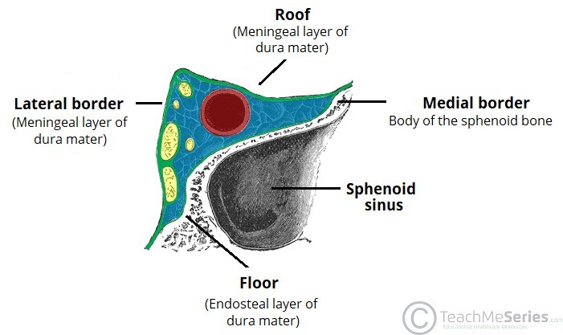

Contents
Several important structures pass through the cavernous sinus to enter the orbit. The can be sub-classified by whether they travel through the sinus itself, or through its lateral wall:
Travels through cavernous sinus: | Travels through lateral wall of cavernous sinus:
Abducens nerve (CN VI)  Carotid plexus (post-ganglionic sympathetic nerve fibres)  Internal carotid artery (cavernous portion) | Oculomotor nerve (CN III)  Trochlear nerve (CN IV)  Ophthalmic (V1) and maxillary (V2) branches of the trigeminal nerve
The cavernous sinus is the only site in the body where an artery (internal carotid) passes completely through a venous structure. This is thought to allow for heat exchange between the warm arterial blood and cooler venous circulation.

Dural Venous Sinus System
Each cavernous sinus receives venous drainage from:
- Ophthalmic veins (superior and inferior) – these enter the cavernous sinus via the superior orbital fissure.
- Central vein of the retina – drains into the superior ophthalmic vein, or directly into the cavernous sinus.
- Sphenoparietal sinus – empties into the anterior aspect of the cavernous sinus.
- Superficial middle cerebral vein – contributes to the venous drainage of the cerebrum
- Pterygoid plexus – located within the infratemporal fossa.
It is important to note that the superior ophthalmic vein forms an anastomosis with the facial vein. Therefore, the ophthalmic veins represent a potential route by which infection can spread from an extracranial to an intracranial site.
The cavernous sinuses empty into the superior and inferior petrosal sinuses, and ultimately, into the internal jugular vein. The left and right cavernous sinuses are connected in the midline by the anterior and posterior intercavernous sinuses. They travel through the sella turcica of the sphenoid bone.

Diagram of the dural venous system relating to the cavernous sinus. Note the anastomosis between the ophthalmic veins and the facial vein.
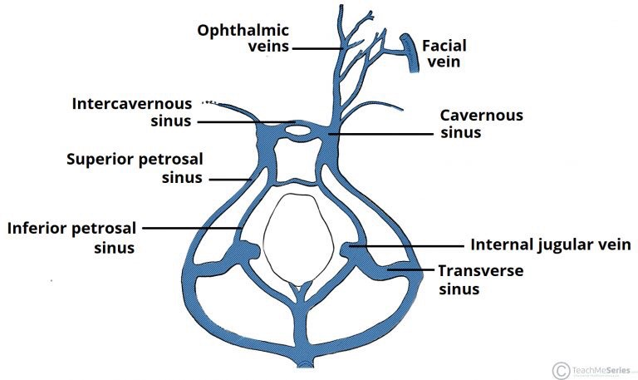

Clinical Significance - Cavernous Sinus Thrombosis
Cavernous sinus thrombosis (CST) refers to the formation of a clot within the cavernous sinus.
This most common cause of CST is infection; which typically spreads from an extracranial location such as the orbit, paranasal sinuses, or the ‘danger zone’ of the face. Infection is able to spread in this manner due to the anastomosis between the facial vein and superior ophthalmic veins.
Common clinical features include headache, unilateral periorbital oedema, proptosis (eye bulging), photophobia and cranial nerve palsies. The abducens nerve (CN VI) is most commonly affected.
Treatment is typically with antibiotic therapy. Where the cause is infection, thrombosis of the cavernous sinus can rapidly progress to meningitis.

- Discuss the walls of the nose

The walls of the nose
The nasal cavity is the most superior part of the respiratory tract. It extends from the vestibule of the nose to the nasopharynx, and has three divisions:
- Vestibule – the area surrounding the anterior external opening to the nasal cavity.
- Respiratory region – lined by a ciliated psudeostratified epithelium, interspersed with mucus-secreting goblet cells.
- Olfactory region – located at the apex of the nasal cavity. It is lined by olfactory cells with olfactory receptors.

Diagram of the Sagittal section of the nasal cavity.
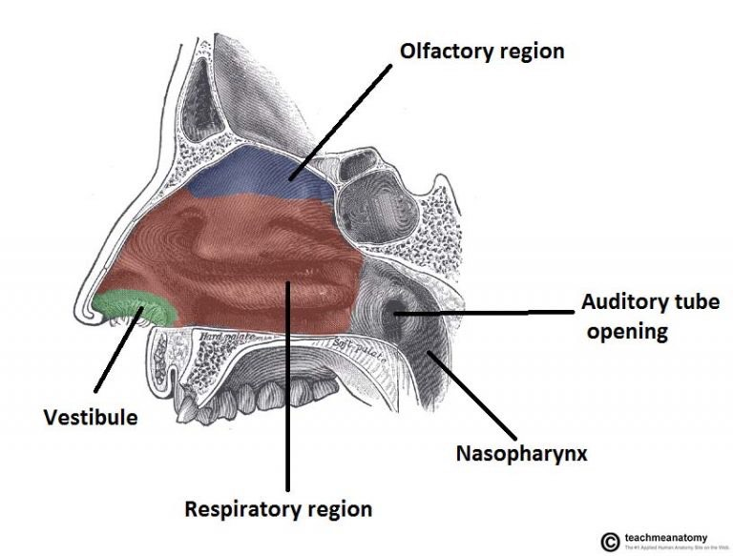

Nasal Conchae
Projecting out of the lateral walls of the nasal cavity are curved shelves of bone. They are called conchae (or turbinates). The are three conchae – inferior, middle and superior.
They project into the nasal cavity, creating four pathways for the air to flow. These pathways are called meatuses:
- Inferior meatus – between the inferior concha and floor of the nasal cavity.
- Middle meatus – between the inferior and middle concha.
- Superior meatus – between the middle and superior concha.
- Spheno-ethmoidal recess – superiorly and posteriorly to the superior concha.
The function of the conchae is to increase the surface area of the nasal cavity – this increases the amount of inspired air that can come into contact with the cavity walls. They also disrupt the fast, laminar flow of the air, making it slow and turbulent. The air spends longer in the nasal cavity, so that it can be humidified.

Diagram showing the Nasal conchae
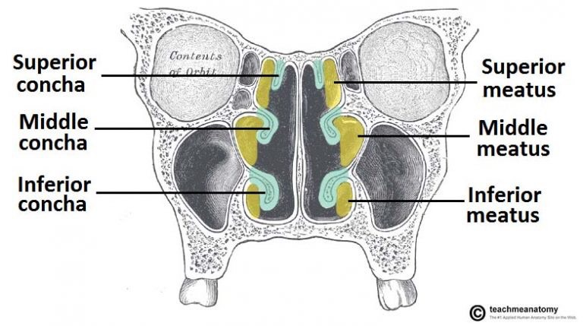

Openings into the Nasal Cavity
One of the functions of the nose is to drain a variety of structures. Thus, there are many openings into the nasal cavity, by which drainage occurs.
The paranasal sinuses drain into the nasal cavity. The frontal, maxillary and anterior ethmoidal sinuses open into the middle meatus. The location of this opening is marked by the semilunar hiatus, a crescent-shaped groove on the lateral walls of the nasal cavity.
The middle ethmoidal sinuses empty out onto a structure called the ethmoidal bulla. This is a bulge in the lateral wall formed by the middle ethmoidal sinus itself. The posterior ethmoidal sinuses open out at the level of the superior meatus.
The only structure not to empty out onto the lateral walls of the nasal cavity is the sphenoid sinus. It drains onto the posterior roof.
In addition to the paranasal sinuses, other structures open into the nasal cavity:
- Nasolacrimal duct – acts to drain tears from the eye. It opens into the inferior meatus.
- Auditory (Eustachian) tube – opens into the nasopharynx at the level of the inferior meatus. It allows the middle ear to equalise with the atmospheric air pressure.

Gateways to the Nasal Cavity
As well as openings for the drainage of structures, nerves, vasculature and lymphatics need to be able to access the nasal cavity.
The cribriform plate is part of the ethmoid bone. It forms a portion of the roof of the nasal cavity. It contains very small perforations, allowing fibres of the olfactory nerve to enter and exit,
At the level of the superior meatus, the sphenopalatine foramen is located. This hole allows communication between the nasal cavity and the pterygopalatine fossa. The sphenopalatine artery, nasopalatine and superior nasal nerves pass through here.
The incisive canal is a pathway between the nasal cavity and the incisive fossa of the oral cavity. It transmits the nasopalatine nerve and greater palatine artery.

Vasculature
The nose has a very rich vascular supply – this allows it to effectively change humidity and temperature of inspired air. The nose receives blood from both the internal and external carotid arteries:
Internal carotid branches:
- Anterior ethmoidal artery
- Posterior ethmoidal artery
The ethmoidal arteries are branch of the ophthalmic artery. They descend into the nasal cavity through the cribriform plate
External carotid branches:
- Sphenopalatine artery
- Greater palatine artery
- Superior labial artery
- Lateral nasal arteries
In addition to the rich blood supply, these arteries form anastomoses with each other. This is particularly prevalent in the anterior portion of the nose .
The veins of the nose tend to follow the arteries. They drain into the pterygoid plexus, facial vein or cavernous sinus.
In some individuals, a few nasal veins join with the sagittal sinus (a dural venous sinus). This represents a potential pathway by which infection can spread from the nose into the cranial cavity.

Clinical Relevance: Epistaxis
Epistaxis is the medical term for a nosebleed. Due to the rich blood supply of the nose, this is a common occurrence. It is most likely to occur in the anterior third of the nasal cavity – this area is known as the Kiesselbach area.
The cause can be local (such as trauma), or systemic (such as hypertension).

