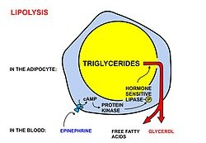step 1

A diagrammatic illustration of the process of lipolysis (in a fat cell) induced by high epinephrine and low insulin levels in the blood. Epinephrine binds to a beta-adrenergic receptor in the cell wall of the adipocyte, which causes cAMP to be generated inside the cell. The cAMP activates a protein kinase, which phosphorylates and thus, in turn, activates a hormone-sensitive lipase in the fat cell. This lipase cleaves free fatty acids from their attachment to glycerol in the fat stored in the fat droplet of the adipocyte. The free fatty acids and glycerol are then released into the blood.

t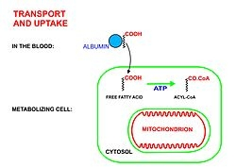step 2
A diagrammatic illustration of the transport of free fatty acids in the blood attached to plasma albumin, its diffusion across the cell membrane using a protein transporter, and its activation, using ATP, to form acyl-CoA in the cytosol. The illustration is, for diagrammatic purposes, of a 12 carbon fatty acid. Most fatty acids in human plasma are 16 or 18 carbon atoms long.

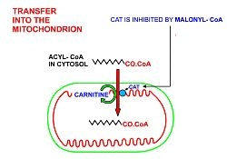
step 3
A diagrammatic illustration of the transfer of an acyl-CoA molecule across the inner membrane of the mitochondrion by carnitine-acyl-CoA transferase (CAT). The illustrated acyl chain is, for diagrammatic purposes, only 12 carbon atoms long. Most fatty acids in human plasma are 16 or 18 carbon atoms long. CAT is inhibited by high concentrations of malonyl-CoA (the first committed step in fatty acid synthesis) in the cytoplasm. This means that fatty acid synthesis and fatty acid catabolism cannot occur simultaneously in any given cell.

