NAME: EGBAGBARA EVAEZI VERONIQUE
MATRIC NUMBER: 15/MHS04/005
COURSE CODE: NTD 206
COURSE TITLE: HUMAN BIOCHEMISTRY AND NUTRITION II

ASSIGNMENT
- Describe the glycolytic pathway
- Compute the stoichiometry of coenzyme reduction and ATP formation in the aerobic oxidation of glucose via glycolysis, the pyruvate dehydrogenase complex reaction, the Citric Acid Cycle and oxidative phosphorylation using 1 NADH= 3ATP and 1 FADH= 2ATP
ANSWERS
- GLYCOLYTIC PATHWAY
The glycolytic pathway is the only pathway that is taken place in all the cells in the body. In this pathway, glucose is converted to pyruvate in aerobic condition or lactate in anaerobic condition along with the production of small quantity of energy. The glycolytic pathway may be considered as the preliminary step before complete oxidation. It also provides carbon skeletons for synthesis of non-essential amino acids as well as glycerol. Most of the reactions in the glycolytic pathway are reversible which are also used for gluconeogenesis.
Glycolysis has two phases which are:
- PREPARATORY PHASE: It consists of the first five steps of the glycolytic pathway. It is the phosphorylation of glucose and its conversion to glyceraldehyde 3-phosphate. Here, the energy of ATP is invested, carbon chains of all the metabolized hexoses are converted into a common product, glyceraldehyde 3-phosphate
- Glucose is first phosphorylated at the hydroxyl group on C-6
- The D-glucose 6-phosphate thus formed is converted to D-fructose 6-phosphate
- (2) is again phosphorylated, this time at C-1 to yield D-fructose 1,6-bisphosphate. For both phosphorylation, ATP is the phosphoryl group donor.
- Fructose 1,6-bisphosphate is split to yield two three carbon molecules, dihydroxyacetone phosphate and glyceraldehyde 3-phosphate
- The dihydroxyacetone phosphate is isomerized to a second molecule of glyceraldehyde 3-phosphate
- PAYOFF PHASE: The oxidative conversion of glyceraldehyde 3-phosphate to pyruvate and coupled formation of ATP and NADH
- Each molecule of glyceraldehyde 3-phosphate is oxidized and phosphorylated by inorganic phosphate (not by ATP) to form 1,3-bisphosphoglycerate
vii-x) Energy is released as the two molecules of 1,3-bisphosphoglycerate are converted to two molecules of pyruvate
Much of this energy is conserved by the coupled phosphorylation of four molecules and ADP to ATP. The next yield is two molecules of ATP per molecule of glucose used, because two molecule of ATP were invested in the preparatory phase. Energy is also conserved in the payoff phase in the formation of two molecules of NADH per molecule of glucose.
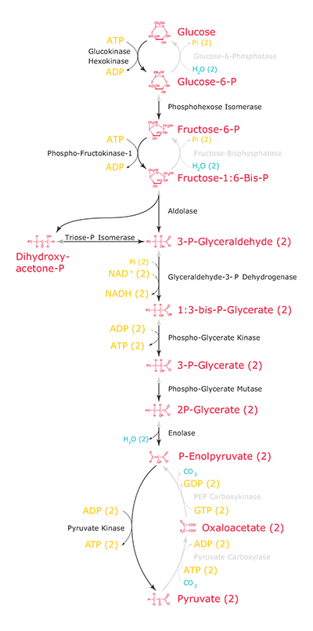
THE GLYCOLYTIC PATHWAY
- Stoichiometry of coenzyme reduction and ATP formation in the aerobic complex reaction, the citric acid cycle and oxidative phosphorylation
REACTION | NO OF ATP | NO OF ATP
Glucose Glucose 6-phosphate | -1 ATP | -1
Fructose6-phosphate fructose 1,6 bisphosphate | -1 ATP | -1
2glycerahdehyde 3-phosphate 2,1,3bisphosphosphoglycerate | 2NADH | 5
2,1,3-bisphosphoglycerate 2,3-phosphoglycerate | 2ATP | 2
2 phosphoenolpyruvate  2 pyruvate | 2ATP | 2
2 pyruvare 2acetyl CoA | 2NADH | 5
2 isocitrate 2α-ketoglutarate | 2NADH | 5
2α-ketoglutarate 2 succinyl-CoA | 2NADH | 5
2 succinyl-CoA 2 succinate | 2ATP or (2GTP) | 2
2 succinate 2 fumerate | 2FADH₂ | 3
2 malate 2oxaloaccetate | 2NADH | 5
TOTAL |  | 34

