NAME: PETER BENJAMIN
MATRIC NO: 18/MHS07/048
DEPARTMENT: PHARMACOLOGY
ANA 202

1.) The heart is a muscular organ in most animals which pumps blood through the blood vessels of the circulatory system. The heart is located between the lungs in the middle compartment of the chest . The heart is divided into four chambers which are:
a.) upper left atria
b.) right atria
c.) lower left ventricle
d.) right ventricle
The heart is enclosed in a protective sac called the pericardium which contains small amount of fluids. The wall of the heart is made up of layers:
a.) epicardium
b.) myocardium
c.) endocardium
The hearts has many functions such as:
a.) the right atrium receives blood from the veins and pumps it to the right ventricle
b.) the right ventricle receives blood from the right atrium and pumps it to the lungs where it is loaded with oxygen
c.) the left atrium receives oxygenated blood from the lungs me pumps it to the left ventricle
d.) the left ventricle pumps oxygenated blood to the rest of the body.

a. Dextrocardia: this is the bending of the heart tube to the left instead of the right. It can also be defined as the condition in which the heart( four chambered heart) is pointed towards the right side instead of normally pointing to the left. It is present at birth. 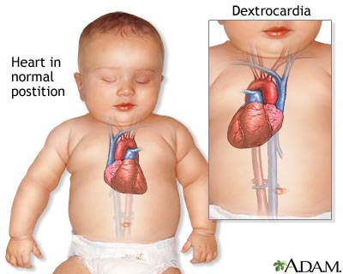

b .Atrial Septal defects: An ASD is a hole between the upper chambers, or the right and left atria of the heart. A hole here lets blood from the left atrium mix with blood in the right atrium.
- Ventricular Septal Defects: A VSD is a hole in the part of your septum that separates your heart’s lower chambers, or ventricles. If you have a VSD, blood gets pumped back to your lungs instead of your body.
- Tetralogy of fallot: it is combination of four defects, including:
- A large ventricular septal defect
- Thickened wall around your right ventricle, or lower chamber.
- Your aorta is located above the hole in your ventricular wall
- Stiff pulmonary valve that prevents blood from flowing easily from the heart to the lungs.
- Aorticopulmonary septal defect: it is a condition in which there is an opening (aortic window) between the aorta and pulmonary trunk near the aortic valve. The aorticopulmonary defect results from localised defect in the formation of the aorticopulmonary septum. The presence of pulmonary and aortic valves and an intact IV septum distinguishes this anomaly from the persistent truncus arteriosus defect.

