ABDULRAZZAQ HINDU MA’AJI
MBBS 300L
17/mhs01/004
GROSS ANATOMY OF HEAD AND NECK ASSIGNMENT
NO1
QUESTION: DISSCUSS THE ANATOMY OF THE TONGUE AND COMMENT ON ITS APPLIED ANATOMY
ANSWER:
The tongue is a muscular organ that is partly in the oral cavity and partly in the oropharynx. The tongue is vital for chewing, swallowing, taste, articulation, oral cleansing as well as for speech. The tongue is covered with moist pink tissue called mucosa. Taste buds are collections of nerve like cells that connects to nerve running into the brain. The tongue is anchored to the mouth by webs of tough tissue and mucosa. The tether holding down the front of the tongue is called the frenulum. In the back of the mouth the tongue is anchored to the hyoid bone. The four common taste are sweet, sour, bitter and salty. The tongue is divided into right and left half by the median sulcus.

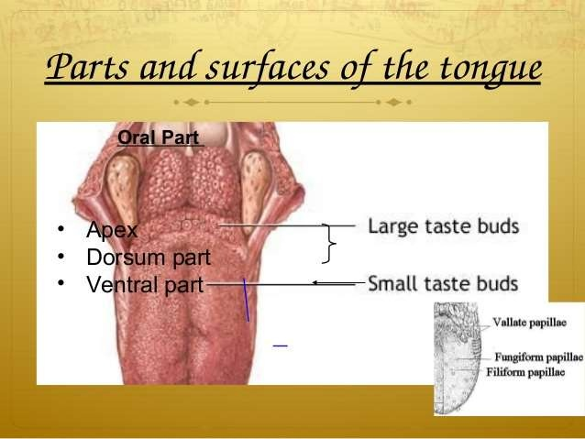

The tongue has
Apex (tip) – that rest against the incisors
Body – which is the anterior two thirds of the tongue
Root – that rest on the floor of the mouth
2 surfaces
Ventral surface or anteroinferior surface of the tongue. It portrays the lingual frenulum which runs vertically from the floor of the mouth to the undersurface of the tongue (limit the movement of the tongue), deep lingual veins seen on either side of frenulum, plica fimbriata (mucosal fold) present on either side of deep lingual vein.
Dorsal surface or dorsum is the posterosuperior surface located partly in the oral cavity and partly in the oropharynx. It is represented by the V-shaped sulcus called the sulcus terminalis, foramen cecum which is posterior to this sulcus. The sulcus terminalis divides the tongue oral and pharyngeal part.
PAPILLAE
Are tiny bumps that give the tongue its rough texture. Thousands of taste buds cover the surfaces of the papillae. They are four varieties – filiform, fungiform, foliate and circumvallate
Filiform papillae – they are small and cone-shaped with one or multi ends. Present over anterior two third of the tongue which acts as an abrasive coating (cleaning and grasping action). They do not contain taste buds.
Fungiform papillae – they are round shaped (mushroom) and larger than filiform. seen on the tip and margins of the tongue. Taste buds are embedded in their surfaces. They respond to both sweet and sour tastes.
Foliate papillae – they are red leaf like mucosal ridges seen at sides near sulcus terminalis. They are poorly developed in humans.
Circumvallate papillae – they are large cylindrical structures. Form a V-shaped row in front of sulcus terminalis. They are eight to twelve in numbers.
MUSCLES OF THE TONGUE
The strength and mobility are supported by its paired muscles which are grouped as either intrinsic or extrinsic.
INTRINSIC MUSCLES OF THE TONGUE
The intrinsic muscles are placed within the bulk of the tongue. They are Superior longitudinal, Inferior longitudinal, Transverse, Vertical muscles.
MUSCLES | ORIGIN | INSERTION | INNERVATION | ACTION
SUPERIOR LONGITUDINAL MUSCLE | Submucous fibrous layer below the dorsum of the tongue and lingual septum | Extends to the lingual margin | Motor: hypoglossal nerve [CN XII] | Turns the apex and sides of the tongue upward to make the dorsum concave
INFERIOR LONGITUDINAL MUSCLE | Root of tongue and body of hyoid bone | Apex of tongue | Motor: hypoglossal nerve [CN XII] | Curls the tip inferiorly and shortens the tongue
VERTICAL MUSCLE | Dorsum surface of the borders of the tongue | Ventral surface of the borders of the tongue | Motor: hypoglossal nerve [CN XII] | Flattens and broadens the tongue
TRANSVERSE MUSCLE | Median fibrous septum | Fibrous tissue at the margin of tongue | Motor: hypoglossal nerve [CN XII] | Narrows and elongates the tongue

EXTRINSIC MUSCLES OF THE TONGUE
The extrinsic muscles originate outside the tongue and the oral cavity, and insert into the tongue itself. They are Genioglossus, Hyoglossus, Styloglossus, palatoglossus.
MUSCLES | ORIGIN | INSERTION | INNERVATION | ACTION
GENIOGLOSSUS | Arises from superior genial tubercle above the origin of geniohyoid | The fibres radiate widely to be inserted into the mucous membrane of the tongue; the lowest3 fibres passing down to the hyoid body | Motor: hypoglossal nerve [CN XII] | Protrusion,  Bilaterally - central part depression,  Unilaterally - diverges to the opposite side
HYOGLOSSUS | Greater cornu, front of body of hyoid bone. | Side of the tongue between styloglossus and inferior longitudinal. | Motor: hypoglossal nerve [CN XII] | Depresses the tongue
STYLOGLOSSUS | Styloid process near its apex | Longitudinal part; into the inferior longitudinal muscles oblique part; into hyoglossus | Motor: hypoglossal nerve [CN XII] | Draws the tongue upwards and backward
PALATOGLOSSUS | Palatine aponuerosis of soft palate | Side of the tongue | Motor: vagus nerve [CN X] | Elevates the posterior part of the tongue,  Bilaterally – approximates the palatoglossal folds to constrict the isthmus of the fauces
SENSORY SUPPLY TO THE MUSCLES: anterior two thirds – lingual nerve, chorda tympani of facial nerve. Posterior one third – glossopharyngeal nerve.
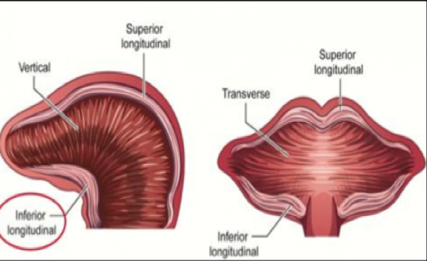
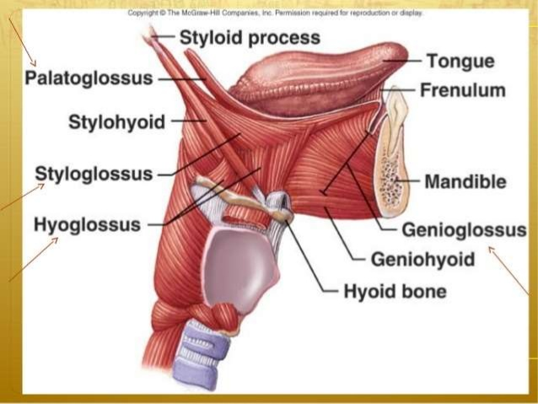

ARTERIAL SUPPLY OF THE TONGUE:
Arterial supply to the tongue is by the Lingual artery which is a branch of external carotid artery.it gives out three branches: Dorsal lingual artery supplies posterior part. Deep lingual artery supplies anterior part. Sublingual artery supplies the sublingual gland and floor of the mouth.
VENOUS DRAINAGE
Dorsal lingual vein drains the dorsum and side of the tongue. Deep lingual vein drains the tip of the tongue and joins the sublingual vein. All these veins terminate directly or indirectly into internal jugular vein
LYMPHATIC DRAINAGE
The tip and sides drain into the submental and submandibular nodes respectively. Central lymphatics drains to deep cervical nodes of either side. Posterior part drains indirectly and bilaterally into deep cervical nodes. The deep cervical nodes usually involved: jugulodigastric and jugulo-omohyoid nodes.
NERVE SUPPLY
Motor supply: all muscles of the tongue (intrinsic and extrinsic) are supplied by hypoglossal nerve, except palatoglossus which supplied by the vagus nerve of pharyngeal plexus.
Sensory supply:
Anterior two third of the tongue for general is by lingual nerve and for taste sensation is by chorda tympani a branch of facial nerve.
Posterior one third of the tongue is by lingual branch of glossopharyngeal verve for both general and taste sensation. Anterior contribution is made by the internal laryngeal branch of the vagus nerve.

Applied anatomy
Thrush (candidiasis): candida albicans ( a yeast) grows over the surface of the mouth and tongue. Thrush can occur in almost anyone but occurs mostly in people taking steroids or with suppressed immune systems, the very young and the elderly.
Canker sores (aphthous ulcer): small painful ulcers appear periodically on the tongue or mouth. A relatively common condition, the cause is unknown: they are unrelated to the cold sores caused by herpes viruses. Canker sores are not contangious.
Hairy tongue: papillae can overgrow the surface of the tongue, giving it a white or black appearance. Scraping off the papillae corrects this harmless condition.
Lingual Carcinoma: A lingual carcinoma in the posterior part of the tongue metastasizes to the superior deep cervical lymph nodes on both sides, whereas a tumor in the anterior part usually does not metastasize to the inferior deep cervical lymph nodes until late in the disease. Because these nodes are closely related to the IJV, metastases from the tongue may be widely distributed through the submental and submandibular regions and along the IJVs in the neck.

NO2
QUESTION: Write an essay on the air sinuses
ANSWER:
The air sinuses also known as the paranasal sinuses are air filled spaces located within the bones of the skull and facial bones. They are centered on the nasal cavity and have various functions, including lightening the weight of the head, humidifying and heating inhaled air, increasing the resonance of speech and serving as a crumple bone to protect vital structures in the event of facial trauma. Four sets of paired sinuses are recognized: maxillary, frontal, sphenoid and ethmoid.

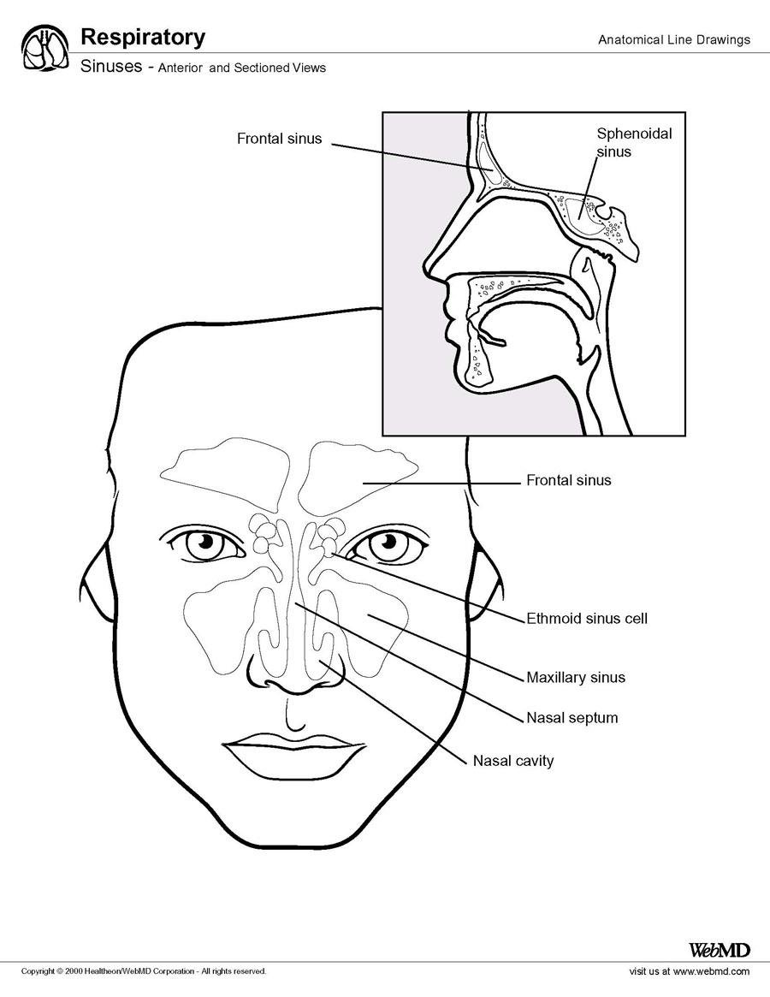
MAXILLARY SINUSES
They are the largest of all paranasal sinuses. They have thin walls which are often penetrated by long roots of the posterior maxillary teeth. The posterior border of this sinus is the bony orbit, the inferior is the maxillary alveolar bone and corresponding teeth roots the medial border is made up of the nasal cavity and the lateral and anterior border are limited by the cheek bones. Posteriorly two anatomical spaces known as pterygopalatine and infratemporal fossa exist. The submandibular lymph nodes are the main destination during lymphatic drainage. The blood supply includes a contribution from the anterior superior alveolar artery, middle superior artery and posterior superior alveolar artery. Innervation occurs through nerves of the same names as the arteries.
SPHENOIDAL SINUSES
This is most posterior of all sinuses in the head, they are large and irregular just their septum, which is made by the sphenoid bone. Laterally, a cavernous sinus exist which is part of the middle cranial fossa and also the carotid and cranial nerves III, IV, VI, VII, VIII can be found. The anterior wall separates these pair of sinuses from the nasal cavity, as does the hypophyseal fossa, pituitary gland and the optic chiasm superiorly and the nasopharynx and pterygoid canal inferiorly. The lymphatic drainage occurs in the same way as the posterior ethmoid sinus. The posterior ethmoid artery and the posterior lateral nasal branches supply the sphenoidal sinuses. The posterior ethmoidal nerve and orbital branch of pterygopalatine ganglion innervate them.
FRONTAL SINUSES
Anteriorly the frontal sinuses are contained by the forehead and the superciliary arches, superiorly and posteriorly by the anterior cranial fossa and inferiorly by the bony orbit, the anterior ethmoidal sinuses and the nasal cavity. Medially the sinuses face one another, separated by the midline. The pair of sinuses are irregular in shape when compar to one another and are underdeveloped at birth. They reach their full size and shape around seven to eight years of age. They drain primarily into the ethmoidal infundibulum and the corresponding lymph drainage occurs via the submandibular lymph nodes. It is innervated by the ophthalmic nerve, including the supraorbital and supratrochlear branches. They are supplied by the anterior ethmoidal artery, supraorbital artery and supratrochlear artery.
ETHMOIDAL SINUSES
Superior to the ethmoidal sinus is the anterior cranial fossa and the frontal bone, laterally the orbit can be found, while the nasal cavity is situated medially. The ethmoid sinuses are unique because they are the only paranasal sinuses that are more complex than just a single cavity. On each side of the midline, anywhere from three to eighteen ethmoidal air cells may be grouped together. These air cells are smaller individual sinuses grouped together to form one large one which encompasses the anterior, middle and posterior nasal meatuses. The anterior and middle ethmoidal sinuses send their lymphatic drainage to the submandibular lymph nodes while the posterior ethmoidal sinus send its own to the retropharyngeal lymph nodes. The anterior and posterior ethmoidal arteries as well as the posterior lateral nasal branches provide an ample of blood supply to this region. Meanwhile the posterior and anterior ethmoidal nerves and the posterior lateral superior and inferior nasal nerves help innervate it.
SINUSITIS
This is an extremely common outpatient case which presents as an inflammation of the epithelia of the sinuses. The causes can be either a viral or bacterial infection, or an allergic reaction. The inflammation can be acute or chronic and the axillary sinuses are the most frequently affected. Antivirals, antibiotics and antihistamines are prescribed in persistent cases.

