NAME:ONYENDU IFEANYI JOHN

MATRIC NUMBER:19/MHS11/118

It is responsible for the decay of organic matter

b. They mediate the spoilage of wood,clothes etc

C.they are eaten by many human societies

d.they with fungal diseases and infections in humans

2.
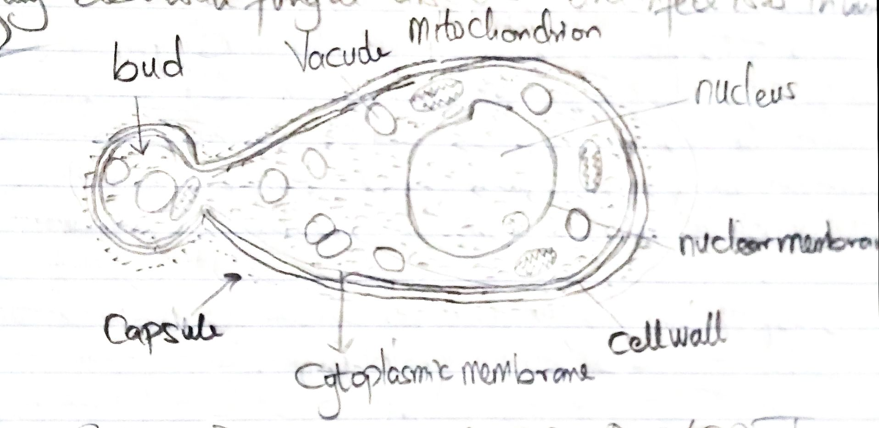

Labelled diagram of a fungi(yeast)

3.this is when two mating types of hyphae grow in the same medium,the two gamentanga(plasmogamy)and a zygote is formed which may undergo prolonged domancy or resting stage.the nuclei in the fuse in twos and undergo meiosis independently,the zygote germates under favourable conditions to produce a fruiting which at maturity liberates the haploid spores.

4.they have definite structures for water and nutrient absorption from the soil,therefore the plant body is divided ito two (an aerial and subterranean portion)the subterranean portion is the rhizoid and is not a true root as the case of land plants that are advanced.

the aerial portion being exposed to the atmosphere demands some modifications that prevents excessive loss of water through the body surface.

Some other modifications that permit elimination of excess water from the plant body and not only exchange of gases between the internal parts of the plant and the atmosphere therefore openings are made available on the aerial parts of the plant.

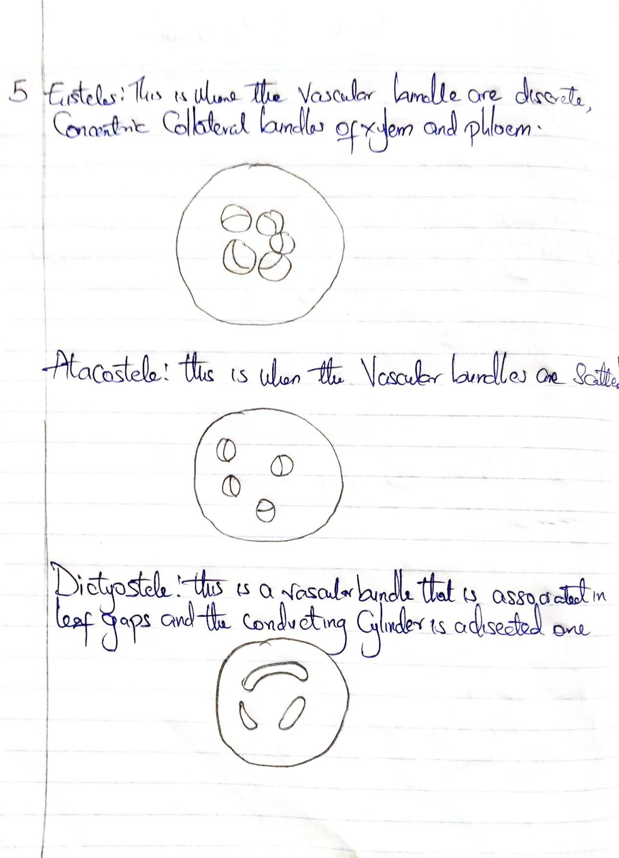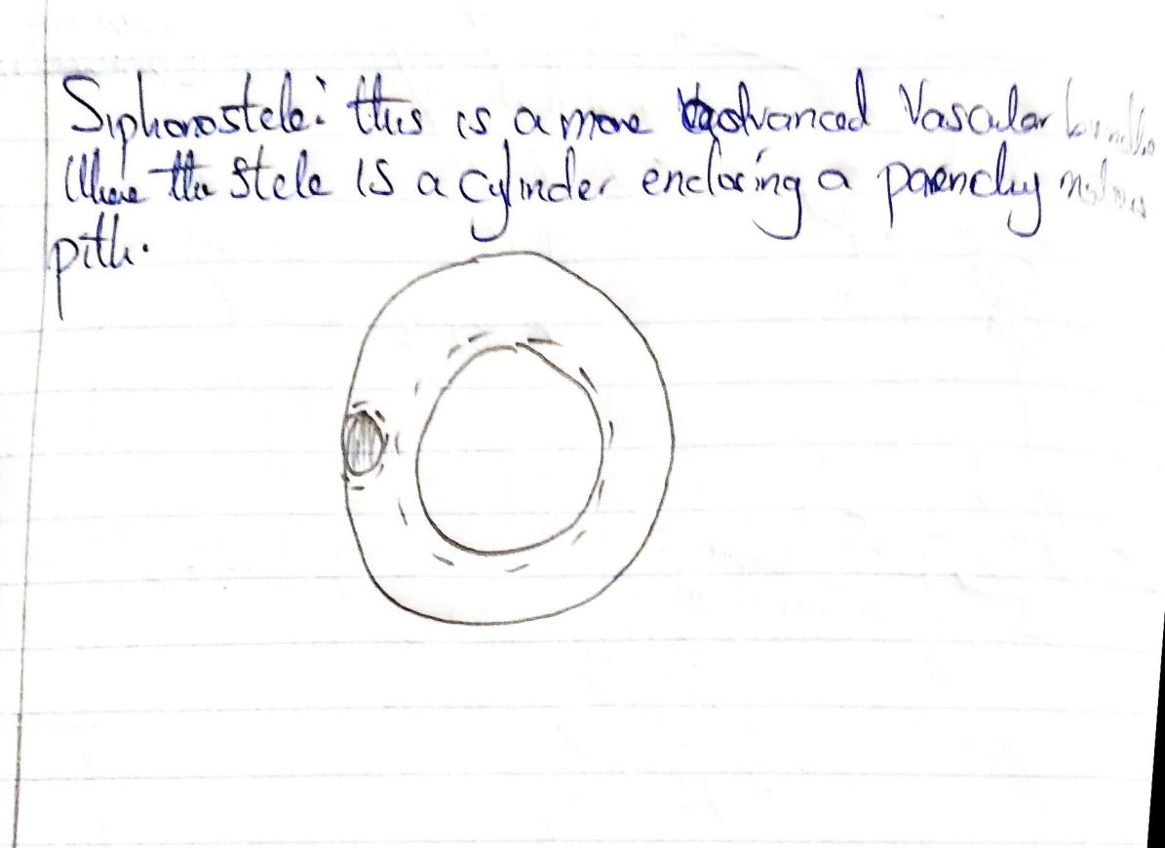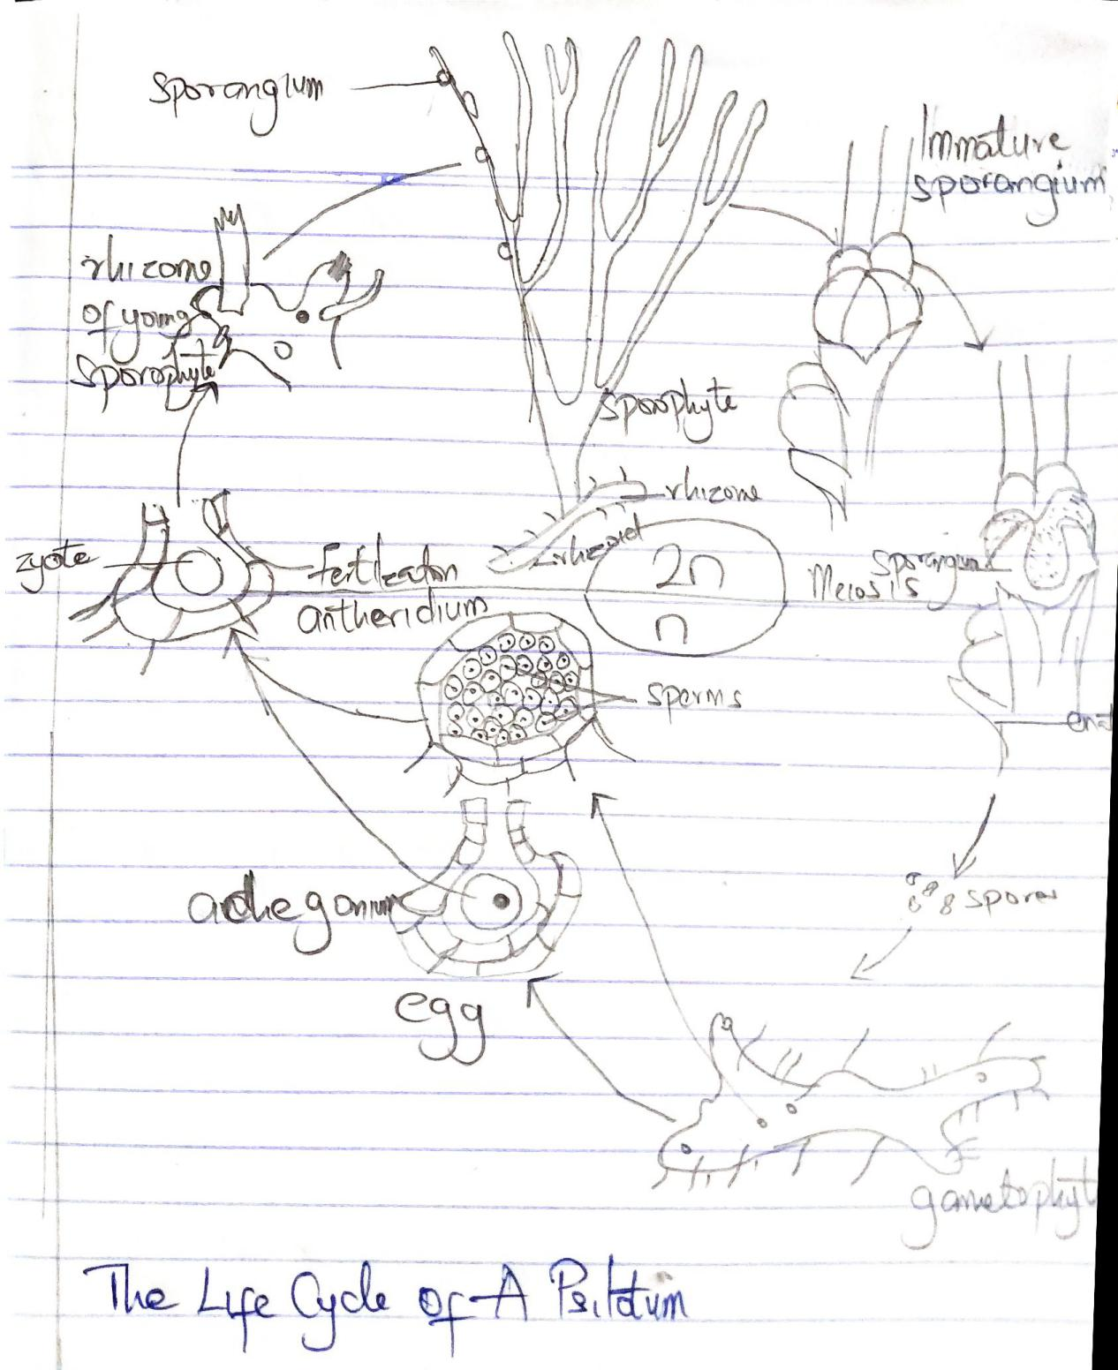

Life cycle of a psilotum.

