NWANKWO IKECHUKWU
19/MHS01/264
MBBS
BIOLOGY 102
ASSIGNMENT
- How is fungi important to mankind?
Fungi are important to everyday human life. Fungi are important decomposers in most ecosystems. Fungi, as food, play a role in human nutrition in the forms of mushrooms, and also as agents of fermentation in the production of bread, cheeses, alcoholic beverages, and other food preparations. Together with bacteria, fungi are responsible for breaking down organic matter and releasing carbon, oxygen, nitrogen, and phosphorus into the soil and the atmosphere.

- Illustrate the cell structure of a unicellular fungus with a well labeled diagram.
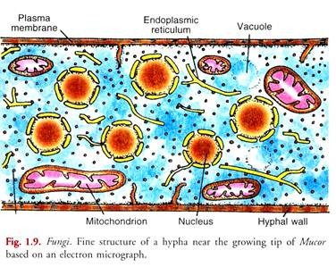
- Outline the sexual reproduction in a typical filamentous form of fungi.
There are three sequential stages. They are:
- Plasmogamy
- Karyogamy
- Meiosis
Sexual reproduction in the fungi consists of three sequential stages: plasmogamy, karyogamy, and meiosis. The diploid chromosomes are pulled apart into two daughter cells, each containing a single set of chromosomes (a haploid state). Plasmogamy, the fusion of two protoplasts (the contents of the two cells), brings together two compatible haploid nuclei. At this point, two nuclear types are present in the same cell, but the nuclei have not yet fused. Karyogamy results in the fusion of these haploid nuclei and the formation of a diploid nucleus (i.e., a nucleus containing two sets of chromosomes, one from each parent). The cell formed by karyogamy is called the zygote. In most fungi the zygote is the only cell in the entire life cycle that is diploid. The dikaryotic state that results from plasmogamy is often a prominent condition in fungi and may be prolonged over several generations. In the lower fungi, karyogamy usually follows plasmogamy almost immediately. In the more evolved fungi, however, karyogamy is separated from plasmogamy. Once karyogamy has occurred, meiosis (cell division that reduces the chromosome number to one set per cell) generally follows and restores the haploid phase. The haploid nuclei that result from meiosis are generally incorporated in spores called meiospores.
Fungi employ a variety of methods to bring together two compatible haploid nuclei (plasmogamy). Some produce specialized sex cells (gametes) that are released from differentiated sex organs called gametangia. In other fungi two gametangia come in contact, and nuclei pass from the male gametangium into the female, thus assuming the function of gametes. In still other fungi the gametangia themselves may fuse in order to bring their nuclei together. Finally, some of the most advanced fungi produce no gametangia at all; the somatic (vegetative) hyphae take over the sexual function, come in contact, fuse, and exchange nuclei.
Fungi in which a single individual bears both male and female gametangia are hermaphroditic fungi. Rarely, gametangia of different sexes are produced by separate individuals, one a male, the other a female. Such species are termed dioecious. Dioecious species usually produce sex organs only in the presence of an individual of the opposite sex.

- How do bryophytes adapt to their environment?

- They have waxy cuticle that prents the body, the zygote and the embryo from drying out.

- The gametangia provided the futher protection against drying out specifically for the plants gametes.

- Spores are dispersed by wind for seed dispersal to population growth.

- Describe with illustration the following terminologies

- Eusteles: a stele typical of diotyledonous plants that consists of vascular bundles of xylem and phloem strands with parenchymal cells between the bundles.
- Atoctostele: a type of eustele, found in monocots, in which the vascular tissue in the stems exists as scattered bundles.
- Siphonostele: a stele consisting of a core of pith surrounded by concentric layers of xylem and phloem.
- Dictyostele: a stele in which the vascular cylinder is broken up into a longnitudinal series or network of vascular strands around a central pith (as in many ferns).

- Illustrate the life cycle of a primitive vascular plant.

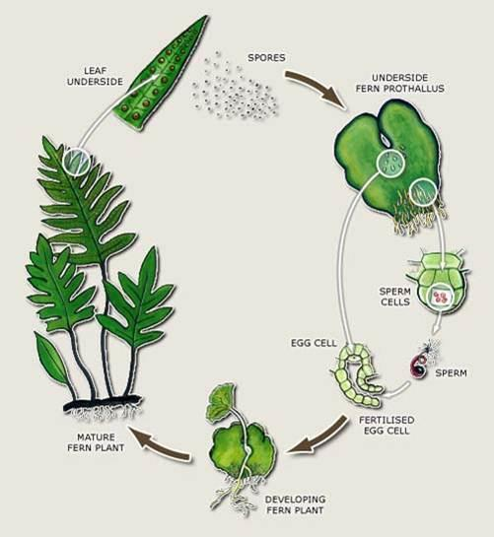
The primitive life cycle of a vascular plant.S

