NAME: EGBORO BETHEL OROWO
COLLEGE: MEDICINE AND HEALTH SCIENCES
DEPARTMENT: PHARMACY
MATRIC NO.: 19/MHS11/050
DATE: 05-05-2020
BIO 102 ASSIGNMENTS
- IMPORTANCE OF FUNGI TO MANKIND
- Fungi are responsible for the mediation of decay of organic matter.
- Fungi e.g. yeast (Saccharomyces cerevisiae) are important in food industry.
- Mushrooms are eaten by humans. Species e.g. Penicillium notatum produce important antibiotics.
- Some fungi are parasites to some pests e.g. houseflies, grasshoppers and therefore constitute important biological control agents in regard to such pests.

- DIAGRAM OF THE CELL STRUCTURE OF A UNICELLULAR FUNGUS 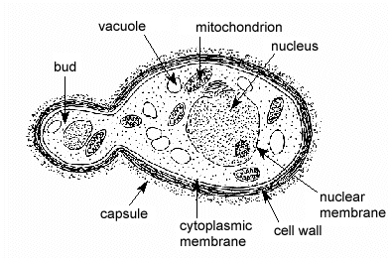
YEAST ( Saccharomyces cerevisiae)

- SEXUAL REPRODUCTION IN A TYPICAL FILAMENTOUS FORM OF FUNGI.
-Sexual reproduction occurs when two mating types of hyphae grow in the same medium. Chemical interaction in the two mating types of hyphae induces growth perpendicular to the hyphae in opposite directions. These growths are delimited by a wall such that many nuclei are isolated in what is called a gamentangium.
-the two gamentangia fuse (plasmogamy) and a zygote is formed which may undergo prolonged dormancy or resting stage. The nuclei in the zygote fuse in twos and undergo meiosis independently.
-the zygote germinates under favorable conditions to produce a fruiting which at maturity liberates the haploid spores.

- ADAPTATION OF BRYOPHYTES TO THEIR ENVIRONMENT
- They have definite structures for water and nutrient absorption from the soil; therefore the plant body is divided into two (an aerial portion and a subterranean portion). The subterranean portion is the rhizoid and it is not a true root as the case of land plants that are advanced.
- The aerial portion being exposed to the atmosphere demands some modifications that prevents loss of water through the body surface (i.e. desiccation)
- Some other modifications that permit removal of excess water from plant body and not only exchange of gases between the internal part of the plants; the atmosphere openings are available on the aerial parts of the plant.

- a. eusteles: this, in herbaceous dicotyledonous plants; the vascular bundles are discrete, concentric collateral bundles of xylem and phloem.
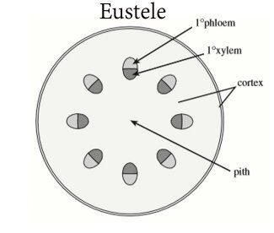
b. atactostele: this, in grasses and many monocotyledonous plants; the vascular bundles are scattered.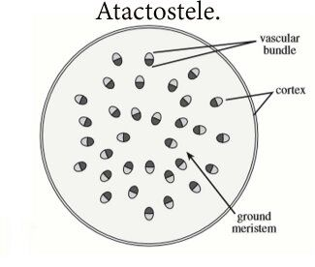

- siphonostele: this, in more advanced vascular systems e.g. stems of ferns and higher vascular plants, the stele is a cylinder enclosing a parenchymatous pith.
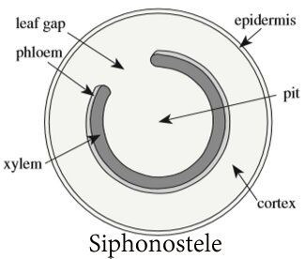

- dictyostele: in siphonosteles, vascular supply to leaves is associated with leaf gaps and the conducting cylinder is a dissected one, it is known as dictyostele.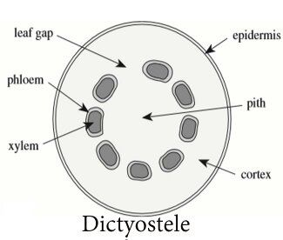
- LIFE CYCLE OF A PRIMITIVE VASCULAR PLANT
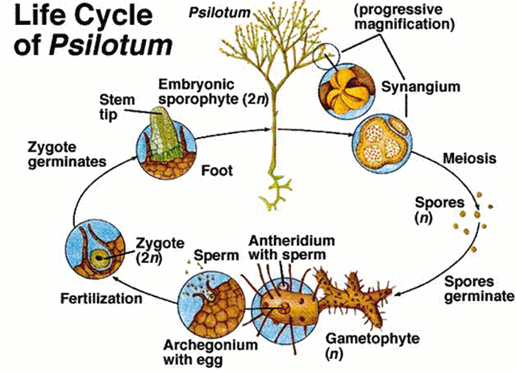
Three-lobed sporangia (each subtended by two scales) are borne on the vertical axes. The sporangium contains haploid spores and originates from diploid cells of the stem. Sporangium develops into a globose structure inside which sporogenous cells undergo meiosis to produce haploid spores. Short stalk of the sporangium has a trace connected to the stele of the vertical axis. The plant is homosporous i.e. spores have uniform size and shape.
Spores after liberation germinate into cylindrical, dichotomously-branched gametophytes. Gametophytes are saprophytic, and often associated with certain filamentous fungi in mycorrhizal relationship and are hardly visible to the naked eye. Externally, they have many rhizoids but internally, they are largely parenchymatous. At maturity, the terminal ends of the cylindrical bear the archegonia while the antheridia are borne as protuberance lower down on the branches. Sperms having many flagella are released when antheridia are ripe which swim into the archegonia and the resulting zygote subsequently develops into a sporophyte.

