NAME; ABIMBOLA OLAMIDE REBECCA
MATRIC NUMBER; 18/MHS02/004
COURSE TITLE; ENDOCRINE & REPRODUCTIVE PHYSIOLOGY
COURSE CODE; PHS 204
ASSIGNMENT TITLE; DISCUSS THE GESTATION PERIOD IN A NORMAL FEMALE
DEPARTMENT; HUMAN ANATOMY

Lactation
Secretion and yielding of milk by females after giving birth. This milk is produced by mammary glands, which are contained within the breast. The breast unlike most of the other organs continue to increase in size after childbirth .although mammary growth begins during pregnancy under the influence of ovarian and placental hormones, and some milk is formed, copious milk secretion sets in only after delivery. Since lactation ensures after a premature birth, it would appear that milk production is held back during pregnancy. The mechanism by which this inhibitory effect is brought about, or by which lactation is initiated at delivery, has long been subject of argument that revolves around the opposing actions of estrogen, progesterone and prolactin as studied in laboratory animals, goats, and cattle. During pregnancy the combination of estrogen and progesterone circulating in the blood appears to inhibit milk secretion by blocking the release of prolactin from the pituitary gland and by making the mammary gland cell unresponsive to the pituitary hormone. The blockade is removed at the end of pregnancy by the expulsion of the placenta and the loss of its supply of hormones as well as by the decline in hormone production by the ovaries,whilesufficient estrogen remains in circulation to promote the secretion of prolactin by the pituitary and also favour lactation
For lactation to continue, necessary patterns of hormones secretion must be maintained; disturbances of the equilibrium by the experimental removal of pituitary gland in animals or by comparable diseased condition.

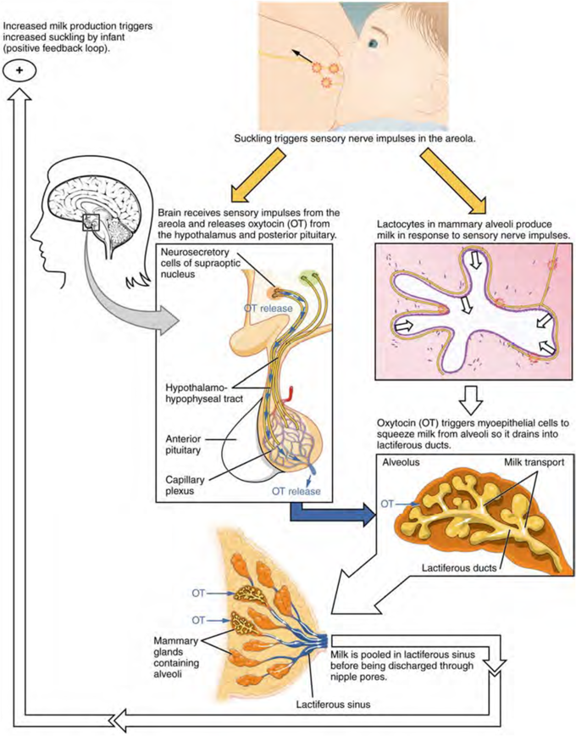

Gestation
Gestation ca be known as baby due date or pregnancy due date
The unborn baby spends around 38 weeks in the uterus, but the average of pregnancy, or gestation, is counted at 40 weeks
Pregnancy is counted from the first day of the woman’s last period, not the date of conception which generally occurs two weeks later
Since some women are unsure of the date of their last menstruation (perhaps due to period irregularities), a baby is considered full term if its birth falls between 37 to 42 weeks of its estimated due date
The unborn baby spends around 37 weeks in the uterus (womb), but the average length of pregnancy, or gestation, is calculated as 40 weeks. This is because pregnancy is counted from the first day of the woman’s last period, not the date of conception which generally occurs two weeks later, followed by 5 to 7 days before it settles in the uterus. Since some women are unsure of the date of their last menstruation (perhaps due to period irregularities), a pregnancy is considered full term if birth falls between 37 to 42 weeks of the estimated due date
A baby born prior to week 37 is considered premature, while a baby that still hasn’t been born by week 42 is said to overdue. In many cases, labour will be induced in the case of an overdue baby
Length of gestation
The average length of human gestation is 280 days or 40 weeks, from the first day of women’s last menstrual period. The medical term for the due date is estimated date of confinement (EDC). However, only about four per cent of woman actually gives birth on their EDC.
A simple method to calculate the due date is to add seven days to the date of the first day of your last period, then add nine months.
Determining baby due date
Irregular menstrual cycles can mean that some women aren’t sure of when they conceived. Some clues to the length of gestation include
- Ultrasound examination( especially when performed between six and twelve weeks)
- Size of uterus on vaginal or abdominal examination
- The time fetal movement are first felt(an approximate guide only)

