NAME; ABIMBOLA OLAMIDE REBECCA
MATRIC NUMBER; 18/MHS02/004
COURSE TITLE; HISTOLOGY OF THE SYSTEMS (ORGANOLOGY)
COURSE CODE; ANAL 204
DEPARTMENT; HUMAN ANATOMY
QUESTION
Describe the microanatomy of small and large intestine
Note
You are expected to state functions, segment, layers, general features and epithelium of each part of the small and large intestine
The small intestine is the longest section of the digestive tube and consists of three segment forming a passage from the pylorus to the large intestine
- Duodenum; a short section that receives secretions from the pancreases and liver via the pancreatic and common bile ducts
- Jejunum ; considered to be roughly 40% of the small gut in man, but closer to 90% in animals
- Ileum ; empties into the large intestine ;considered to be about 60% of the intestine in man ,but veterinary anatomists usually refer to it as being only the short terminal section of the small intestine
In most animal, the length of the small intestine is roughly 3.5 times body length, your small intestine or that of a large dog is about 6meter in length although precise boundaries between these three segments of bowel are not observed grossly or microscopically
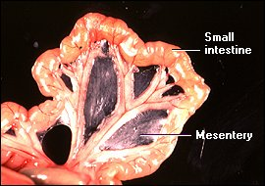

The microvillus border of intestinal epithelial cells is referred to as the brush border
Cells types that populates the small intestine epithelium
- Enteroendocrine cells ;which as part of the enteric endocrine system sense the luminal environment and secretes hormones such as cholecystokinin and gastrin into the blood
- Goblet cells ; which secrete a lubricating mucus into the intestinal lumen
- Paneth cells ;which provide an important anti-bacterial defense for the small intestine
- Stem cells; which allows rapid constant turnover of small intestinal epithelial cells.

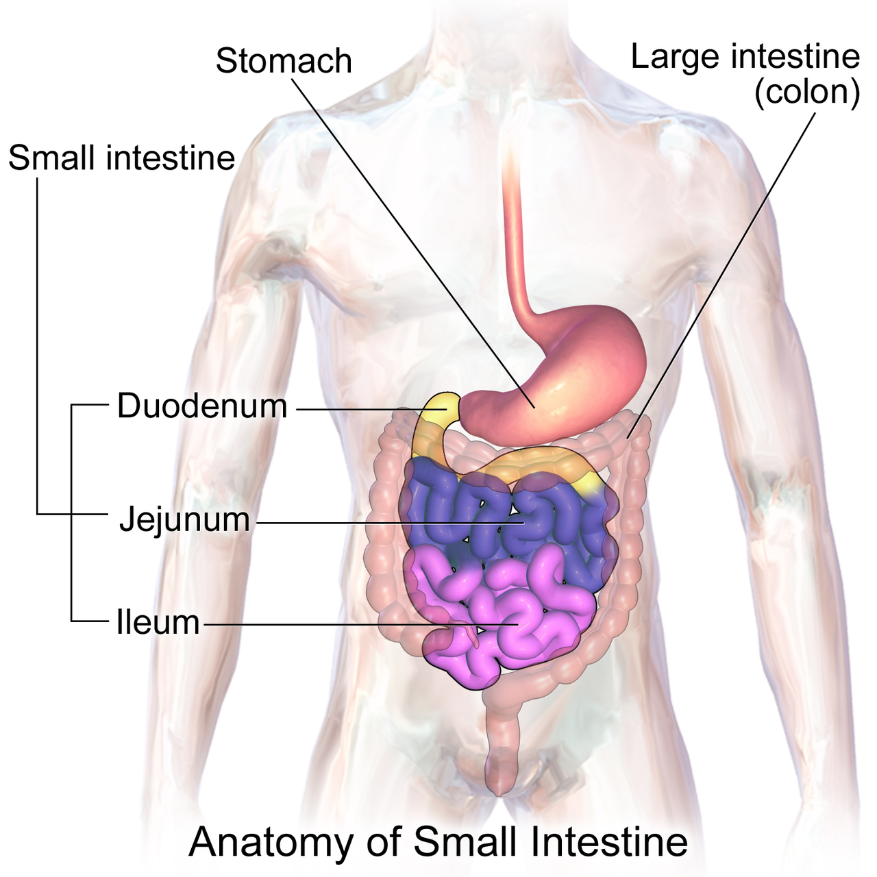
Large intestines
The large intestine is that part of the digestive tube between the terminal ileum and anus.Depending on the species, ingesta from the small intestine enters the large intestine through either the ileocecal or ileocolic valve. Within the large intestine, three major segments are recognized
- the cecum is a bind-ended pouch that humans carries a worm-like extension called the vermiform appendix
- the colon constitutes the majority of the length of the large intestine and is subclassified into ascending, transverse and descending segments
- the rectum is the most short ,terminal segment of the digestive tube,continous with the anal canal

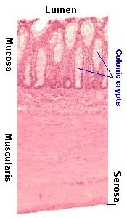
Function of large intestines
The residue of chime that enters the large intestine contains few nutrients except water which is reabsorbed as the residue linger in the large intestine, typically for 12 to 24 hours

