NAME; ABIMBOLA OLAMIDE REBECCA
MATRIC NUMBER; 18/MHS02/004
COURSE CODE; SYSTEMATIC EMBRYOLOGY (ORGANOGENESIS)
COURSE CODE; ANAL206
ASSIGNMENT TITLE; EMBRYOLOGY
QUESTION
DISCUSS THE ROTATION OF THE INTESTINE
During normal abdominal development, the 3 division of the GI tract (i.e. foregut, midget, hindgut) heriniate out from the abdominal
As the intestines develop, they normally move from the base of the umbilical cord back into the abdominal cavity. As the intestine return to the abdomen, it makes two rotations and settles into its normal position
During normal abdominal development the3 divisions of the GI tract (i.e., foregut, midgut, and hindgut) herniated out from the abdominal cavity where they undergo a 270 degree counterclockwise rotation around the superior mesenteric vessels. Following this rotation the bowel return to the abdominal cavity, with fixation of the duodenojejunal loop to the left of the midline and the cecum in the right lower quadrant.
In stage 13, ca.32days, the midgut begins to extend into the umbilical coelom and forms the umbilical loop, whereby initially from the apex only a wide connection to the umbilical vesicle exist.inthe further development this junction becomes constricted to become the omphalomesenteric duct as a meckel’s deverticulum
1. Stomach
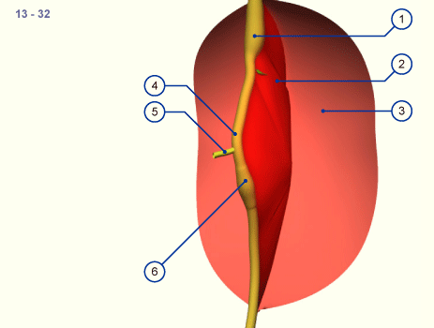
The intestinal tube become enwrapped by the visceral peritoneum that connects it to the posterior body wall forming the dorsal mesenterium(red surface).in this stage the intestinal tube is almost straight and is connected to the umbilical vesicle by the omphalomesenteric duct.
1. Stomach
2. Mesenterium
3. Parietal peritoneum
4. Intestinal loop
5. Omphalomesenteric duct
6. Cecum
Only when the umbilical loop lengthens and grows into the umbilical coelom does it experience a rotation of 90 degree in a clockwise direction as seen from the embryo
Intestinal rotation; stage 14, ca.33 days
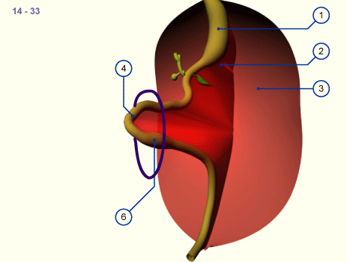
1. Stomach
2. Mesenterium
3parietal peritoneum
4intestinal loop
6. Cecum
The developing umbilical loop extends further into the umbilical coelom because there is no more room for it within the embryo’s abdominal cavity .it is the time of the strongest flexion of the embryo. Very soon a thickening in the region of the caudal pedicle of the intestinal tube is also to be seen; the cecum visually, it becomes an important fixed point for purposes of orientation.
Intestinal rotation stage 16,ca.39 days
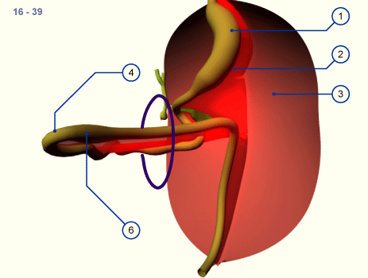
1. Stomach
2. Mesenterium
3. Parietal peritoneum
4. Intestinal loop
5. Cecum
As development proceeds the intestinal loop turns further around it s own axis. In stage 18(ca, 44 days,)the extension of the intestinal loop into the umbilical coelum has reached its maximum.
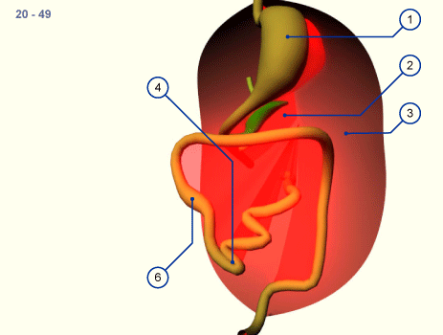
After the reintegration of the intestinal loops into the abdominal cavity from the physiologic umbilical hernia
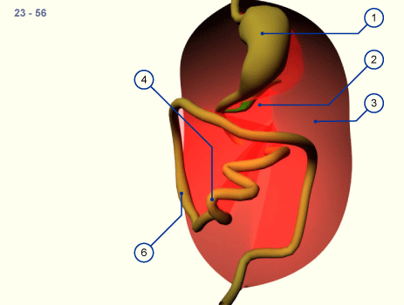
As a rule the cecum grows caudally and comes to lie in the right iliac fossa.Through rotation of the whole small intestine of more than 270 degree, the mesenterium also rotates thereby and moves from off from the inferior part of the duodenum to the small intestine.

