STUDENT INDUSTRIAL WORK EXPERIENCE SCHEME(SIWES)
A TECHNICAL REPORT ON THE THREE(3) MONTHS INDUSTRIAL TRAINING
PROGRAMME
HELD AT THE NATIONAL AGENCY FOR FOOD,DRUGS AND ADMINISTRATION
CONTROL,YABA, LAGOS.
PRESENTED BY
IKIERE DEBORAH TAMARADOUBRA
MATRIC NO; 16/MHS07/014
SUBMITTED TO
THE DEPARTMENT OF PHARMACOLOGY AND THERAPEUTICS
AFE BABALOLA UNIVERSITY,ADO-EKITI, EKITI STATE.
IN PARTIAL FULFILLMENT OF THE REQUIREMENT FOR THE AWARD OF B.Sc
PHARMACOLOGY.

CHAPTER 1
1.1 BRIEF HISTORY OF STUDENT INDUSTRIAL WORK EXPERIENCE SCHEME
The Student Industrial Work Experience Scheme (SIWES) was established by the Industrial Training Found (ITF) in 1973 to enable students of tertiary institutions have basic technical knowledge of industrial works based on their courses of study before the completion of their program in their respective institutions. SIWES is common to tertiary institutions that run courses involving industrial training courses and programmes.
Student Industrial Work Experience Scheme is compulsory for students of natural, environmental, engineering and social sciences in Nigeria tertiary institutions. SIWES is funded and co-ordinated by the Industrial Training Fund (ITF) of the Federal republic of Nigeria. SIWES as a skill acquisition programme is aimed at bridging the gap between theory and practice. It is a three-fold programme involving the student, the tertiary institution of learning and the employer of labour.
At the end of the programme, students are expected to have gained quality training that will prepare them for future challenges.
In general, strategies have been mapped out to monitor and evaluate student’s performance through strict supervision and daily recording of work done in the log book.

1.2.1. OBJECTIVES OF STUDENT INDUSTRIAL WORK EXPERIENCE SCHEME
1. To provide students with industrial skills and needed experience in the course of study.
2. To expose students to work methods and techniques in handling equipments that may not be available in the university.
3. To prepare students for work situation likely to be met after graduation.
4. To expose students to the world of work easier and enhance contexts.
5. To provide students with an opportunity to apply their theoretical knowledge in real work.
6. To enlist and strengthen employers involvement in the entire educational process of preparing university graduates for employment in industries.

NATIONAL AGENCY FOR FOOD,DRUGS AND ADMINISTRATION CONTROL
The National Agency for Food and Drug Administration and Control (NAFDAC) is a federal agency under the Federal Ministry of Health that is responsible for regulating and controlling the manufacture, importation, exportation, advertisement, distribution, sale and use of food, drugs, cosmetics, medical devices, chemicals and packaged water in Nigeria.
FUNCTIONS OF NAFDAC
- Regulate and control the importation, exportation, manufacture, advertisement, distribution, sale and use of drugs, cosmetics, medical devices, packaged water and chemicals.
- Undertake the registration of food, drugs, medical devices, bottled water and chemicals.
- Establish and maintain relevant laboratories or other institutions in strategic areas of Nigeria as may be necessary for the performance of its functions.
- Undertake appropriate investigation into the production premises and raw materials for food, drugs, cosmetics, medical devices, bottled water and chemicals and establish a relevant quality assurance system, including certification of the production sites and of the regulated products
- Undertake inspection of imported foods, drugs, cosmetics, medical devices, bottled water, and chemicals and establish a relevant quality assurance system, including certification of the production sites and of the regulated products.

NATIONAL CONTROL LABORATORY FOR VACCINES AND OTHER BIOLOGICALS (NCLVB), Yaba, Lagos.
The National Control Laboratory for Vaccines and other Biologics (NCLVB) is a unit under the LABORATORY SERVICES DIRECTORATE of the National Agency for Food and Drug Administration and Control (NAFDAC). It was formerly under the Central Drug / Vaccine Quality Control Laboratory and was then known as The National Vaccine Quality Control Laboratory.
The National Vaccine Quality Control Laboratory was commissioned on the 15th of February, 1999 by the then Honourable Minister of Health Professor Debo Adeyemi.
The commissioning of the laboratory came at a time when there was a concerted effort worldwide to control and eradicate vaccine preventable diseases such as Poliomyelitis, Measles, Mumps, Rubella, Diphtheria, Tetanus, Pertussis, Haemophilus influenza type b (Hib), Meningitis, Hepatitis A and B, Varicella etc.
The Laboratory was saddled with the responsibility of ensuring the safety, potency, efficacy and Lot release of vaccines in conjunction with being a resource for the performance of the six critical functions of a National Control Authority (NCA) recommended by the World Health Organization (WHO).
The National Vaccine Quality Control Laboratory officially became autonomous from the Central Drug / Vaccine Quality Control Laboratory on 24th August, 2009. It has since then changed to National Control Laboratory for biologics (NCLB) and presently National Control Laboratory for vaccines and other biologics (NCLVB)
To effectively perform its functions, NCLVB consists of the following units:
1. Chemistry Lab
2. Microbiology Lab
3. Serology Lab
4. In-Vivo Lab
5. Tissue Culture Lab
6. Quality Assurance Unit
7. Sample Receipt Unit
8. Administration Unit
9. Specification and Archiving Unit
10. Animal Facility
The laboratory has qualified experienced personnel in Vaccine Quality Control testing, trained abroad and locally.
During my Industrial training period at NAFDAC, I was posted to two(2) laboratories in the NCLVB and the laboratories are Serology and In-Vivo laboratory.

CHAPTER TWO

2.1. INTRODUCTION TO THE LABORATORY
A laboratory is a building or a room where scientific experiments, analysis, and research are carried out.

2.2. GENERAL LABORATORY SAFETY
Introduction:
Laboratory safety rules differ with the biologics and vaccines laboratory. Therefore, persons engaged in testing of vaccines and other biologics laboratories such as:
- Serology and Tissue culture laboratory are predisposed to hazards such as: Pathogenicity of microorganisms and exposure to blood of infected patients.
- The Chemistry laboratory are predisposed to chemical hazards such as: Exposure to harmful chemicals (example: Ethidium bromide, 2-4, dichlorophenoxyacetic acid) through spills, splashes e.t.c
It is thereby necessary to ensure that four (4) major laboratory safety regulations are observed.
They include;
1. Laboratory hygiene.
2. General Laboratory Precautions.
3. General Handling and Storage of Chemicals.
4. Handling Glassware and sharp objects.

2.2.1. LABORATORY HYGIENE
1. Food and drinks are not to be stored or prepared in the laboratory or chemical store rooms. All food and drinks should be consumed in specially designated areas such as the canteen or pantry.
2. Appropriate personal protective equipment (PPE) should be used and hands should be washed regularly when working with chemical reagents, especially before meals or snacks.
3. Personal items such as backpacks should not be stored on work benches
4. Long hair should be properly tied back.
5. Mouth pipetting should be avoided, other pipetting devices such as; micropipette or pipette filler should be used.

2.2.2. GENERAL LABORATORY PRECAUTIONS
1. The work bench is to be kept clean at all times, and free from chemicals and apparatus which are not required.
2. Wearing of appropriate personal protective equipment (PPE) is mandatory in the laboratory.
3. Before starting an experiment, procedures and the potential hazards of the starting materials and products must be known.
5. It is preferable to clean up after each stage of an experiment. Apparatus which has been contaminated with harmful chemicals should be rinsed before being left for final cleaning.
6. When leaving the lab before the completion of an experiment, a warning sign should be put next to the set-up, to indicate work in progress. This is to include relevant information such as name, contact number and hazardous conditions.

2.2.3. GENERAL HANDLING AND STORAGE OF SAMPLES AND CHEMICALS
1. All containers of reagents and chemicals should be labelled properly with their chemical name, concentration, date of preparation, and your name. Toxic chemicals should be clearly marked poison or toxic and carry a special warning.
2. Laboratory reagents and chemicals are to be capped and placed on the appropriate shelves immediately after use, with their labels at the front.
3. Laboratory cupboards and refrigerators should be inspected regularly. Unused samples should not be stored indefinitely, but should be safely disposed of after a long storage.

2.2.4 PERSONAL PROTECTION
It is imperative to be aware of all forms of personal protective equipment which are available and be familiar with their use.
Examples of personal protective equipment (PPE) include;
-Eye protective equipment e.g. goggles, eye spectacles, face shield.
-Coveralls e.g. labcoats, overalls.
-Gloves
-hairnet

2.3. LABORATORY EQUIPMENT AND THEIR USES
The following are the laboratory equipment and their uses,
They include:
- Centrifuge
The centrifuge is a mechanical equipment using centrifugal or rotational force to separate substances of different densities. It is widely used to separate solids from liquids or liquids from other liquids.
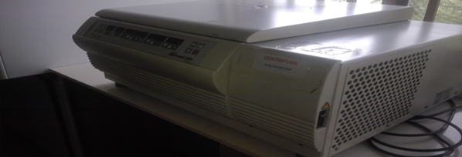
- Bio-safety cabinet
The bio-safety cabinet or laminar flow unit is designed to create clean and dust free conditions in laboratories. This equipment prevents contamination of biological samples.
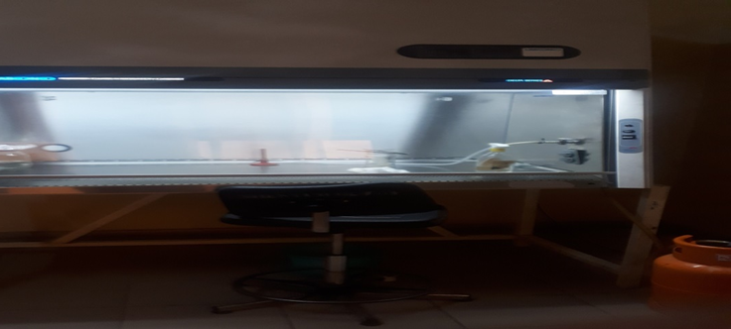
Figure 2
- Fume hood:
For experiments that involve carcinogenic chemicals, strong acids or substances that produces bad odour.
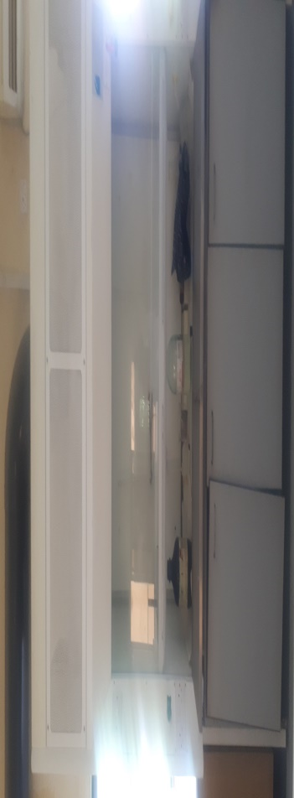
Figure 3: Fume hood
- Micropipette and pipette tips
Micropipettes are used to measure and deliver accurate volumes of liquid. Pipette Tips are disposable, autoclavable attachments for the uptake and dispensing of liquids using a micropipette.
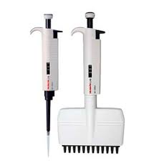
- Heating Block
A heat block is an incubator with a stainless steel chamber and aluminum blocks. It provides rapid, even heating and can accommodate different tube sizes.
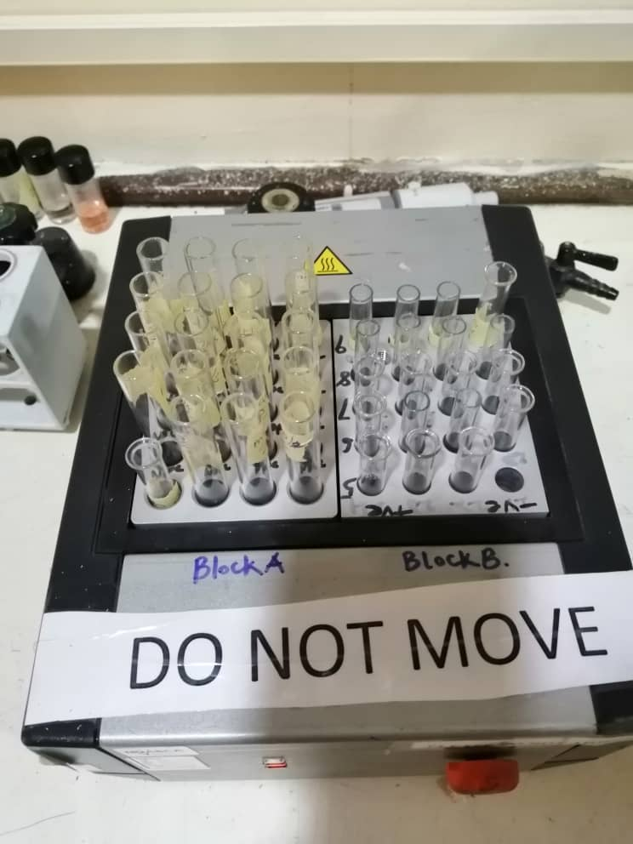

- Weighing balance
It is a simple instrument used to measure force or weight in a laboratory setting. The analytical weighing balance is extremely sensitive and has high readability and a broad weighing range.
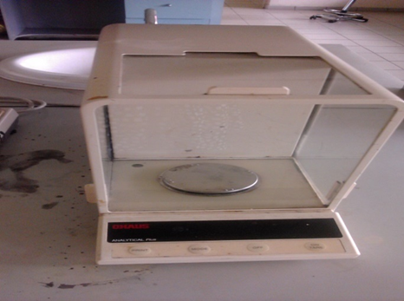

CHAPTER THREE
3.1 EXPERIENCE IN SEROLOGY LABORATORY
The tests done in this laboratory are to determine the sensitivity, specificity and efficiency of various test kits and medical devices.
The type of samples worked on in this laboratory are;
a.)Rapid diagnostic test kit( Malaria, pregnancy, HIV, Syphilis test kits)
b.)Medical laboratory re-agent(not rapid)
c.)Other medical devices
Tests are also done on blood samples to check the blood group , genotype, blood sugar level and the presence of anticoagulants in the blood.

3.2 EXPERIENCE IN IN-VIVO LABORATORY
The various tests done in this laboratory are
- Safety test
- Potency test
- Toxicity test
This test are done to find out the potency, efficiency, specificity of a vaccine.
A.)SAFETY TEST
This test is done using an Albino mice with weight of 17-22g and a tetanus vaccine, A recombinant humanized anti-EGFR monoclonal antibody, Injection water and the sample vaccine(NOTE: The vaccines always come in freeze dried form and you have to use injection water or distilled water to melt it, then vortex for about a minute). The mice are grouped and separated into various cages. The vaccine is kept at room temperature before injecting the mice. The route of administration for this test is mostly Intravenous and Subcutaneous route of administration.
After administration of the vaccine, the mice are been observed for 7 days (1 week) to see if there is any ill health, growth, death or changes in the body and behavior of the vaccine. If the mice dies or has ill health, then the vaccine is either expired or not good and it is therefore not safe for use in the general public.

B.) POTENCY TEST
TEST FOR BACTERIAL ENDOTOXINS
The bacterial endotoxins test (BET) is a test to detect or quantify endotoxins from Gram-negative bacteria using amoebocyte lysate from the horseshoe crab (Limulus polyphemus or Tachypleus tridentatus). There are three methods for this test:
• Method A. The gel-clot technique, which is based on gel formation;
• Method B. The turbidimetric technique, based on the development of turbidity after cleavage of an endogenous substrate;
• Method C. The chromogenic technique, based on the development of color after cleavage of a synthetic peptide-chromogenic complex.
APPARATUS
Depyrogenate all glassware and other heat stable materials in a hot air oven using a validated process. A commonly used minimum time and temperature is 30 minutes at 250°C. If employing plastic apparatus such as microplates and pipet tips for automatic pipetters, use apparatus shown to be free of detectable endotoxin and which does not interfere in the test.
REAGENTS AND TEST SOLUTIONS
• Amoebocyte lysate
A lyophilized product obtained from the lysate of amebocytes (white blood cells) from the horseshoe crab (Limulus polyphemus or Tachypleus tridentatus). Amebocyte lysate reacts to some β-glucans in addition to endotoxins. Amebocyte lysate preparations which do not react to glucans are available: they are prepared by removing the G factor reacting to glucans from amebocyte lysate or by inhibiting the G factor reacting system of amebocyte lysate and may be used for the endotoxin testing in the presence of glucans.
• Lysate TS
Dissolve amebocyte lysate in water BET or in a buffer recommended by the lysate manufacturer, by gentle stirring. Store the reconstituted lysate, refrigerated or frozen, according to the specifications of the manufacturer.
• Water BET
Water for injections or water produced by other procedures that shows no reaction with the lysate employed, at the detection limit of the reagent.

Preparation of Standard Endotoxin Stock Solution
A Standard Endotoxin Stock Solution is prepared from an endotoxin reference standard that has been calibrated against the International Standard for endotoxins. Follow the specifications in the package leaflet and on the label for preparation and storage of the Standard Endotoxin Stock Solution.
Endotoxin is expressed in International Units (IU) of endotoxin.
Note: One International Unit (IU) of endotoxin is equal to one Endotoxin Unit (EU).
Preparation of Standard Endotoxin Solution
After mixing the Standard Endotoxin Stock Solution vigorously, prepare appropriate serial dilutions of Standard Endotoxin Solution, using water BET.
Use dilutions as soon as possible to avoid loss of activity by adsorption.
Preparation of sample solutions
Prepare sample solutions by dissolving or diluting drugs using water BET. Some substances or preparations may be more appropriately dissolved or diluted in other aqueous solutions. If necessary, adjust the pH of the solution to be examined (or dilution thereof) so that the pH of the mixture of the lysate TS and sample solution falls within the pH range specified by the lysate manufacturer, usually 6.0 to 8.0. The pH may be adjusted by the use of acid, base, or suitable buffer as recommended by the lysate manufacturer. Acids and bases may be prepared from concentrates or solids with water BET in containers free of detectable endotoxin. Buffers must be validated to be free of detectable endotoxin and interfering factors.
DETERMINATION OF MAXIMUM VALID DILUTION
The Maximum Valid Dilution (MVD) is the maximum allowable dilution of a sample at which the endotoxin limit can be determined.
Determine the MVD from the following equation:
MVD = $$\frac{potency ×Release limit}{λ(Sensitivity of assay)}$$

METHOD A: GEL-CLOT TECHNIQUE
The gel-clot technique is for detecting or quantifying endotoxins based on clotting of the lysate TS in the presence of endotoxin. The minimum concentration of endotoxin required to cause the lysate to clot under standard conditions is the labeled sensitivity of the lysate TS. To ensure both the precision and validity of the test, perform the tests for confirming the labeled lysate sensitivity and for interfering factors as described below under Preparatory testing.
Preparatory testing
Test for confirmation of labeled lysate sensitivity
Confirm in four replicates the labeled sensitivity, λ, expressed in IU/ml of the lysate prior to use in the test. The test for confirmation of the lysate sensitivity is to be carried out when a new lot of lysate is used or when there is any change in the test conditions which may affect the outcome of the test.
Prepare standard solutions having at least four concentrations equivalent to 2λ , λ, 0.5λ and 0.25λ by diluting the Standard Endotoxin Stock Solution with water BET.
Mix a volume of the lysate TS with an equal volume of one of the standard solutions (such as 0.1 ml aliquots) in each tube. When single test vials or ampoules, containing lyophilized lysate are employed, add solutions of standards directly to the vial or ampoule. Put the reaction mixture in a heating block for a constant period according to directions of the lysate manufacturer (usually at 37±1°C for 60 ± 2 minutes), avoiding vibration. Test the integrity of the gel for tests carried out in tubes, take each tube in turn directly from the heating block and invert it through approximately 180 degrees in one smooth motion. If a firm gel has formed that remains in place upon inversion, record the result as positive. A result is negative if an intact gel is not formed.
The test is considered valid when the lowest concentration of the standard solutions shows a negative result in all replicate tests.
The endpoint is the lowest concentration in the series of decreasing concentrations of standard endotoxin that clots the lysate.

METHOD B. TURBIDIMETRIC TECHNIQUE
This technique is a photometric assay measuring increases in reactant turbidity. On the basis of the particular assay principle employed, this technique may be classified as either an endpoint-turbidimetric assay or a kinetic-turbidimetric assay.
The endpoint-turbidimetric assay is based on the quantitative relationship between the concentration of endotoxins and the turbidity (absorbance or transmission) of the reaction mixture at the end of an incubation period.
The kinetic-turbidimetric assay is a method to measure either the time (onset time) needed to reach a predetermined absorbance or transmission of the reaction mixture, or the rate of turbidity development.
The test is carried out at the incubation temperature recommended by the lysate manufacturer (which is usually 37 ± 1°C).

REFERENCES
- Anacker, R. L., W. D. Bickel, W. T. Haskins, K. C. Milner, E. Ribi, and J. A. Rudbach. 1966. Frequency of occurrence of native hapten among enterobacterial species. J. Bacteriol. 91:1427-1433.
- Anderson, E. H. 1946. Growth requirements of virusresistant mutants of Escherichia coli strain "B". Proc. Natl. Acad. Sci. U.S.A. 32:120-128.
- . Elin, R. J., and S. M. Wolff. 1973. Nonspecificity of the Limulus amebocyte lysate test: positive reactions with polynucleotides and proteins. J. Infect. Dis. 128:349-352.

