NAME: IKPEAZU PRINCESS
MATRIC NUMBER: 17/MHS01/156
QUESTION 1
Discuss the anatomy of the tongue and comment on its applied anatomy.
ANSWER
The tongue is a mobile muscular organ that can assume a variety of shapes and positions. It is partly in the oral cavity and partly in the oropharynx. The tongue is involved with mastication, taste, deglutition (swallowing), articulation, and oral cleansing; however, its main functions are forming words during speaking and squeezing food into the oropharynx when swallowing
PARTS AND SURFACES OF THE TONGUE. They include;
- a root
- a body
- an apex
- a curved dorsum
- an inferior surface
The root of the tongue:
is the part of the tongue that rests on the floor of the mouth and is usually defined as the posterior third of the tongue
The body of the tongue:
is the anterior two thirds of the tongue
The apex (tip) of the tongue:
is the anterior end of the body, which rests against the incisor teeth
- NOTE: The body and apex of the tongue are extremely mobile.
The dorsum (dorsal surface) of the tongue :
is the posterosuperior surface, which is located partly in the oral cavity and partly in the oropharynx. The mucous membrane on the anterior part of the tongue is rough because of the presence of numerous small lingual papillae(small nipple like process):
- Vallate papillae: Large and flat topped, they lie directly anterior to the terminal sulcus and are arranged in a V-shaped row
- Foliate papillae: Small lateral folds of the lingual mucosa. They are poorly developed in humans
- Filiform papillae: Long and numerous, they contain afferent nerve endings that are sensitive to touch
- Fungiform papillae: Mushroom shaped pink or red spots, they are scattered among the filiform papillae but are most numerous at the apex and margins of the tongue
NOTE: The vallate, foliate, and most of the fungiform papillae contain taste receptors in the taste buds.
A shallow midline groove of the tongue divides the tongue into right and left halves called the median sulcus.
- The inferior surface of the tongue;
- is covered with a thin, transparent mucous membrane through which one can see the underlying veins
- This surface is connected to the floor of the mouth by a midline fold called the frenulum of the tongue
- The frenulum allows the anterior part of the tongue to move freely
- On each side of the frenulum, a deep lingual vein is visible through the thin mucous membrane
- 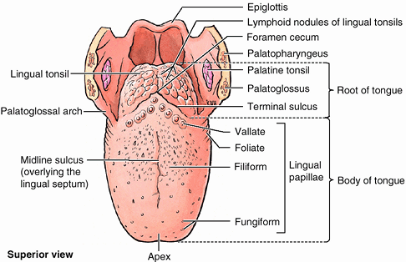There are four basic taste sensations: sweet, salty, sour, and bitter
- Sweetness is detected at the apex
- saltiness at the anterolateral margins
- sourness at the posterolateral margins
- bitterness at the posterior part of the
tongue

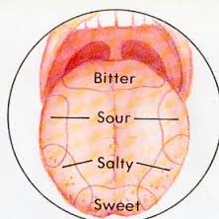
Muscles of the Tongue
The muscles of the tongue are divided into extrinsic and intrinsic muscles. Extrinsic muscles alter the position of the tongue while intrinsic muscles alter its shape. The four intrinsic and four extrinsic muscles in each half of the tongue are separated by a median fibrous lingual septum, which merges posteriorly with the lingual aponeurosis
Extrinsic Muscles of the Tongue
These include:
- genioglossus
- Hyoglossus
- styloglossus
- palatoglossus
They originate outside the tongue and attach to it and mainly move the tongue but they can alter its shape as well
Intrinsic Muscles of the Tongue
They include:
- superior longitudinal muscle
- inferior longitudinal muscle
- transverse muscle
- vertical muscles
They have their attachments entirely within the tongue and are not attached to bone
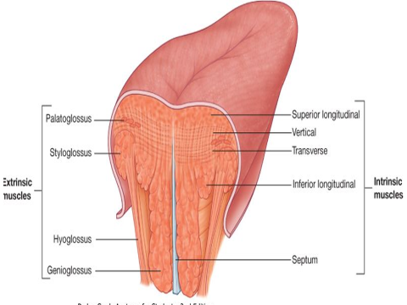

Vasculature of the Tongue
Arterial supply
- The arteries of the tongue are derived from the lingual artery, which arises from the external carotid artery
On entering the tongue, the lingual artery passes deep to the hyoglossus muscle and give rise to the:
- The dorsal lingual arteries which supply the posterior part (root); are prevented from communicating by the lingual septum
- the deep lingual arteries supply the anterior part which communicate with each other near the apex of the tongue.
Venous drainage
- The veins of the tongue are the dorsal lingual veins, which accompany the lingual artery;
- the deep lingual veins, which begin at the apex of the tongue, run posteriorly beside the lingual frenulum to join the sublingual vein
- The sublingual veins in elderly people are often varicose (enlarged and tortuous)
- All these lingual veins terminate, directly or indirectly, in the IJV
Innervation of the Tongue
Motor innervation
- All muscles of the tongue, except the palatoglossus (actually a palatine muscle supplied by the vagus nerve(X) of the pharyngeal plexus), receive motor innervation from the hypoglossal nerve (CN XII)
Sensory innervation
The anterior two thirds of the tongue are supplied by:
- the lingual nerve (CN V₃) for general sensation
- the chorda tympani, a branch of the facial nerve (CN VII) transferring nerve fibers to the lingual nerve, for taste
The posterior third of the tongue and the vallate papillae are supplied by:
- the lingual branch of the glossopharyngeal nerve (CN IX) for both general sensation and taste
Another contribution is made by the internal laryngeal branch of the vagus (CN X) for general sensation and taste
- Hence CN VII, CN IX, and CN X provide nerve fibers for taste; those from CN VII are ultimately conveyed by CN V₃
Clinical anatomy
- Lingual Carcinoma
A lingual carcinoma in the posterior part of the tongue metastasizes to the superior deep cervical lymph nodes on both sides, whereas a tumor in the anterior part usually does not metastasize to the inferior deep cervical lymph nodes until late in the disease.
Because these nodes are closely related to the IJV, metastases from the tongue may be widely distributed through the submental and submandibular regions and along the IJVs in the neck.
2.Frenectomy
- An overly large lingual frenulum (tongue-tie) interferes with tongue movements and may affect speech
- In unusual cases, a frenectomy (cutting the frenulum) in infants may be necessary to free the tongue for normal movement and speech
3.Thyroglossal Duct Cyst
- A cystic remnant of the thyroglossal duct, associated with development of the thyroid gland, may be found in the root of the tongue and be connected to a sinus that opens at the foramen cecum
- Surgical excision of the cyst may be necessary
- Most thyroglossal duct cysts are in the neck, close or just inferior to the body of the hyoid bone

QUESTION 2
Write an essay on the air sinuses.
ANSWER
The air sinuses are also referred to as paranasal sinuses; which are air-filled extensions of the respiratory part of the nasal cavity. There are four paired sinuses named according to the bone in which they are located; maxillary, frontal, sphenoid and ethmoid.
FUNCTION
The function of the sinuses is not clear. It is thought that they may contribute to the humidifying of the inspired air. They also reduce the weight of the skull.
FRONTAL SINUSES
- Most superior in location, found under the forehead
- Variable in size, but always triangular shaped
- Drain into the nasal cavity via the frontonasal duct

SPHENOID SINUSES
- Found more posteriorly and are related superiorly and laterally to the cranial cavity
- Drain out onto the roof of the nasal cavity.
- The relationship of the sinus are of clinical importance – the pituitary gland can be surgically accessed via passing through the nasal roof, into the sphenoid sinus and through the sphenoid bone.

ETHMOID SINUSES
There are ethmoidal sinuses; anterio, middle and posterior. They empty into the nasal cavity at different places:
- Anterior – Hiatus semilunaris
- Middle – Ethmoid bulla
- Posterior – Superior meatus

MAXILLARY SINUSES
- Largest of the sinuses.
- It is located laterally and slightly inferior to the nasal cavities
- Drains into the nasal cavity at the hiatus semilunaris, underneath the frontal sinus opening.
NOTE: it’s a potential pathway for spread of infection – fluid draining from the frontal sinus can enter the maxillary sinus
CLINICAL RELEVANCE
- SINUSITIS: As the paranasal sinuses are continuous with the nasal cavity, an upper respiratory tract infection can spread to the sinuses. And infection of the sinuses causes inflammation of the mucosa causing SINUSITIS.
NOTE: CN V₂ supplies both the maxillary sinus and maxillary teeth, and so inflammation of the sinus can cause toothache.

