NAME: OYEBOADE Rukayah Kiitan
MATRIC NO: 17/ENG08/004
DEPARTMENT: Biomedical Engineering
COURES CODE: BME352
COURSE TITLE: Introduction to Molecular and Cell Biology

QUESTION
Explain how the E proteins mediates virion vesicular transport in definite host cells.

ANSWER
The coronavirus E protein is a small membrane protein that has an important role in the assembly of virions. Coronaviruses (CoVs) are enveloped viruses with large positive-sense single-stranded RNA genomes. CoVs infect a variety of mammalian and avian species, and can cause serious disease in humans. The CoV E protein has a well-established role in the assembly of virions where it may induce membrane curvature or aid in membrane scission.
The E protein, along with N, S, and M, are the major coronavirus structural proteins. The E protein is targeted to the Golgi region in infected cells and also when expressed from cDNA.
The E protein is the smallest (76- to 109-amino-acid) of the major structural proteins, but also the most enigmatic. During the replication cycle, E is abundantly expressed inside the infected cell, but only a small portion is incorporated into the virion envelope. s. About 30 amino acids in the N-terminus of the E proteins allow attachment to the membrane of viruses. . In addition, coronavirus E proteins play a critical role in the assembly and morphogenesis of virions within the cell.
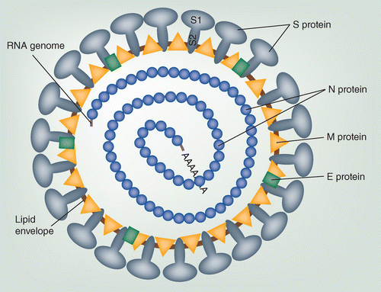

Figure 1- Schematic representation of a coronavirus particle.
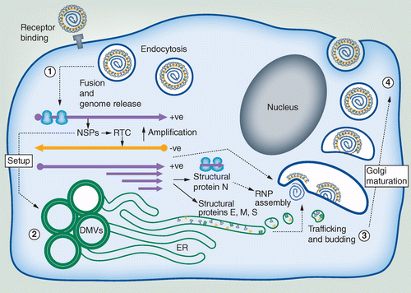
Figure 2- The coronavirus replication cycle highlighting areas where membrane interaction occurs.

After the virus enters the host cell and uncoats, the genome is transcribed and then translated. Coronavirus genome replication and transcription takes place at cytoplasmic membranes and involve coordinated processes of both continuous and discontinuous RNA synthesis that are mediated by the viral replicate, a huge protein complex encoded by the 20-kb replicase gene.¹² The replicase complex is believed to be comprised of up to 16 viral subunits and a number of cellular proteins. Besides RNA-dependent RNA polymerase, RNA helicase, and protease activities, which are common to RNA viruses, the coronavirus replicase was recently predicted to employ a variety of RNA processing enzymes that are not (or extremely rarely) found in other RNA viruses and include putative sequence-specific endoribonuclease, 3′-to-5′ exoribonuclease, 2′-O-ribose methyltransferase, ADP ribose 1′-phosphatase and, in a subset of group 2 coronaviruses, cyclic phosphodiesterase activities.^{13,14} The proteins are assembled at the cell membrane and genomic RNA is incorporated as the mature particle forms by budding from the internal cell membranes.

