NAME: ONOTHOJA DOMERO EWOMA
MATRIC NO: 17/MHS01/263
COURSE: GROSS ANATOMY OF THE HEAD AND NECK

Assignment
- Discuss the Gross Anatomy of the Tongue and comment on its clinical anatomy.

THE TONGUE
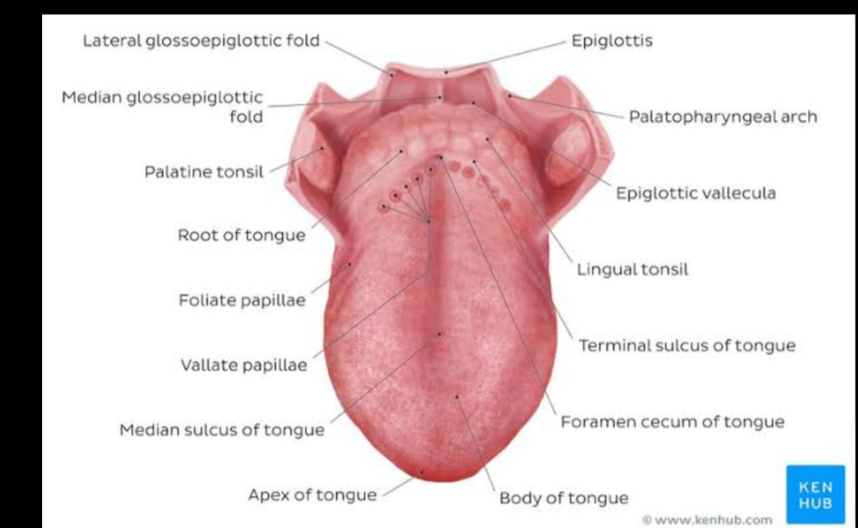
- The tongue is a mobile muscular structure covered with mucous membrane that forms part of the floor of the oral cavity which is somewhat triangular in shape with a blunt apex of the tongue.
- The tongue has an apex and a root. The apex is directed anteriorly and sits immediately behind the incisor teeth. The root is attached to the mandible and hyoid bone.
FUNCTIONS OF THE TONGUE
The main functions of the tongue are; forming words during speech, mastication, taste, squeezing food into the oropharynx as a part of swallowing and oral cleansing.
SURFACES OF THE TONGUE
- The superior or anterior 2/3rd of the tongue is in a horizontal plane.
- The pharyngeal surface or posterior 1/3rd of the tongue curves inferiorly and becomes oriented in the vertical plane.
- The superior and pharyngeal surfaces are separated by a v-shaped terminal sulcus of the tongue. The terminal sulcus forms the inferior margin of the oropharyngeal isthmus between the oral and pharyngeal cavities.
- At the apex of the v-shaped sulcus, is a small depression (the foramen cecum of the tongue) which marks the site in the embryo where the epithelium invaginated to form the thyroid gland.
- NOTE: In some people, a thyroglossal duct persists and connects the foramen cecum on the tongue with the thyroid gland in the neck.

PAPILLAE
The superior surface of the oral pat of the tongue is covered by hundreds of papillae. They are:
- Filiform Papillae- they are small coned shaped projection of the mucosa that end in one or more points.
- Fungiform Papillae- they are rounder in shape and larger than the filiform papillae. They tend to be concentrated along the tongue’s margins.
- Vallate Papillae- they are the largest of the papillae. They are blunt-ended cylindrical papillae invaginations on the tongue’s surface. There are only about 8-12 vallate papillae in a single V-shaped line immediately anterior to the terminal sulcus of the tongue.
- Foliate Papillae- they are linear folds of mucosa on the sides of the terminal sulcus of the tongue.
- In general, papillae increase the area of contact between the surface of the tongue and the contents of the oral cavity except the filiform papillae which has taste buds on its surface.
Inferior Surface of the Tongue
- The under surface of the oral part of the tongue lacks papillae but has a number of linear muscular folds. It has a single median fold (frenulum of tongue) and is continuous with the mucosa covering the floor of the oral cavity overlying the lower margin of a sagittal septum which internally separates the right and left sides of the tongue.
- On each side of the frenulum is a lingua vein and lateral to each vein is a rough fimbriated fold.
Pharyngeal Surface
- The mucosa covering the pharyngeal surface of the tongue is irregular in contour because of the many small nodules of lymphoid tissue in the submucosa.
- These nodules are collectively the LINGUAL TONSILS.
- There are no papillae on the pharyngeal surface.
MUSCLES OF THE TONGUE
- The bulk of the tongue is composed of muscles. The tongue is completely divided into a left and right half by the median sagittal septum. This means the muscles of the tongue occur in pairs.
- The muscles are both intrinsic and extrinsic lingual muscles.
- Except for the palatoglossus which is innervated by the vagus nerve (nerve X) all muscles of the tongue are innervated by the hypoglossal nerve (nerve XII).
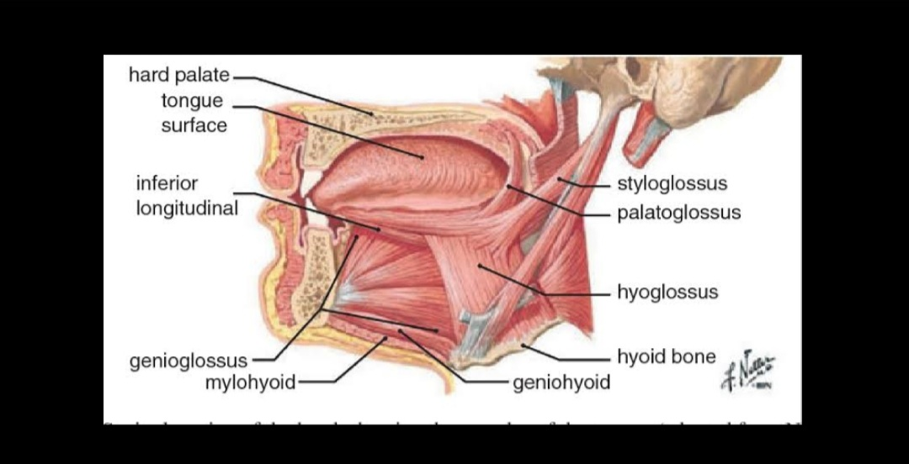
INTRINSIC MUSCLES
They originate and insert within the tongue. They are: superior longitudinal, inferior longitudinal, transverse and vertical muscles. They alter the tongue’s shape.
MUSCLE | ORIGIN | INSERTION | INNERVATION | FUNCTION
Superior longitudinal | Submucosal connective tissue at the back of the tongue and from the median septum of the tongue. | Muscle fibres pass forward and obliquely to the submucosal connective tissue and mucosa on tongue’s margin. | Hypoglossal nerve (XII) | Shortens tongue, curls apex and sides of tongue.
Inferior Longitudinal | Root of tongue (some fibred from hyoid) | Apex of tongue | Hypoglossal nerve (XII) | Shortens tongue, uncurls apex and turns it downward
Transverse | Median Septum of tongue | Submucosal connective tissue of lateral margins of tongue | Hypoglossal nerve (XII) | Narrows and elongates tongue
Vertical | Submucosal connective tissue on dorsum of tongue | Connective tissue in more ventral areas of tongue | Hypoglossal nerve (XII) | Flattens and widens tongue

EXTRINSIC MUSCLES
There are 4 major extrinsic muscles on each side of the tongue. They are; Styloglossus, Hypoglossus, Genioglossus and Palatoglossus.

MUSCLE | ORIGIN | INSERTION | INNERVATION | ACTION
Styloglossus | Styloid process (anterolateral surface) | Lateral surface of tongue | Hypoglossal nerve (XII) | Elevates and retracts tongue
Hypoglossus | Greater horn and adjacent part of the body of hyoid bone | Lateral surface of the tongue | Hypoglossal nerve (XII) | Depresses tongue
Genioglossus | Superior mental spines | Body of hyoid; entire length of tongue | Hypoglossal nerve (XII) | Protrudes tongue; depresses centre of cord.
Palatoglossus | Inferior surface of palatine aponeurosis | Lateral margin of tongue | Vagus nerve via pharyngeal branch to pharyngeal plexus | Depresses palate, elevates back of tongue, moves palatoglossal fold towards midline

ARTERIES
- The major artery of the tongue is the lingual artery.
- On each side, it originates from the external carotid artery in the neck adjacent to the tip of the greater horn of the hyoid bone.
- It forms an upward bend and then loops downward and forward to pass deep to the hypoglossus muscle.
- It accompanies the muscle through the aperture formed by the margins of the myeloid, super and middle constrictor muscles and enters the floor of the oral cavity.
- The lingual artery then travels forward in the plane between the hypoglossus and genioglossus muscles to the apex of the tongue.
- The lingual artery also supplies the sublingual gland, gingiva and oral mucosa in the floor of the oral cavity.
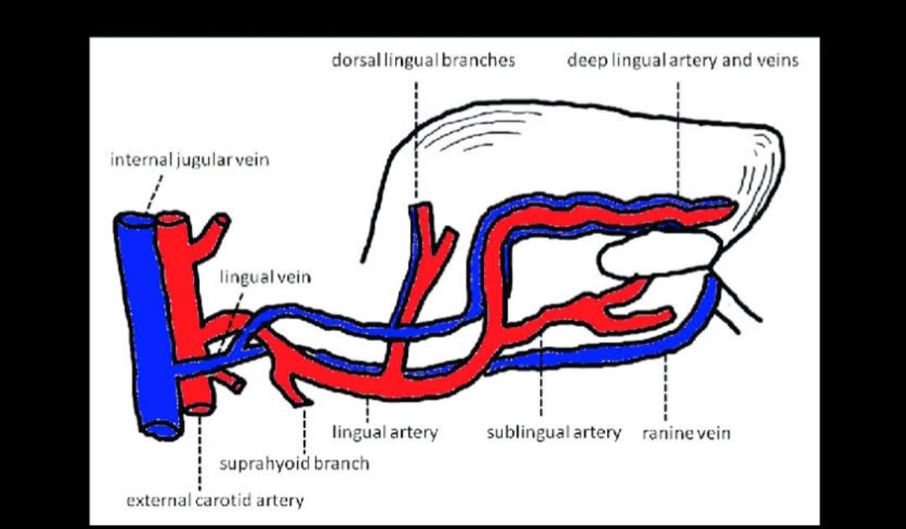
INNERVATION
The innervation of the tongue is complex and it involved various nerves, these nerves are:
- Glossopharyngeal nerve (IX)- taste and general sensation from the pharyngeal part of the tongue are carried by this nerve.
- Lingual nerve- general sensory innervation from the oral part of the tongue is carried by this nerve.
- Facial Nerve (VIII)- taste from the oral part of the tongue is carries to the central nervous system by this nerve.
- Hypoglossal nerve (XII)
VEINS
The veins of the tongue are the dorsal lingual veins, which accompany the lingual artery. The deep lingual veins, which begin at the apex of the tongue, run posteriorly beside the lingual frenulum to join the sublingual vein.
Some or all of them may drain into the internal jugular vein, or they may do so indirectly, joining ﬁrst to form a lingual vein that accompanies the initial part of the lingual artery.
LYMPHATICS
Most of the lymphatic drainage converge towards and follows the venous drainage. However, lymph from the frenulum, tip of the tongue and central lower lip run an independent course. Lymph from the tongue takes four routes:
- Lymph from the root drains bilaterally into the superior deep cervical lymph nodes.
- Lymph from the medial part of the body drains bilaterally and directly into the inferior deep cervical lymph nodes.
- Lymph from the right and left lateral parts of the body drain into the submandibular lymph nodes on the ipsilateral side.
- The apex and frenulum drain into the submental lymph nodes, the medial portion draining bilaterally
All lymph from the tongue ultimately drains to the deep cervical nodes, and passes via the jugular venous trunks into the venous system at the right and left venous angles.
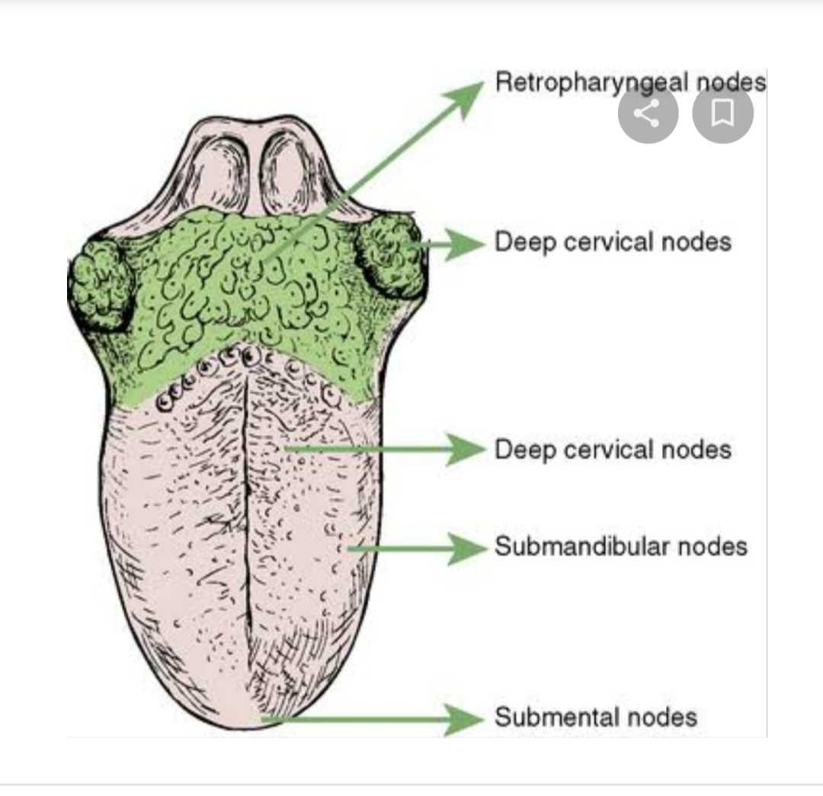
APPLIED ANATOMY
Ankyoglossia (tongue-tie)- it is a condition present at birth that restricts the tongues range of motion. In this condition, the lingual frenulum tethers the bottom of the tongue’s tip to the floor of the mouth. People with this condition have difficulty sticking out their tongue and speech language impairment.
Cause: the frenulum separates before birth typically, but here it remains attached to the bottom of the tongue. Some cases with this have been associated to genetic factors.
It can be treated through a surgical procedure called Lingual Frenectomy.

- Write an essay on the air sinuses
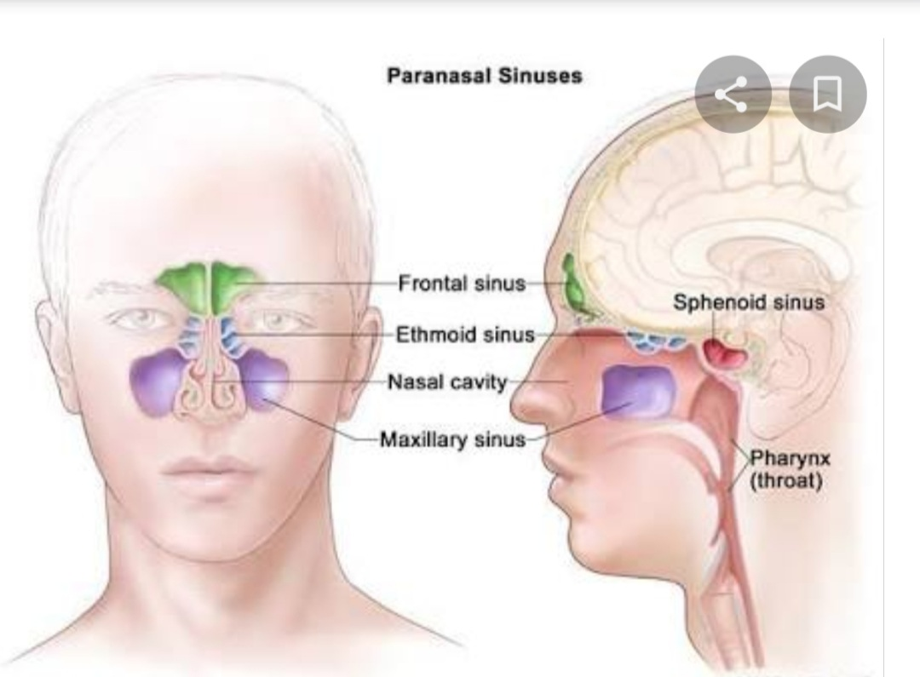
Paranasal Sinuses are air-filled extensions of the respiratory part of the nasal cavity into the cranial bones-ethmoid, sphenoid, maxilla and frontal bones. The sinuses are named according to the bone in which they are found hence, we have the Ethmoidal sinuses, Sphenoidal sinuses, Maxillary sinuses and Frontal sinuses.
They develop as outgrowth from the nasal cavities and erode into surrounding bones. All are:
lined by respiratory mucosa, which is ciliated and mucus secreting
open into the nasal cavities
innervated by branches of the trigeminal nerve [V]
- Ethmoidal Cells- the ethmoidal cells are formed by a variable number of individual air chambers, which are divided into anterior, middle, and posterior ethmoidal cells based on the location of their apertures on the lateral wall of the nasal cavity.
Because the ethmoidal cells often erode into bones beyond the boundaries of the ethmoidal labyrinth, their walls may be completed by the frontal, maxillary, lacrimal, sphenoid, and palatine bones.
The ethmoidal cells are innervated by the: anterior and posterior ethmoidal branches of the nasociliary nerve from the ophthalmic nerve (V1) and the maxillary nerve (V2) via orbital branches from the pterygopalatine ganglion.
The ethmoidal cells receive their blood supply through branches of the anterior and posterior ethmoidal arteries.
- Sphenoidal Sinuses- they are found on either side within the body of the sphenoid, open into the roof of the nasal cavity via apertures on the posterior wall of the spheno-ethmoidal recess.
Innervation of the sphenoidal sinuses is provided by:
i) the posterior ethmoidal branch of the ophthalmic nerve

ii) the maxillary nerve (V2) via orbital branches from the pterygopalatine ganglion.
The sphenoidal sinuses are supplied by branches of the pharyngeal arteries from the maxillary arteries.
- Maxillary Sinuses- they are the largest of the paranasal sinuses and completely ﬁll the bodies of the maxillae. Each is pyramidal in shape with the apex directed laterally and the base deep to the lateral wall of the adjacent nasal cavity. The medial wall or base of the maxillary sinus is formed by the maxilla, and by parts of the inferior concha and palatine bone that overlie the maxillary hiatus. The opening of the maxillary sinus is near the top of the base, in the centre of the semilunar hiatus, which grooves the lateral wall of the middle nasal meatus.
The maxillary sinuses are innervated by infra-orbital and alveolar branches of the maxillary nerve (V2), and receive their blood through branches from the infra-orbital and superior alveolar branches of the maxillary arteries.
- Frontal Sinuses- they are variable in size and are the most superior of the sinuses. Each is triangular in shape and is in the part of the frontal bone under the forehead. The base of each triangular sinus is oriented vertically in the bone at the midline above the bridge of the nose and the apex is laterally approximately one-third of the way along the upper margin of the orbit. Each frontal sinus drains into the lateral wall of the middle meatus via the frontonasal duct, which penetrates the ethmoidal labyrinth and continues as the ethmoidal infundibulum at the front end of the semilunar hiatus. The frontal sinuses are innervated by branches of the supra-orbital nerve from the ophthalmic nerve (V1). Their blood supply is from branches of the anterior ethmoidal arteries.

