NAME: ONOTHOJA DOMERO EWOMA
MATRIC NO: 17/MHS01/263
COURSE: GROSS ANATOMY OF THE HEAD AND NECK

- Write an essay on the carvenous sinus

Answers
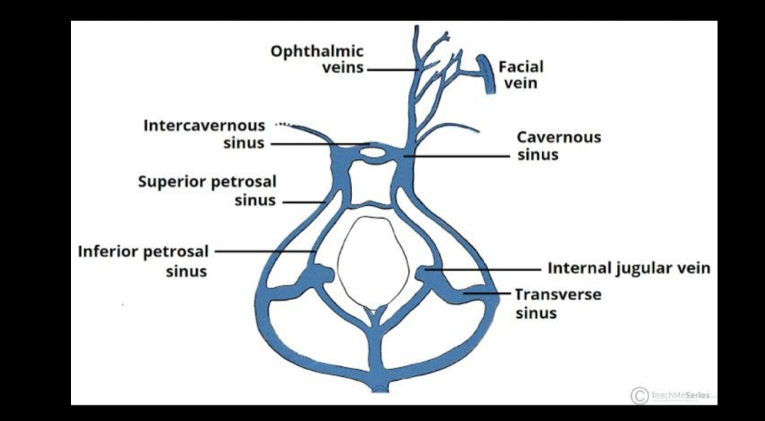
The cavernous sinus is a large venous plexus.
It is located on each side of the sella turcica on the upper surface of the body of the sphenoid, which contains the sphenoid (air) sinus.
The cavernous sinus consists of a venous plexus of extremely thin-walled veins that extends from the superior orbital ﬁssure anteriorly to the apex of the petrous part of the temporal bone posteriorly.
It receives blood from the superior and inferior ophthalmic veins, superﬁcial middle cerebral vein, and sphenoparietal sinus.
The venous channels in these sinuses communicate with each other through venous channels anterior and posterior to the stalk of the pituitary gland—the intercavernous sinuses and sometimes through veins inferior to the pituitary gland.
The cavernous sinuses drain postero-inferiorly through the superior and inferior petrosal sinuses and emissary veins to the basilar and pterygoid plexuses
Inside each cavernous sinus is the internal carotid artery with its small branches, surrounded by the carotid plexus of sympathetic nerve(s), and the abducent nerve. The oculomotor (CN III) and trochlear (CN IV) nerves, plus two of the three divisions of the trigeminal nerve (CN V) are embedded in the lateral wall of the sinus.
The artery, carrying warm blood from the body’s core, traverses the sinus ﬁlled with cooler blood returning from the capillaries of the body’s periphery, allowing for heat exchange to conserve energy or cool the arterial blood. This does not appear to be as important in humans as it is in running animals (e.g., horses and cheetahs) in which the carotid artery runs a longer, more tortuous course through the cavernous sinuses, allowing cooling of blood before it enters the brain.
Pulsations of the artery within the cavernous sinus are said to promote propulsion of venous blood from the sinus, as does gravity.

- Walls of the Noses
The nasal cavity is made up of two walls: the lateral and the medial wall.
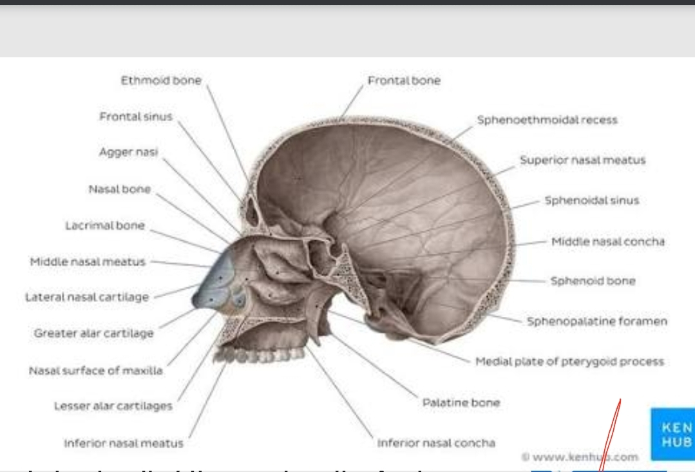

Lateral wall
The lateral wall is characterized by three curved shelves of bone (conchae), which are one above the other and project medially and inferiorly across the nasal cavity. The medial, anterior, and posterior margins of the conchae are free. The conchae divide each nasal cavity into four air channels.
An inferior nasal meatus between the inferior conchae and the nasal ﬂoor
A middle nasal meatus between the inferior and middle conchae
A superior nasal meatus between the middle and superior conchae
A spheno-ethmoidal recess between the superior concha and the nasal roof.
These conchae increase the surface area of contact between tissues of the lateral wall and the respired air. The openings of the paranasal sinuses, which are extensions of the nasal cavity that erode into the surrounding bones during childhood and early adulthood, are on the lateral wall and roof of the nasal cavities. In addition, the lateral wall also contains the opening of the nasolacrimal duct, which drains tears from the eye into the nasal cavity.

Medial Wall
The medial wall of each nasal cavity is the mucosa-covered surface of the thin nasal septum, which is oriented vertically in the median sagittal plane and separates the right and left nasal cavities from each other. The nasal septum consists of:
- the septal nasal cartilage anteriorly
- posteriorly, mainly the vomer and the perpendicular plate of the ethmoid bone
- small contributions by the nasal bones where they meet in the midline, and the nasal spine of the frontal bone
- contributions by the nasal crests of the maxillary and palatine bones, rostrum of the sphenoid bone, and the incisor crest of the maxilla.

