NAME: IMOLUAMEN MERCY OSEMEGBE.
MATRIC NUMBER: 19/MHSO9/010.
DEPARTMENT: DENTISTRY AND DENTAL SURGERY.
COURSE: BIO 102
QUESTION 1:
Importance of fungi to mankind:
- Fungi such as yeast (Saccharomyces cerevisiae) are important in food industry.
- Mushrooms are eaten by many human societies.
- Some species of fungi e.g Penicillium notatum produces important antibiotics.
- Without fungi and other microbes, the surface of the earth would have been clogged up with dead matters with all the various elements locked up in them instead of returning in various cycles.
- Some fungi serve as parasites to certain horrible pests and therefore constitute important biological control agents in regards to such pests.

QUESTION 2:
Unicellular forms of fungi include brewers yeast or bread yeast ( Saccharomyces cerevisiae). Yeast cells are found on exposed sugary fluids e.g palm wine and sugary fruits where fermentation processes are mediated. Cell exist in diploid/haploid states. Under favourable environmental conditions, in both states, they multiply rapidly by simple mitotic cell divisions- budding involving nuclear division and division of the cytoplasm in such a way that one segment of the constricted cytoplasm is smaller than the others.
Diploid cells arise from haploid cells by the processes of plasmogamy and karyogamy. A diploid cell may undergo meiosis under certain conditions to produce 4 haploid spores- ascopores (contained in simple structure ascus)
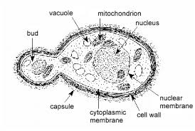
QUESTION 3:
Sexual reproduction in a typical filamentous form of fungi ( Rhizopus stolonifer)
Sexual reproduction is by fusion of two compatible hyphae:
- The compatible hyphae come together. In both the mycelia, a small outgrowth develops. It is known as progametangia.
- Nuclei and cytoplasm move towards the apical region and progametangia make contact.
- The apical region is separated from the rest of the hyphae by septae formation. This is known as gametangia.
- Gametangia conjugate to form a multinucleated structure.
- Plasmogamy is followed by Karyogamy and diploid (2n) zygote is formed, It is known as zygospore. Rest of the unpaired nuclei degenerate.
- Zygospores enlarge and become thick walled and resistant to adverse environmental conditions. On getting favourable conditions, Zygospores germinate.
- The inner wall of zygospore develops into promycelium forming germ sporangiophore, with germ sporangium formed apically.
- Meiosis occurs and haploid meiospores are formed. They come out of the germ sporangium wall and develop into new mycelia.
QUESTION 4:
Ways in which Bryophytes adapt to their environment:
- They have definite structures for water and nutrient absorption from the soil; therefore the plant body is divided into two (an aerial portion and a subterranean portion). The subterranean portion is the rhizoid and is not a true root as the case of land plants that are advanced.
- The aerial portion being exposed to the atmosphere demands some modifications that prevents excessive loss of water through the body surface (i.e desiccation).
- Some other modification that permit elimination of excess water from the plant body and not only exchange of gasses between the internal parts of the plant and the atmosphere therefore openings are available on the aerial parts of the plant.
QUESTION 5:
- Eustele: a stele typical of dictyledonous plants that consist of vascular bundles of xylem and phloem strands with parenchymal cells between the bundles.
- Actactostele: a type of eustele, found in monocots, in which the vascular tissue in the stem exists as scattered bundles.
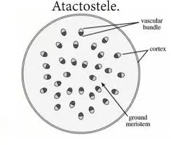
- Siphonostele: A stele consisting of vascular tissue surrounding a central core of pith parenchyma.
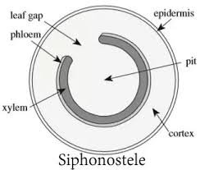

- Dictyostele: A stele in which the vascular cylinder is broken up into a longitudinal series or network of vascular strands around a central pith (as in many ferns)
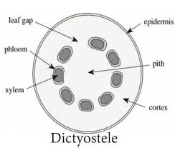

QUESTION 6:
Life cycle of primitive vascular plant ( Psilotum)

