NAME: OKAFOR MMESOMA SHARON
MATRIC NO: 18/MHS01/260.
COURSE TITLE: EMBRYOLOGY
COURSE CODE :

ASSIGNMENT
DISCUSS THE SECOND WEEK OF DEVELOPMENT.
The second week of embryonic development involves three major events;
- Completion of implantation of the blastocyst.
- Formation of a bilaminar germ disc (epiblast and hypoblast)
- Development of extra embryonic structures ( amniotic cavity, amnion, umbilical vessel or yolk sac, connecting stalk and chorionic sac)
Day 8
The blastocyst is partially embedded in the endometrium. The syncytiotrophoblast will continue to invade the endometrium thereby eroding the capillaries and blood vessels. As the syncytiotrophoblast continues to invade the endometrium, cells of the cytotrophoblast divide and move deeper into the region of the syncytiotrophoblast where they fuse and loose their individual membranes. The cells of the embryoblast then differentiates into two types of cells; cuboidal cells called hypoblast near the blastocystic cavity and columnal cells called epiblast near the amniotic cavity. Cells of the epiblast which lies adjacent to the cytotrophoblast are reffered to as “ amnioblast”. Both amnioblasts and the rest of the epiblasts line the amniotic cavity. The epiblast and hypoblast give rise to the formation of bilaminar germ disc.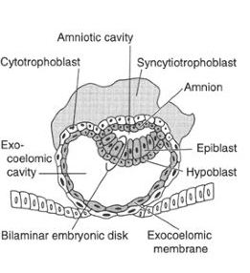
Day 9-10
The blastocyst is deeply embedded in the endometrium. The surface epithelium is closed by fibrin coagulum. Vacuoles appear at the region of trophoblast and fuse to form larger lacunae and this phase of development is known as the lacunae stage. The cells of hypoblast adjacent to the cytotrophoblast forms a thin membrane called the Exocoelemic membrane or Heuser’s membrane and this lines the Exocoelemic cavity or primitive yolk sac or primary umbilical vesicle.

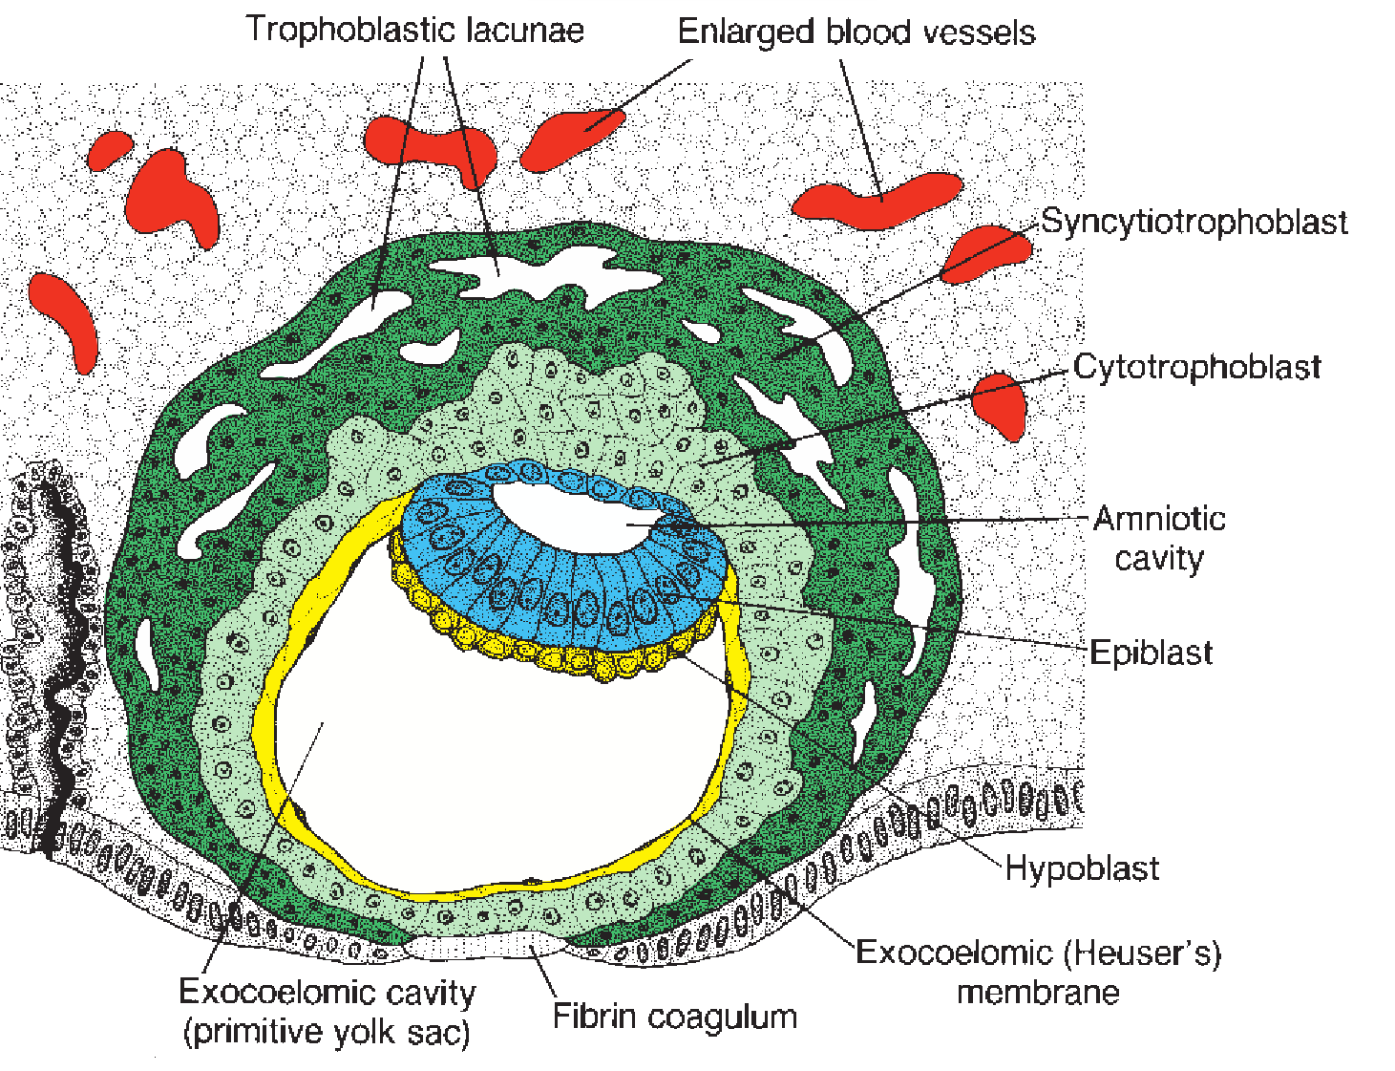

Day 11-12
The blastocyst is fully embedded in the endometrium. The surface epithelium entirely covers the fibrin coagulum. Cells of the syncytiotrophoblast erode the endothelial lining of the endometrial capillaries. These ruptured capillaries are known as sinusoids. The ruptured sinusoid communicates with the trophoblastic lacunae and maternal blood enters the lacunar system. At this stage, a primordial utero-placental circulation was established. This sinusoid communication transports nutrients, O₂ and blood to the blastocyst( developing embryo). A new population of cells appears between the inner surface of the cytotrophoblasts and the outer surface of the exocoelemic cavity. These cells derived from the yolk sac cells form a loose connective tissue called the extraembryonic mesoderm. Large cavities develop in the mesoderm and form a new space called extraembryonic cavity or chorionic cavity or extraembryonic coelom. This space surrounds the primitive yolk sac and amnion cavity except where there is a germ disc connected to the trophoblast by a connecting stalk ( develops into umbilical cord). The extraembryonic cavity divides the mesoderm inot two parts; the part of the mesoderm that lines the cytotrophoblast called ” the extraembryonic somatic mesoderm”. Then the part of the mesoderm that lines between the extraembryonic cavity and exocoelomic membrane called “ the extraembryonic splanchnic mesoderm. As the conceptus implants, a reaction takes place called “ the decidual reaction” where the cells of the endometrium (decidual cells) swells as a result of glycogen and lipid accumulation in the cytoplasm. The primary function of the reaction is to provide nutrition for the early embryo and an immunologically priviledged site for the conceptus.

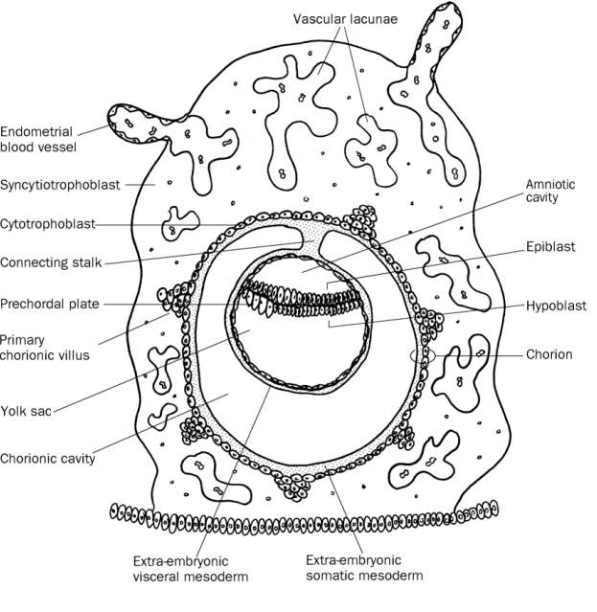
Day 13
The surface defect in the endometrium has been completely covered by the surface epithelum. Cells of the cytotrophoblast acquire a syncytium giving rise to a shape which looks like a villi. When this occurs, they are referred to as ‘’ primary villi” in the region of syncytiotrophoblast. The primary yolk sac which was previously large becomes smaller forming the “secondary yolk sac” or “ secondary umbilical vesicle”. A positon of the secondary yolk sac is pinched off and forms the “ extraembryonic cyst”. The extraembryonic coelom enlarges to form the “ chorionic cavity”.
CLINICAL CORRELATES
The syncytiotrophoblast produces a hormone called human chorionic gonadotropin (hcG) which enters the maternal blood via lacunae and keeps the corpus luteum in the ovary dueing pregnancy.
Extrauterine implantation; Blastocysts may implant outside the uterus which results in ectopic pregnancies.

