NAME: ASO OGHENERO CUTHBERT
MATRIC NUMBER: 16/MHS01/049
LEVEL: 400
DEPARTMENT: PHARMACOLOGY
ANA 202 ASSIGNMENT

- The human heart is an organ that pumps blood throughout the body via the circulatory system, supplying oxygen and nutrients to the tissues and removing carbon dioxide and other wastes.
In humans, the heart is roughly the size of a large fist and weighs between about 10 to 12 ounces (280 to 340 grams) in men and 8 to 10 ounces (230 to 280 grams) in women. The heart is divided into four chambers, which are:
a.) upper left atria
b.) right atria
c.) lower left ventricle
d.) right ventricle
A double-walled sac called the pericardium encases the heart, which serves to protect the heart and anchor it inside the chest. Between the outer layer, the parietal pericardium, and the inner layer, the serous pericardium, runs pericardial fluid, which lubricates the heart during contractions and movements of the lungs and diaphragm.
The heart's outer wall consists of three layers. The outermost wall layer, or epicardium, is the inner wall of the pericardium. The middle layer, or myocardium, contains the muscle that contracts. The inner layer, or endocardium, is the lining that contacts the blood.
The tricuspid valve and the mitral valve make up the atrioventricular (AV) valves, which connect the atria and the ventricles. The pulmonary semi-lunar valve separates the right ventricle from the pulmonary artery, and the aortic valve separates the left ventricle from the aorta. The heartstrings, or chordae tendinae, anchor the valves to heart muscles.
The sinoatrial node produces the electrical pulses that drive heart contractions.
The heart has many functions such as:
a.) the right atrium receives blood from the veins and pumps it to the right ventricle
b.) the right ventricle receives blood from the right atrium and pumps it to the lungs where it is loaded with oxygen
c.) the left atrium receives oxygenated blood from the lungs me pumps it to the left ventricle
d.) the left ventricle pumps oxygenated blood to the rest of the body.

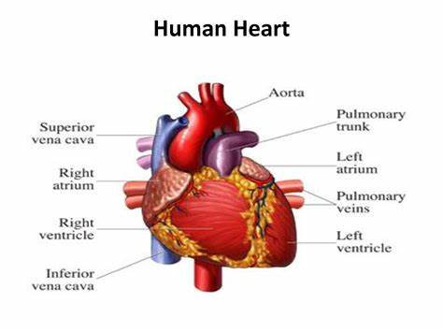
Diagrammatic representation of the human heart

- Congenital anomalies of the heart

A congenital heart defect is a problem with your heart that you’re born with. They’re the most common kind of birth defect.
There are different types of congenital heart defects. Most affect the walls, valves, or blood vessels of your heart. Some are serious and may need several surgeries and treatments.
- Hole in the heart
This means you’re born with a hole in the wall, or septum, that separates the left and right sides of your heart. The hole lets blood from the two sides mix.
- Atrial Septal Defect (ASD)
An ASD is a hole in the wall between the upper chambers, or the right and left atria, of your heart. A hole here let’s blood from the left atrium mix with blood in the right atrium. Some ASDs close on their own. Your doctor may need to repair a medium or large ASD with open-heart surgery or another procedure.
- Complete Atrioventricular Canal Defect (CAVC)
This is the most serious septal defect. It’s when you have a hole in your heart that affects all four chambers.
A CAVC prevents oxygen-rich blood from going to the right places in your body. Your doctor can repair it with patches. But some people need more than one surgery to treat it.
- Truncus Arteriosus
This is when a baby is born with one major artery instead of two that carry blood to the rest of the body. Often times, the baby may need surgery as an infant to repair the defect
- Pulmonary valve stenosis
This is the most common valve defect in newborns. Babies with severe cases often have strained right ventricles. Your doctor can usually treat it with a catheter procedure. She will use a catheter, or thin tube, with a balloon on the end to inflate and stretch open the strained valve.

