Name: Awe Ayomide .B.
Matric. Number: 19/MHS01/443
Course code: ANA 301
Question: A) Write an essay on the cavernous sinus.
B) Discuss the walls of the nose.

A) The cavernous sinus is a paired dural venous sinus located within the cranial cavity. It is divided by septa into small ‘caves’ – from which it gets its name. It also creates a cavity called the lateral sellar compartment bordered by the temporal bone of the skull and the sphenoid bone, lateral to the sella tunica.
Each cavernous sinus has a close anatomical relationship with several key structures in the head, and is arguably the most clinically important venous sinus.
The dural venous sinuses are channels between the two layers of dura mater which are responsible for the venous drainage of the brain, skull, orbit and internal ear.
The cavernous sinus is located on either side of the pituitary fossa and body of the sphenoid bone between the endosteal and meningeal layers of the dura. It spans from the apex of the orbit to the apex of the petrous temporal bone. Unlike other dural venous sinuses, it is divided by numerous fibrous septa into a series of small caves, which is where its name is derived from. The normal lateral wall should be either straight or concave.
The cavernous sinus is the only site in the body where an artery (internal carotid) passes completely through a venous structure. This is thought to allow for heat exchange between the warm arterial blood and cooler venous circulation.

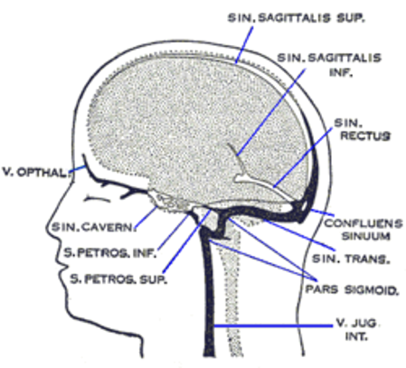

Boundaries
The cavernous sinuses are located within the middle cranial fossa, on either side of thesella turcica of the sphenoid bone (which contains the pituitary gland). They are enclosed by the endosteal and meningeal layers of the dura mater.
• roof: fold of dura mater attached to the anterior and middle clinoid processes
• anterior wall: medial end of the superior orbital fissure
• posterior wall: petrous apex
• medial wall: endosteum overlying the body of the sphenoid bone
• lateral wall: dura mater from the ridge of the roof to the floor of the middle cranial fossa
• floor: endosteum overlying the base of the greater wing of the sphenoid bone

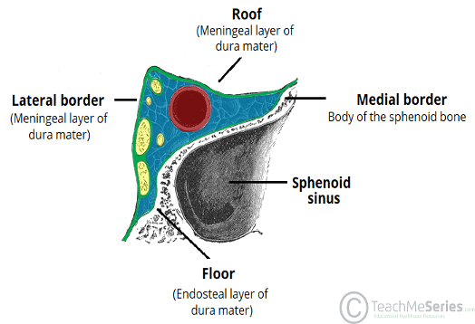

The cavernous sinus is roofed by an inner layer of dura mater that continues with the diaphragma sellae that covers the superior part of the pituitary gland. The roof of the sinus also has several other attachments. Anteriorly, it attaches to the anterior and middle clinoid processes, posteriorly it attaches to the tentorium (at its attachment to the posterior clinoid process). Part of the periosteum of the greater wing of the sphenoid bone forms the floor of the sinus. The body of the sphenoid acts as the medial wall of the sinus while the lateral wall is formed from the visceral part of the dura mater.

Contents
The cavernous sinus contains the internal carotid artery and several cranial nerves. Abducens nerve (CN VI) traverses the sinus lateral to the internal carotid artery. The remainder of the cranial nerves pass through the lateral wall of the carotid sinus, and from superior to inferior they are:
Oculomotor nerve (CN III)Trochlear nerve (CN IV)Trigeminal nerve (CN V) - ophthalmic and maxillary divisions.

Internal carotid artery
In addition to the thin walled veins that traverse the cavernous sinus, a lone arterial vessel also uses the area as a conduit. The internal carotid artery (a branch of the common carotid artery) – along with its postganglionic sympathetic plexus from the superior cervical ganglion – gains access to the cavernous sinus posteriorly.
As the petrous part of the internal carotid artery leaves the carotid canal, it curves vertically and superiorly above foramen lacerum to enter the cavernous sinus. Here the artery is also referred to as the cavernous part.
Within the sinus, the internal carotid artery travels anteriorly, in a horizontal manner until it reaches the anterior limit of the sinus. Here it curves vertically and superiorly to exit the sinus through its roof and become the cerebral part of the internal carotid artery. It is noteworthy that the cavernous part of the internal carotid artery is the only arterial vessel that is completely surrounded by venous networks. This fact is of great clinical significance, which will be discussed later.
There are also other non-vascular structures that utilize the cavernous sinus as a pathway to their points of supply. Five cranial nerves (CN) use this pathway to gain access to their points of innervation.
Abducent nerve(CN VI): This motor nerve leave the pons and gains access through the posterior part of the sinus after passing of the apical potion of the petrous temporal bone. It has also been known to access the cavernous sinus by way of the petrosal sinus, adjacent to the clivus.
Within the cavernous sinus, it takes an inferolateral course, relative to the internal carotid artery. It exits the sinus by way of the superior orbital fissure to gain access to the orbit, where it innervates the lateral rectus muscle of the eyeball.

Oculomotor nerve: the other nerves travelling through the cavernous sinus do so between the endothelial lining and the dura mater of its lateral wall. The most superior of the four nerves in the lateral wall is the oculomotor nerve (CN III). At the posterior aspect of the roof of the cavernous sinus, the free and attached edges of tentorium cerebelli forms a space through which CN III enters the lateral wall of the sinus. It takes an anterior, inferomedial course (relative to the other nerves in the lateral wall) towards the anterior extremity of the sinus.
Here it bifurcates into it's superior and inferior rami that pass through the superior orbital fissure. Along with sympathetic fibers from the internal carotid plexus, CN III provides motor supply to inferior oblique, levator palpebrae superioris, and the inferior, medial and superior recti muscles.

Trochlear nerve: the smallest of the cranial nerves, the trochlear nerve (CN IV), enters the posterior aspect of the cavernous sinus after leaving the posterior part of the brainstem and decussating with the same nerve from the opposite side. It continues anteriorly in the lateral wall of the cavernous sinus, inferior to CN III(oculomotor nerve) and passes through the superior orbital fissure at the anterior aspect of the sinus. Once in the orbit, CN IV has the responsibility of innervating the muscles of the eyeball that are responsible for inferolateral motions.

Trigeminal nerve: two of the three branches of the trigeminal nerve (CN V) pass through the cavernous sinus. Prior to entering the cavernous sinus, the proximal portion of the nerve lies in Meckel’s cave, where it forms the trigeminal ganglion. After leaving the cave, the mandibular division (CN V3) courses inferiorly to pass through foramen ovale (without entering the cavernous sinus).
The other two branches, the ophthalmic and the maxillary divisions of trigerminal nerve (CN V1 and CN V2, respectively), travel through the lateral wall of the sinus. Both take courses inferior to CN III and CN IV, however, CN V2 is the most inferior of them all. Both CN V branches in the sinus travels horizontally. CN V2 leaves the sinus via foramen rotundum, while the three branches of CN V1 exit the cranial fossa via the superior orbital fissure. CN V1 and CN V2 are purely sensory and supply specific regions of the face.

Travels through cavernous sinus: | Travels through lateral wall of cavernous sinus:
· Abducens nerve (CN VI) | · Oculomotor nerve (CN III)
· Carotid plexus (post-ganglionic sympathetic nerve fibres) | · Trochlear nerve (CN IV)
Internal carotid artery (cavernous portion) | · Ophthalmic (V1) and maxillary (V2) branches of the trigeminal nerve

Note:
1. The mandibular branch of the trigeminal nerve is not associated with the underneath the trigeminal ganglion (Gasser ganglion), which is anatomically posteriorly to the cavernous sinus.
• The maxillary branch of the trigeminal nerve is external but immediately adjacent to the lateral wall of the cavernous sinus, which becomes important in the differential diagnosis of lesions of the cavernous sinus - lesions of this nerve tends to distort the sinus rather than occupy it.
Relations
• superiorly: middle cerebral artery, optic chiasm
• anteriorly: apex of the orbit
• posteriorly: cerebral peduncle
• medially: pituitary fossa, pituitary gland
• laterally: temporal lobe (medial surface), Meckel's cave (posteroinferiorly)
• inferiorly: sphenoid sinus

Communications
The cavernous sinus is an unconventional venous system in the sense that it does not have a unidirectional flow of blood. Owing to the fact that there are no valves in the sinus and its connected veins, the direction of blood flow is dependent on venous pressure. The veins that communicate with the cavernous sinus are:
· Superior ophthalmic vein
· Inferior ophthalmic vein
· Superficial middle cerebral vein
· Middle meningeal vein
· Hypophyseal veins

Superior ophthalmic vein: the cavernous sinus generally has five venous tributaries. The superior ophthalmic vein receives blood from the ethmoidal, nasofrontal, vorticose (drains the ocular choroid), and central retinal veins. It drains into the anterior part of the sinus via the superior orbital fissure.
Inferior ophthalmic vein: the inferior ophthalmic vein collects blood from the eyelids, lacrimal sac, and some vorticose contributions, as well as the anterior floor and medial wall of the orbit. In addition to draining to the cavernous sinus, it also drains to the pterygoid plexus.
Superficial middle cerebral vein: at the point where the internal carotid artery emerges, the superficial middle cerebral vein pierces the roof of the sinus. Here, it drains blood from the cortices that are adjacent to it as it courses through the lateral sulcus.
Middle meningeal vein: branches of the middle meningeal vein may join the sphenoparietal sinus on its way to the cavernous sinus. Before piercing the roof of the sinus, it travels along the edge of the lesser wing of the sphenoid between the layers of dura mater.
Hypophyseal veins: efferent hypophyseal veins of both the adenohypophysis and neurohypophysis drain to the cavernous sinus.
Vascular connections
It receives venous blood from:
• inferior and superior ophthalmic veins
• intercavernous sinus
• sphenoparietal sinus
• superficial middle cerebral vein
• central retinal vein
• a frontal tributary of the middle meningeal vein
Drainage of the cavernous sinus is via:
• superior petrosal sinus to the transverse sinus
• inferior petrosal sinus directly to the jugular bulb
• venous plexus on the internal carotid artery (ICA) to the clival (basilar) venous plexuses
• emissary veins passing through
• foramen Vesalii
• foramen ovale: communicates between the CS and pterygoid venous plexus
• foramen lacerum
Depending on relative pressures the superior ophthalmic veins either drain to or from the cavernous sinus.
Additionally, the cavernous sinuses connect to each other via the intercavernous sinuses.

Venous connections
The cavernous sinus receives blood from:
· Superior and inferior ophthalmic veins
· Sphenoparietal sinus
· Superficial middle cerebral veins
· Inferior cerebral veins
Blood leaves the sinus via superior and inferior petrosal sinuses as well as via the emissary veins through the foramina of the skull (mostly through foramen ovale). There are also connections with the pterygoid plexus of veins via inferior ophthalmic vein, deep facial vein and emissary veins.

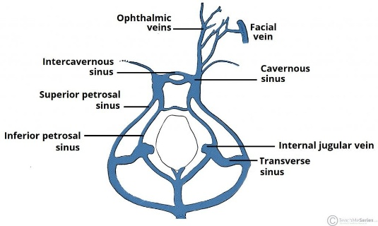

The left and right cavernous sinuses communicate by way of the anterior and posterior intercavernous sinuses. These vessels travel anteriorly and posteriorly (respectively) around the infundibulum of the pituitary gland, deep to the diaphragma sellae, between the layers of dura mater.
The cavernous sinus in turn drains to the superior and inferior petrosal sinuses. Both sinuses join the sigmoid sinus, which then becomes the internal jugular vein. The internal jugular vein meets with the subclavian vein to become the left (or right) brachiocephalic vein.
Artery
The internal carotid artery(ICA) enters the posterior inferior aspect of the sinus and bends upon itself as the carotid siphon (cavernous segment - C4). Two branches arise from this segment: meningohypophyseal trunk and inferolateral trunk.
The artery is surrounded by a plexus of sympathetic nerves from the superior cervical ganglion.

Fat
Fatty deposits may be present within the cavernous sinus, especially in obese patients or in those who are taking corticosteroids.

Applied anatomy
Cavernous sinus thrombosis (CST) refers to the formation of a clot within the cavernous sinus.
This most common cause of CST is infection; which typically spreads from an extracranial location such as the orbit, paranasal sinuses, or the ‘danger zone’ of the face. Infection is able to spread in this manner due to the anastomosis between the facial vein and superior ophthalmic veins.
Common clinical features include headache, unilateral periorbital oedema, proptosis (eye bulging), photophobia and cranial nerve palsies. The abducens nerve (CN VI) is most commonly affected.

Lesions affecting the cavernous sinus may affect isolated nerves or all the nerves traversing through it.
· The pituitary gland lies between the two paired cavernous sinuses. An abnormally growing pituitary adenoma, sitting on the bony sella turcica, will expand in the direction of least resistance and eventually compress the cavernous sinus.
· Cavernous sinus syndrome may result from mass effect of these tumors and cause ophthalmoplegia (from compression of the oculomotor nerve, trochlear nerve, and abducens nerve), ophthalmic sensory loss (from compression of the ophthalmic nerve), and maxillary sensory loss (from compression of the maxillary nerve). A complete lesion of the cavernous sinus disrupts CN III, IV, and VI, causing total ophthalmoplegia, usually accompanied by a fixed, dilated pupil. Involvement of CN V (V1 and variable involvement of V2) causes sensory loss in these divisions of trigerminal nerve.
Because of its connections with the facial vein via the superior ophthalmic vein, it is possible to get infections in the cavernous sinus from an external facial injury within the danger area of the face. In patients with thrombophlebitis of the facial vein, pieces of the clot may break off and enter the cavernous sinus, forming a cavernous sinus thrombosis. From there the infection may spread to the dural venous sinuses. Infections may also be introduced by facial lacerations and by bursting pimples in the areas drained by the facial vein.
Potential causes of cavernous sinus syndrome include metastatic tumors, direct extension of nasopharyngeal tumours, meningioma, pituitary tumors, aneurysms of the intracavernous carotid artery, carotid-cavernous fistula, bacterial infection causing cavernous sinus thrombosis, aseptic cavernous sinus thrombosis, idiopathic granulomatous disease (Tolosa–Hunt syndrome), and fungal infections. Cavernous sinus syndrome is a medical emergency, requiring prompt medical attention, diagnosis, and treatment.

B) The wall separating the two cavities of the nose, the nasal septum, is made up of bone inside and cartilage closer to the tip of the nose. The bony part is formed by the perpendicular plate of the ethmoid bone at the top, and the vomer bone below.

i) Medial wall: This wall is the nasal septum, which is formed by the perpendicular plate of the ethmoid bone, the vomer, cartilage, and the nasal crests of the maxillary and palatine bones.

ii) Lateral wall: This wall is hallmarked by three nasal conchae (superior, middle, and inferior) that project inferiorly from the wall. The lateral wall of the nasal cavity is a region of the nasopharynx essential for humidifying and filtering the air we breathe in nasally.
Here we can find a structure called agger nasi. The agger nasi is also referred to as the ‘nasoturbinal concha’ or ‘nasal ridge.’ It can be described as a small mound or ridge found in the lateral side of the nasal cavity. The structure is located midway along the anterior aspect of the middle nasal concha. An abnormally enlarged form may restrict the drainage of the frontal sinus by obstructing the frontal recess area.Bones: anterior nasal aperture (piriform aperture) formed by maxilla and nasal bones. They divide the nasal cavity into four passages that have openings to the paranasal sinuses:

The sphenoethmoid recess lies posterior to the superior concha and has the opening for the sphenoidal sinus.

The superior nasal meatus lies between the superior and middle conchae and has openings to the posterior ethmoidal sinuses.

The middle nasal meatus is longer and deeper than the superior nasal meatus. The frontal sinus communicates with the middle nasal meatus via the infundibulum, a passageway that opens into the semilunar hiatus (groove in the ethmoid bone). The maxillary sinus opens into the semilunar hiatus. An ethmoidal bulla (a round swelling formed by the middle ethmoidal cells, or air-filled cavities) is formed just above the semilunar hiatus. The middle and anterior ethmoidal sinuses drain into the middle nasal meatus.

The inferior nasal meatus is found below the inferior nasal concha. The nasolacrimal duct opens into this meatus.

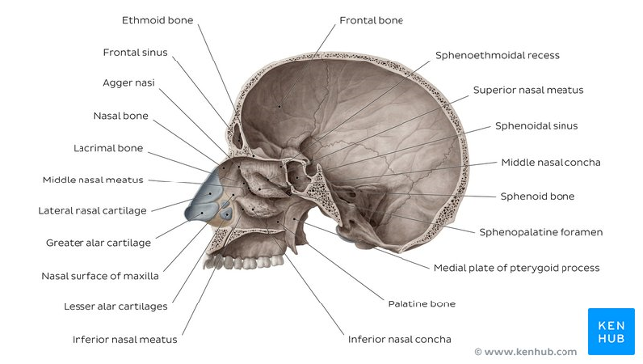6

ASSOCIATED STRUCTURES
The nasal surface of the maxilla forms the antero-lateral part of the bony nasal cavity. It is located inferior to the nasal bone and gives rise in part, to the inferior nasal concha. The sphenopalatine foramen is found in the posterior most region of the nasal cavity, at the back of the middle meatus. The foramen is formed by the processes on the superior border of the palatine bone, and the under surface of the sphenoidal body, which form a foramen. It connects the nasal cavity to the pterygopalatine fossa, and thus transmits the sphenopalatine artery and vein as well as the superior nasal and nasopalatine nerves.
The medial plate of the pterygoid process is an inferior projection of the sphenoid bone. The plate forms a laterally pointing hook like process at its most inferior point, known as the pterygoid hamulus. The tensor veli palatine muscle glides around this structure. The lateral surface of the medial plate forms the medial border of the pterygoid fossa, and the medial surface forms the lateral boundary of the choana of the adjacent nasal cavity.
The limen nasi is approximately 10mm in length and is defined as the boundary between the nasal cavity proper and the vestibule. It is relatively wide and superficial anteriorly but gradually narrows as it extends posteriorly towards the anterior region of the middle concha. It lies upon the upper edge of the lateral crus of the greater alar cartilage and detached pieces of cartilage may take part in its formation.
The inferior nasal meatus lies beneath the inferior nasal concha and the lateral nasal wall. It is broader in front than behind and extends the entire length of the lateral wall of the nose and the anterior third contains the termination of the nasolacrimal or ‘tear’duct. This opening is covered by a mucosal valve known as Hassner’s valve. The middle nasal meatus is located above the inferior and below the middle nasal concha. It is also part of the ethmoidal complex as it drains the maxillary, frontal and anterior ethmoidal sinuses. The superior meatus is located below the superior nasal concha and drains the posterior ethmoidal air cells.
The sphenoethmoidal recess is a small cleft like pocket located above the superior nasal concha and drains the sphenoid sinus. The sphenoethmoidal recess is a space found superior to the superior turbinate bone and drains the sphenoidal sinus as well as some of the ethmoidal sinuses. The frontal sinuses are situated between the brow ridges and lie between the two layers of the frontal bone. They are unlikely to be symmetrical and are not usually involved in sinusitis.
The sphenoidal sinus is contained within the body of the sphenoid bone itself. There is a great deal of variation in the shape and size of this sinus between individuals. The sinus drains into the sphenoethmoidal recess which is located superior to the choana. The main expansion of their size occurs during puberty and they perform a similar function to the other sinuses.
The nasal vestibule is the visible part of the internal nasal cavity from an external view. The vestibule is maintained by the greater and lesser alar cartilages and contains small hairs which trap dirt and small particles during inspiration. The vestibules are lined by stratified squamous epithelium, and are separate from the nasal cavity proper, which is lined with respiratory epithelium.
Nerve supply
The nerve supply to the nose and paranasal sinuses comes from two branches of the trigeminal nerve (CN V): the ophthalmic nerve(CN V1), the maxillary nerve (CN V2), and branches from these.
In the nasal cavity, the nasal mucosa is divided in terms of nerve supply into a back lower part (posteroinferior), and a frontal upper part (anterosuperior). The posterior part is supplied by a branch of the maxillary nerve – the nasopalatine nerve which reaches the septum. Lateral nasal branches of the greater palatine nerve supply the lateral wall.
The frontal upper part is supplied from a branch of the ophthalmic nerve – thenasociliary nerve, and its branches – the anterior and posterior ethmoidal nerves.
Most of the external nose – the dorsum, and the apex are supplied by the infratrochlear nerve, (a branch of the nasociliary nerve).The external branch of the anterior ethmoidal nerve also supplies areas of skin between the root and the alae.
The alae of the nose are supplied by nasal branches of CN V2, the infraorbital nerve, and internal nasal branches of infraorbital nervethat supply the septum and the vestibule.
The maxillary sinus is supplied by superior alveolar nerves from the maxillary and infraorbital nerves. The frontal sinus is supplied by branches of the supraorbital nerve. The ethmoid sinuses are supplied by anterior and posterior ethmoid branches of the nasociliary nerve. The sphenoid sinusis supplied by the posterior ethmoidal nerves.

