OKEKE CHINENYE BLOSSOM
18/mhs01/264
EMBRYOLOGY ASSIGNMENT
200lvl MEDICINE AND SURGERY

SECOND WEEK OF EMBRYONIC DEVELOPMENT
Three thing occur
-The completion of implantation Of blastocysts
-Formation of Bilaminar Embryonic Disc
-Formation of Extraembryonic structure

DAY8
- Blastocyst is partially embedded in the endometrium
- Syncytiotrophoblast continue to invade the endometrium and continue to erode the blood vessels and glands
- More cells in the cytotrophoblast divide and migrate to the syncytiotrophoblast where they fuse and loose their individual membrane.
- Cells of embryo last divide into 2 which are
Hypoblast: small cuboidal cells adjacent to the blastocyst cavity
Epiblast: high columnar cells adjacent to the amniotic cavity

- Epiblast and hypoblast together form a flat ovoid disc called Bilaminar Embryonic disc
- Small cavities form appears in the epiblast and enlarge to become the amniotic cavity
- Amnioblast(epiblast adjacent to cytotrophoblast) together with the remaining epiblast line the amniotic cavity

DAY 9
- Blastocyst is more deeply embedded in the endometrium and the penetration defect in the surface epithelium is covered by a coagulant called Fibrin
- Vacuoles form around the Trophoblast and become larger to form the Lacunae
- The cells of the hypoblast adjacent to the cytotrophoblast forma thin layer of membrane called exocoelomic/ Heuser’s membrane
- The Heuser’s membrane lines the inner surface of cytotrophoblast
- The exocolomic membrane together with the hypoblast line the Exocolemic cavity or Primitive Yolk sac
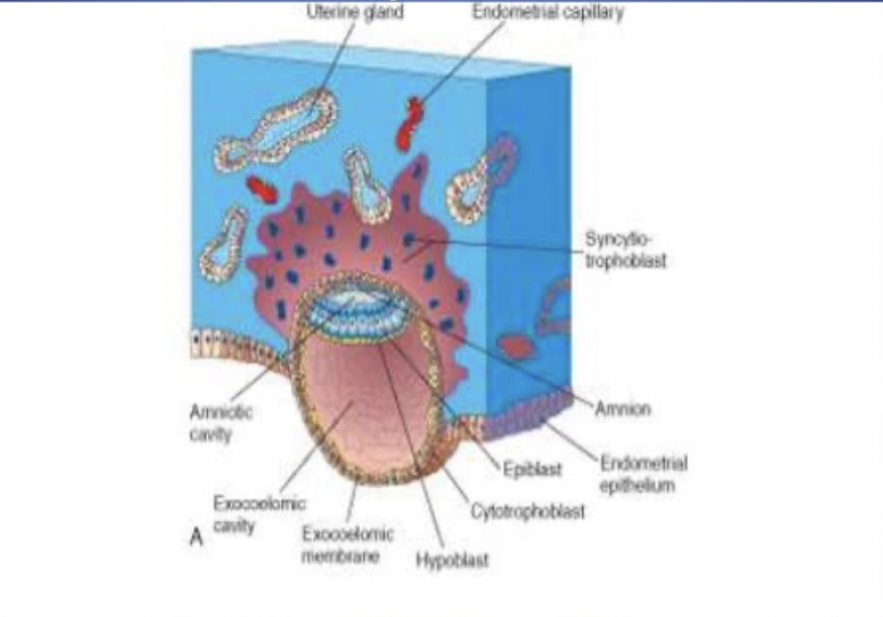

DAY 11-12
- Blastocyst is completely embedded in the endometrium
- Surface epithelium entirely covers the original defects in uterine wall
- Blastocyst slightly protrudes into the linen of the uterus
- Cells of the syncytiotrophoblast penetrates the storms and erode the endothelial lining in the endometrial capillaries
- Ruptured endothelial capillaries are called sinusoids
- Lacunae communicated with the sinusoids and the maternal blood enters the Lacunar system
- When the maternal blood flows in it provides nutrition and oxygen for the embryo
- Communication of the ruptured endometrial capillaries and lacuna form the primordial uteroplacental Circulation
- A new population of cels form between the inner surface of cytotrophoblast and the outer surface of the exocolomic cavity
- These cells are derived from yolk sac and form a fine loose connective tissue called Extra-embryonic Mesoderm
- Large cavities form between the Extra-embryonic mesodermal don’t form a new space called Extra-embryonic cavity or Extra-embryonic Coelom
- The space sleeping the primitive yolk sac and the amniotic cavity
- The Extra-embryonic mesoderm lining the cytotrophoblat and amnion is known as Extra-embryonic Somatic Mesoderm
- Lining the yolk sac is called Extraembryonic Splanchnic Mesoderm
- The endometrial connective tissue undergo DECIDUAL reaction
- This involved the swelling of the endometrium due to the accumulation of glycogen and lipids in the cytoplasm known as Decidual cells
- The primary function is to provide nutrition to the embryo.

DAY13
- Surface defect in the endometrium has been completely covered by the surface epithelium
- Bleeding occurs occasionally in the implantation site due to the increased blood flow in the lacunae spaces
- Cells of cytotrophoblast proliferate and penetrate to the syncytiotrophoblast forming cellular columns sleepiness by syncytium
- Cellular Column surrounded by syncytium is known as primary villi
- Primary yolk save reduces to become secondary yolk sac
- In humans the Yolk sac has no yolk but is useful in the transportation of nutrients to the embryo
- During formation, large portions of the exocoelomic cavity are picked off which forms exocoelomic cysts
- These are found in the Extra-embryonic cavity
- Meanwhile the Extra-embryonic coelom expands to form the chorionic cavity
- The Extra-embryonic Mesoderm lining cytotrophoblat is known as chorionic plate
- The only place where Extra-embryonic Mesoderm a transverse the chorionic cavity is in the connecting stalk
- With development of blood vessel, the connecting stalk becomes umbilical cord

