Ekpan River - Google Maps https://www.google.com/maps/place/Ekpan+River/@5.5535672,5.73766...
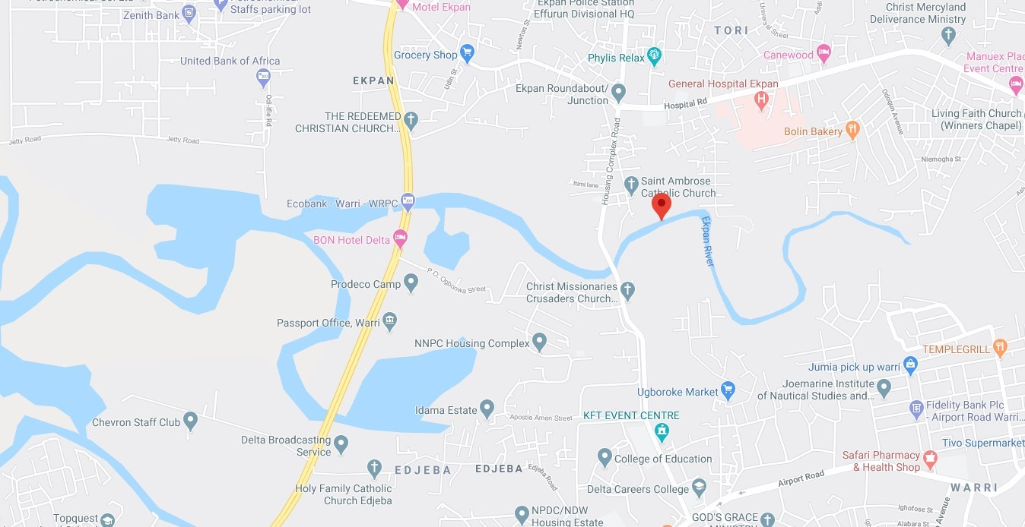

STUDY CASE

Ekpan River is a slow flowing river in the Western Niger Delta (Fig.1). It is located in Delta State of Nigeria. It took its source from Utagba- Uno in Ndokwa LGA and flows to Agbarho, Warri through Ekpan from where it flows through the rainforest belt of Forcados and finally discharges into the Atlantic Ocean. The entire length of the River lies between latitude 5°30' N of the equator and longitude 5°44' E. Seventy- five percent of the river is fringed with the mangrove trees consisting of mainly the black Mangrove (Avicenna germinans) which blossoms during the raining season. The River is characteristically turbid due to the various anthropogenic activities there such as farming, sand dredging, lumbering, fish farming. It serves as a major drainage channel for the area, receiving domestic and treated industrial waste from Warri Refining and Petrochemical Company as well as other industries around Warri metropolis such as Chevron Nig. Ltd, Niger CAT, Julius Berger, Oando, Delattre Benzons Nig

Study Stations
The study area is divided into two stations:

Station1. This is the upstream section of the river and is situated 5 km away from an existing bridge .The catchments are densely populated. This river receives effluents from both the Chevron Nigeria Company and Warri Refinery and Petrochemical Company

Station 2. This is the downstream section and is located 12 km away from the bridge across the NNPC housing complex. The station has deforested bank thereby exposing this section of the river to direct sunlight. Few palm trees, white and red mangroves as well as submerged macrophytes are present. Anthropogenic activities in this station include fishing, bathing and washing.

Water Sampling
Water samples were collected monthly from the river at the two selected stations (9.0 km apart), between August and November 2011. The sampling stations were visited between 10.0am and 2.00pm on each sampling day. Two liters of water sample were collected and used for the determination of the physio – chemical parameters using standard methods described by APHA (1989).

