STUDENT INDUSTRIAL WORK EXPERIENCE SCHEME (SIWES)
REPORT OF THREE MONTHS INDUSTRIAL TRAINING
AT
NOMAGBON PHRMACEUTICAL, BENIN CITY,
EDO STATE

BY
UMERAH STEPHANIE ONYEKA
16/MHS07/036

TABLE OF CONTENT
CHAPTER ONE
1.0 INTRODUCTION
1.1 ACKNOLEGDEMENT
1.2 BACKGROUND HISTORY OF FIRM & BRIEF HISTORY OF THE EXECUTIVE DIRECTOR
CHAPTER TWO
2.0 INTRODUCTIONS TO EQUIPMENT
CHAPTER THREE
3.0 CHEMISTRY
3.1 ANALYSIS ON BENZYL BENZOATE
3.2 ANALYSIS ON MAGNESIUM TRISILICATE MIXTURE
CHAPTER FIVE
6.0 SUMMARY
6.1 REFERENCE

ACKNOWLEDGEMENTS
My sincere appreciation firstly goes to GOD, everyone who has contributed directly and indirectly to the successful completion of this piece.
To all my mentors who taught me and made a significant contribution to my life. I cannot mention all your names here. Thank you for your commitment, may God almighty reward you in abundance.

CHAPTER ONE

INTRODUCTION
The student industrial training work experience scheme (siwes) is a designed skill training program that forms part of the approved minimum academic standard in various academic programs in Nigeria tertiary institutions.

This program enables student to acquaint themselves with modern machineries and technology currently in the use with respect to their course of study, in addition it enables students to have basic insight of what its profession will be in future.

HISTORY OF NOMAGBON PHARMACEUTICALS
Nomagbon pharmaceutical limited is a pharmaceutical company which is located at no 43 oyemwen street, off upper lawani, new Benin, Edo State.
The company is owned by chief (sir) Anthony emwinoma Osodolor. He is the former chairman of the pharmaceutical society of Nigeria (PSN) (1974-1980), he is also the present chairman of Nigeria association of industrial pharmacist. Mr. Osodolor was born on the 8th July, 1936. He is a native of Aduwawa village at Ikpoba-Okha local government area of Edo, state and is married with children.
Nomagbon pharmaceutical was established in 1982, as a retail outlet for drugs, was incorporated as a private company in 1985. In 1995 was diversified into drug production, registered and accredited by NAFDAC,PCN, and other regulatory bodies . Drugs produced by the company are Nomasan syrup, Nomalyn, liquid quinine and Nomagesic balm e.t.c.
Nomagbon pharmaceuticals limited has been recognized by numerous professional organization, certification and by industrial publications, others have applauded their commitment to quality and stellar business performance. The company is proud of the contributions made toward breathing health into the lives of the people in Africa and around the world.

CHAPTER TWO

INTRODUCTION TO EQUIPMENTS
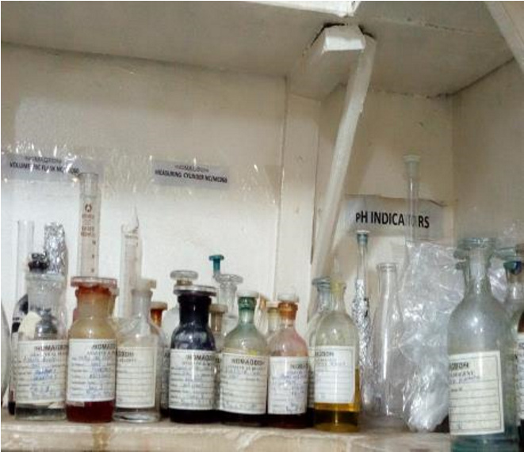 |  | 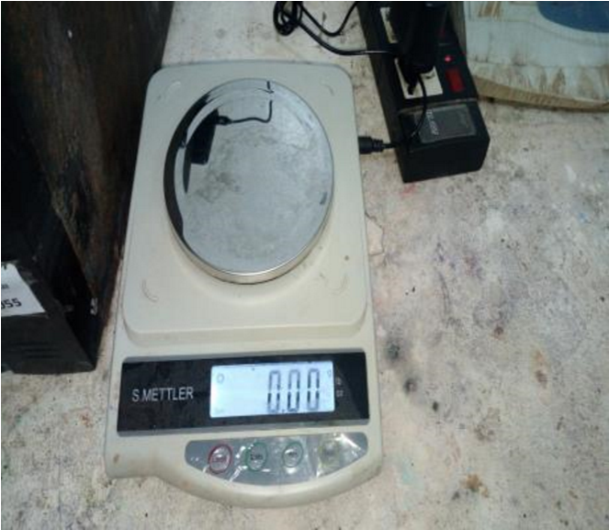 |  | 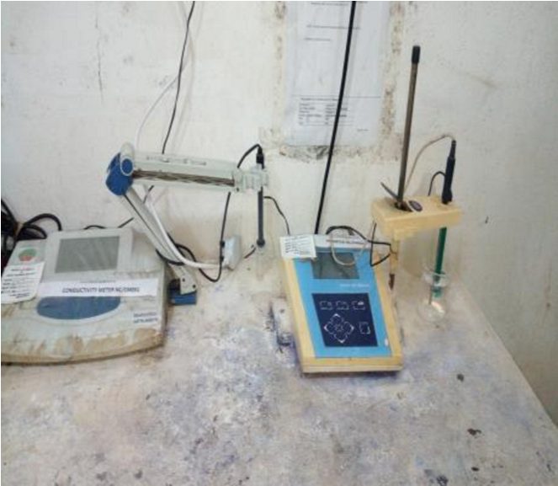
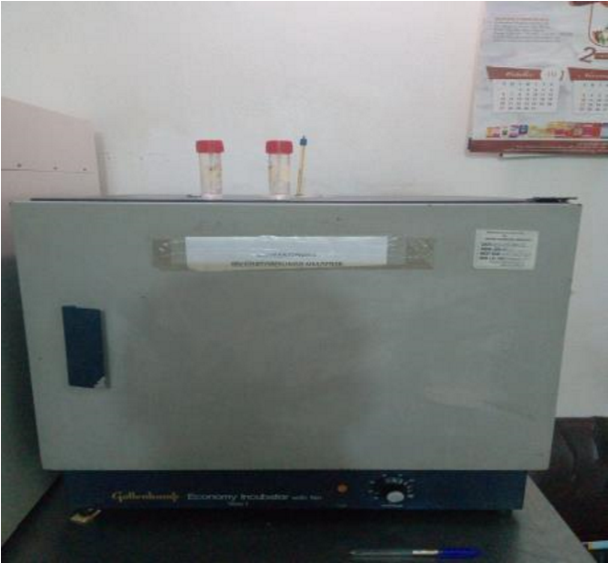
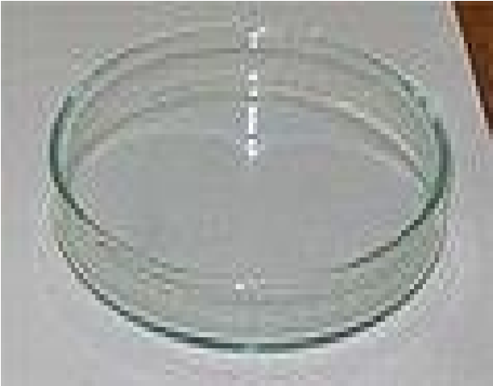
Different reagents WEIGHT SCALE

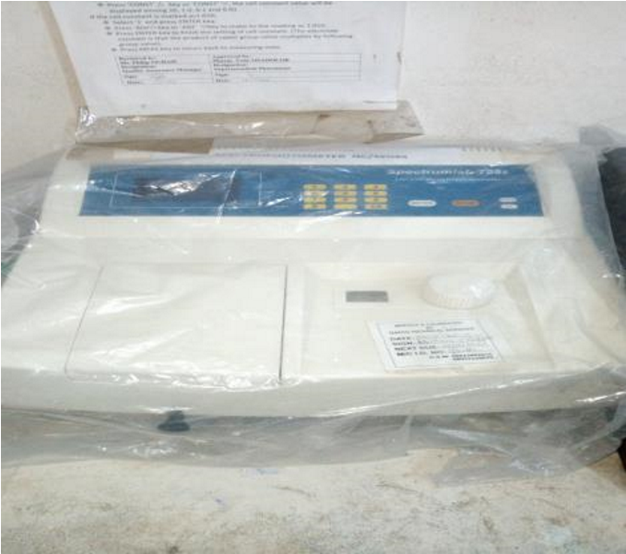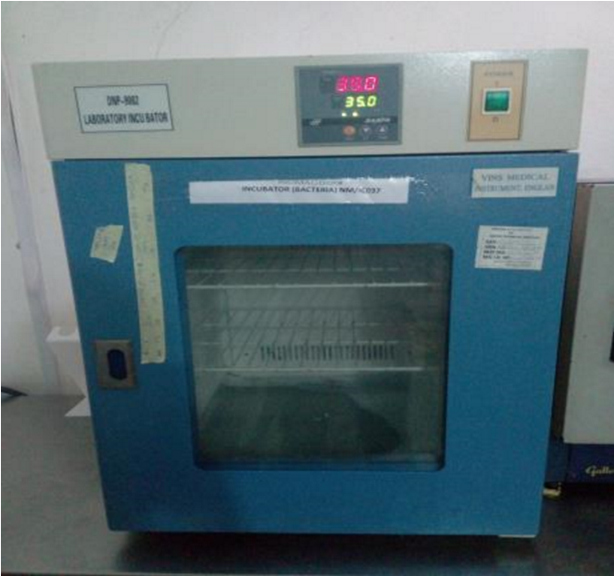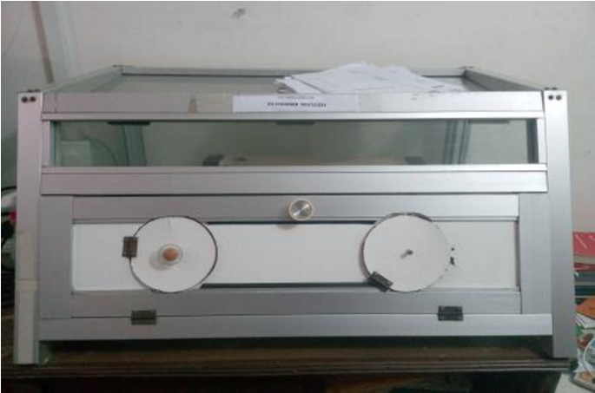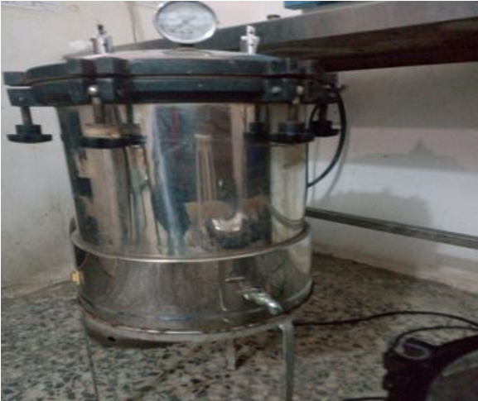

CHAPTER 3
ANALYSIS
TITLE: ANALYSIS ON BENZYL BENZOATE
AIM: TO DETERMINE THE QUALITY OF THE PRODUCT IF IT
MEETS SPECIFICATION
DESCRIPTION | B.P | RESULT
COLOUR | White emulsion | Complied
Ph | 6.80-8.20 | Complied
Wt/ml | 1.10-1.20 | Complied
Aroma | Aromatic | Complied

PROCEDURE:
ACTIVE INGREDIENT:
- Benzyl oil
- Emulsifying wax
According to the SOP, take 8ml (2g) of the emulsion, into a 500m bottom flask,50ml of ethanoic KOH was added and stir to dissolve and reflux in a water bath for 1hr,then add 1ml of phenolthalein the solution becomes deep-pink and titrate with 0.5m of hcl until its colorless. Repeat the procedure without the sample (benzyl benzoate emulsion) for the blank.

Results:
Volume of 0.5m hcl used |  | blank |  |  | test
Final burette reading (ml) |  | 20.80 |  |  | 1.40
Initial burette reading (ml) |  | 0.00 |  |  | 0.00
Titre value (ml)
Actual titre value= (blank-test) =(20.80-1.40)=19.40ml
%content = 19.40x0.106x100₈ = 25.73%w/v

% assay= 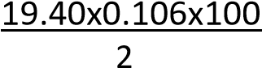 = 102.92%^{w/v} TITLE: ANALYSIS ON LIQUID QUININE
AIM: TO DETERMINE THE QUALITY OF PRODUCTS IF IT MEETS
SPECIFICATION
DESCRIPTION | B.P | RESULT
COLOUR | Almost colorless | Complied
Ph | 1.50-3.50 | Complied
Wt/ml | 0.90-1.10 | Complied
Taste | Bitter | Complied

PROCEDURE:
Take 5ml of liquid quinine and dilute with 25ml of Deionize water in a separating funnel, add 3ml of 1m NaOH to the solution to make media alkaline and extract quinine Sulphate with 3x25 chloroform and wash the extract with 3x10ml of deionized water until its neutral turn litmus.
Evaporate by heating on a water bath to the volume 2-3ml and add 25ml of 0.1m hcl , warm to dissolve the base ,cool and titrate with 0.1m NaOH using bromocresol green as indicator, repeat the operation without the sample for the blank.

Results:
Volume of 0.1m hcl used blank test
Final burette reading (ml) 25.80 20.00 Initial burette reading (ml) 0.00 0.00
Titre value 25.80 20.00 ACTUAL titre value =(blank-test)=>(25.80-20.00)=5.8ml
%content= 5.8x 0.026x1005 =3.03%w/v

% assay =5.8x 0.0261x1000.15g =100.92 %
The endpoint changes from green to colorless.

TITLE: ANALYSIS ON MAGNESIUM TRISILICATE MIXTURE
AIM: TO DETERMINE THE QUALITY OF THE PRODUCT IF ITS
MEETS SPECIFICATION
DESCRIPTION | B.P | RESULT
COLOUR | White | Complied
Ph | 7.50-12.0 | Complied
Wt/ml | 1.00-1.10 | Complied
Taste | Salty | Complied

PROCEDURE:
Active ingredient
- Sodium bicarbonate
- Light magnesium trisilicate
- Magnesium trisilicate

Test For Sodium Bicarbonate
According to the company’s S.O.P (standard operating procedures),quantity of mixture of mag.trisilicate was filtered and 10ml of the filtrate was taken in 250ml conical flask,20ml of deionized water was added and stirred properly, the resulting solution was titrated with 1m hcl using 2-3drops of methyl-orange as indicator while the end point is turns pink.

Result:
Volume of 1m hcl used 1st titration 2nd titration
Final burette reading (ml) 5.80 5.80 Initial burette reading (ml) 0.00 0.00
Titre value 5.80 5.80

Average titre value =^{5.80+5.80} ₂
%content ₌5.80x1.124x0.084x100₁₀ =5.48% w/v
%assay = 5.80x1.124x0.084x1000.5 =109.52%w/v

Test for Light Mag Carbonate:
According to the S.O.P, dissolve 10ml of the Analyte in a minimum quantity of 10ml of 2m hcl and dilute to 200ml with deionized water to the resulting solution, take 20ml of the solution Into a 500m conical flask and add 200ml Deionize water,10ml of ammonium chloride buffer ph10.9,using 0.5ml of mordant black as an indicator and titrate with 0.05m of EDTA (ethylene Diamine tetra acetic acid) which end point is blue-black Solution.

RESULT:
VOLUME OF 0.05M EDTA USED | 1ST titration | 2ND titration
Final burette reading (ml) | 18.40 | 18.40
Initial burette reading (ml) | 0.00 | 0.00
Titre value (ml) | 18.40 | 18.40

Average titre value =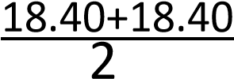 = 18.40ml
% content = 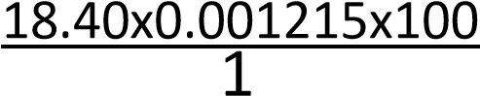=2.24%^{w/v}
% assay = 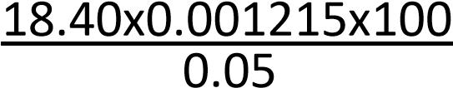=44.71%

Test for Magnesium Trisilicate
According to the S.O.P, 10ml of the mixture (mag trisilicate) was taken up into a 250ml conical flask,7ml of conc. Cl and 7ml of deionize water was added and heated in a water bath for 15mins with continuous stirring.30ml of hot water was added after been heated, the resulting solution was filtered and washed ,the combined solution(filtrate and washed)was made up to 100ml with DI water ,25ml of the solution was taken of 500ml conical flask and 150ml of DI water was added. Using 0.5ml of mordant black as indicator, 5ml of ammonium chloride buffer ph 10.9 titrating with 0.05m EDTA. The end-point is blue-black solution

Result:
Volume of 0.05 EDTA USED 1st titration | 2ndtitration
Final burette reading(ml) 42.00 | 42.00
Initial burette reading(ml) 0.00 | 0.00
Titrevalue(ml) 42.00 | 42.00
Average titre value =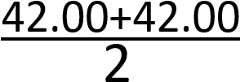 = 42.00ml
% Content =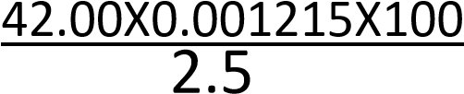 =2.04%^{w/v}
%Assay =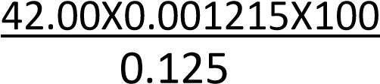 =40.82%

CHAPTER SIX
Summary
The students industrial work experience scheme (SIWES) has expose me as a students to basic work ethics and various machine which in the nearest future I will come in contact with again.
The programme enables me to have a practical insight as regards biochemistry and also to known the different options of biochemistry, these include medical biochemistry , industrial biochemistry, food biochemistry amongst others .
The scheme enables me to know the pharmaceuticals company, which have six basic department administrative department, packaging department, inventory department and the most important are the chemistry and microbiology lab and compounding.
The scheme enables me to be exposed to different analysis carried out on raw materials, in-process and finished products to meet specification in the chemistry lab and to ascertain the status of bacteria and fungi growth in this products using different techniques of analysis such as pour and plate techniques, gram staining techniques, and passive sampling.
The scheme has exposed me to lots of experiences, on How a business is run and managed, in terms of documentations and recording of files on daily activities for reference uses.
The scheme has also exposed me to the compounding department where I learn how some drugs such as Magnesium Trisilicate , Nomasan syrup etc are compounded and how their active ingredients works plus the recipient added to it.
Finally the program (SIWES) is one that needs to be influenced and encouraged in order to improve the quality of graduates produced by Nigeria University and beyond.

