NAME: Ibezim, Emily Chika
MATRIC NUMBER: 17/mhs01/143
DEPARTMENT: Medicine and Surgery
COURSE TITLE: Medical Biochemistry IV
COURSE CODE: BCH 313

QUESTION
1. What do you understand by primary or simple obesity
2. How does congenital syndrome and drug therapy affect obesity
3. Outline the aetiology of cancer and its molecular basis

SOLUTION
1. Obesity is a medical condition in which excess body fat has accumulated to the extent that it may have an adverse effect on health. It is defined by body mass index (BMI) and further evaluated in terms of fat distribution via the waist–hip ratio and total cardiovascular risk factors.
Primary or simple obesity is obesity resulting when caloric intake exceeds energy expenditure. It is not associated with clinical conditions.

2. Secondary obesity is obesity that arises due to medical conditions that causes the individual to gain weight. These diseases include endocrine disorders, hypothalamic disorders, some congenital conditions/syndromes and drug therapy.
There are also some rare causes of secondary obesity like Prader-Willi syndrome, Laurence-Moon-Biedl (Bardet-Biedl) syndrome, Cohen syndrome, Albright hereditary osteodystrophy and Beckwith-Weidemann syndrome to mention a few.

- How Congenital syndromes affect Obesity
As seen above, some congenital syndromes can lead to the secondary type of obesity. An example of this is seen inPrader-Willi syndrome. The obesity associated with PWS (Prader-Willi syndrome) results from a chronic imbalance between energy intake and expenditure due to hyperphagia, decreased physical activity, reduced metabolic rate and an inability to vomit. Individuals with PWS have a lower lean body mass compared with controls contributing to reduced energy expenditure.
In the case of Bardet-Biedl syndrome (BBS) which is a rare developmental disorder with the cardinal features of abdominal obesity, retinopathy, polydactyly, cognitive impairment, renal and cardiac anomalies, hypertension, and diabetes. It has been suggested that heterozygous carriers of BBS are predisposed to obesity, specifically with fat deposition along the abdomen. Thus, Bardet-Biedl syndrome affects obesity in that it leads to abdominal/truncal obesity. Cohen syndrome is also cha by truncal obesity.
- How drug therapy affects Obesity
Drug-induced weight gain is a serious side effect of many commonly used drugs leading to noncompliance with therapy and to exacerbation of comorbid conditions related to obesity. Improved glycemic control achieved by insulin, insulin secretagogues or thiazolidinedione therapy is generally accompanied by weight gain. It is a problematic side effect of therapy due to the known deleterious effect of weight gain on glucose control, increased blood pressure and worsening lipid profile.
The atypical antipsychotic drugs (clozapine, olanzepine, risperidone and quetiapine) are known to cause marked weight gain.
This shows that drug therapy can also affect obesity.

3. Cancer is the uncontrolled growth of abnormal cells anywhere in a body. It is a disease in which abnormal cells divide uncontrollably and destroy body tissue.
AETIOLOGY OF CANCER
Cancer is caused by accumulated damage to genes. Such changes may be due to chance or to exposure to a cancer causing substance.
The substances that cause cancer are called carcinogens. A carcinogen may be a chemical substance, such as certain molecules in tobacco smoke. The cause of cancer may be environmental agents, viral or genetic factors.
We can roughly divide cancer risk factors into the following groups:
1. Biological or internal factors, such as age, gender, inherited genetic defects and skin type
2. Environmental exposure, for instance to radon and UV radiation, and fine particulate matter
3. Occupational risk factors, including carcinogens such as many chemicals, radioactive materials and asbestos
4. Lifestyle-related factors.
•Lifestyle-related factors that cause cancer include:
- tobacco
- alcohol
- UV radiation in sunlight
- some food-related factors, such as nitrites and poly aromatic hydrocarbons generated by barbecuing food).
Lifestyles can prevent cancer

•Cancer causing factors related to work and living environments include:
- asbestos fibres
- tar and pitch
- polynuclear hydrocarbons (e.g. benzopyrene)
- Some metal compounds
- Some plastic chemicals (e.g. Vinyl chloride)

•Bacteria and viruses can cause cancer:
- Helicobacter pylori (H. pylori, which causes gastritis)
- HBV, HCV (hepatitis viruses that cause hepatitis)
- HPV (human papilloma virus, papilloma virus, which causes changes eg. Cervical cells)
- EBV (Epstein-Barr virus, the herpes virus that causes inflammation of the throat lymphoid)

•Radiation can cause cancer:
- ionising radiation (e.g. X-ray radiation, soil radon)
- non-ionised radiation (the sun’s ultraviolet radiation)

•Some drugs may increase the risk of cancer:
- certain antineoplastic agents
- certain hormones
medicines that cause immune deficiency

In 5 – 10 per cent of breast cancer genetic predisposition plays an important role in the emergence of the disease.

MOLECULAR BASIS OF CANCER
Cancer is a genetic disease. It is a disease of uncontrolled growth and proliferation whereby cells have escaped the body’s normal growth control mechanisms and have gained the ability to divide indefinitely. It is a multi-step process that requires the accumulation of many genetic changes over time. These genetic alterations involve activation of proto-oncogenes to oncogenes, deregulation of tumour suppressor genes and DNA repair genes and ‘immortalisation’.
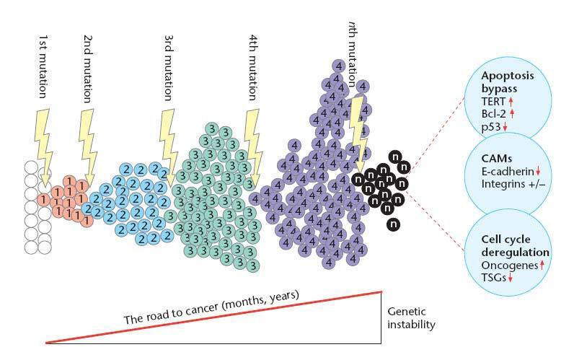
Figure 1: Overview of the road to cancer. Cells may acquire mutations in genes that control proliferation, such as proto-oncogenes and/or tumour suppressor genes. Each new mutation may provide a selective advantage for this cell, leading to ‘clonal expansion’. Cellular properties changed in this process include cell cycle deregulation, apoptosis prevention and cell adhesion properties (CAMs – Cellular adhesion molecules).

Cell cycle regulation and the importance of apoptosis
In normal cells, proliferation and progression through the cell cycle is strictly regulated by groups of proteins that interact with each other in a specific sequence of events (Figure 2). Checkpoints ascertain that individual stages of the cell cycle are completed correctly and ensure that incompletely replicated DNA is not passed onto daughter cells. Core to this control system are cyclin-dependent kinases (CDKs). CDKs are ‘master protein kinases’ that drive progression through the different phases of the cell cycle by phosphorylating and activating other downstream kinases. CDK activity is dependent on the presence of activating subunits called cyclins which are synthesised and degraded in a cell cycle-dependent manner. Cyclin-CDK complexes are further tightly regulated by CDK inhibitors.
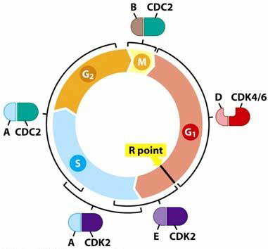
Figure 2: Cyclins and cyclin-dependent kinases (CDKs) regulate the cell cycle. CDK’s and their regulatory subunits, cyclins (A, B, D & E) tightly control transition through the cell cycle. The brackets indicate the periods in which the cyclin-CDK complexes are active and orchestrate all events necessary in this period. The restriction point (R point) is a point in G1 at which the cell becomes ‘committed’ to the cell cycle and after which extracellular proliferation signals are no longer required.

The re-entry of cells into the cell cycle is decided at the restriction point (R point). This decision is influenced by extracellular mitogenic signals which are transmitted via signalling pathways to key regulatory proteins, such as transcription factors (e.g. E2F) in the nucleus (refer to Figure 3, Section 2). These regulatory proteins ultimately activate the S-phase CDKs, which trigger the start of DNA synthesis.
In normal cells, activation of another transcription factor, p53, often referred to as the ‘guardian of the genome’, can impose cell cycle arrest and induce apoptosis (programmed cell death) through its ability to:
induce the expression of cell cycle inhibitors to prevent proliferation of a cell until any damage has been repaired or
initiate apoptosis, if the genomic damage is too great and cannot be repaired.
In >50% of all human tumours the p53 pathway is aberrant. Inactivation of the p53 protein renders it unable to signal and activate the cell’s apoptotic machinery resulting in increased survival of cancer cells.

Cell immortalisation and tumourigenesis
Immortalisation is defined as the acquisition of an infinite lifespan. Normal mammalian somatic cells proliferate a limited number of times before undergoing senescence. Senescent cells may remain metabolically active even though they have permanently ceased proliferation. Immortalisation is an essential step in the malignant transformation of normal cells and can be attributed, in part, to the presence of telomerase, the enzyme responsible for maintaining telomeres at the ends of chromosomes. By extending telomeric DNA, telomerase is able to counter the progressive telomere shortening that would otherwise lead to cell death. Unlike normal cells that lack detectable levels of telomerase activity, approximately 90% of human tumours consist of cells that contain an active telomerase enzyme.

