NAME: ALAKU SARAH OKPHOHRO.
MATRIC NUMBER: 19/MHS02/019.
COURSE: BIO102
DEPT: NURSING SCIENCE.
COLLEGE: MEDICINE AND HEALTH SCIENCES.
GENERAL BIO102 3RD ASSIGNMENT.
QUESTIONS:
- How are fungi important to mankind?
- Fungi are very important to the entire terrestrial ecosystem in material cycling and to mankind.
- They are responsible for the mediation of decay of organic matter.
- Fungi eg; yeast are important in food industry.
- Without fungi and other microbes, the surface of the earth would have been clogged up with dead matters within all the various elements locked up in them instead of returning into various cycles.
- Illustrate the cell structure of a unicellular fungus with a well labelled diagram.

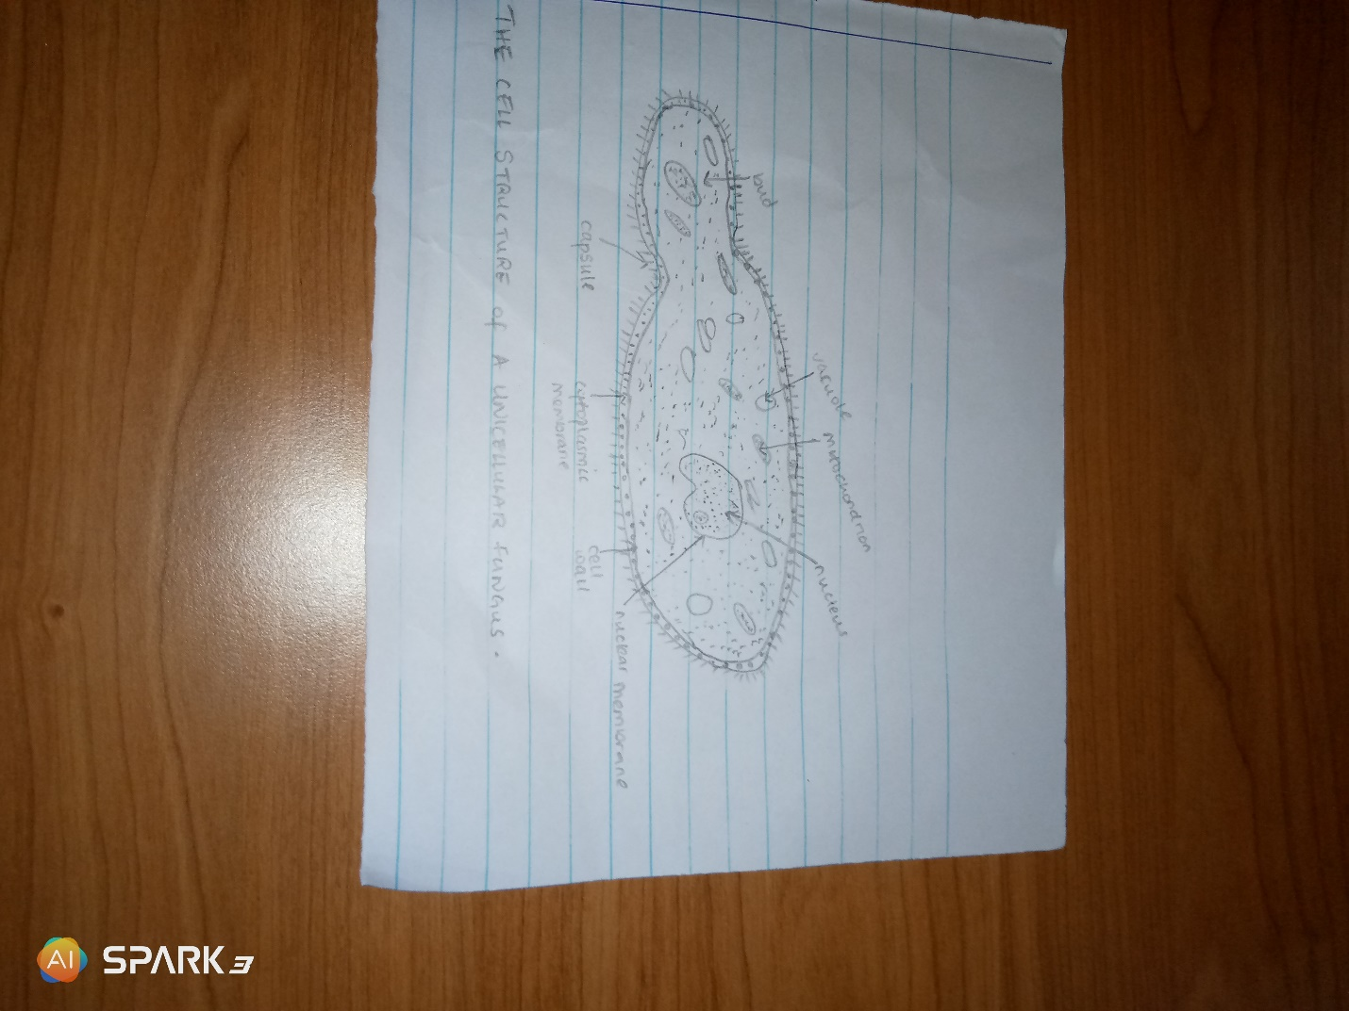

- Outline the sexual reproduction in a typical filamentous form of fungi.
The sexual reproduction occurs when two mating types of hypae grow in the same medium. Chemical interaction in the two mating types of hypae induces growth perpendicular to the hypae in opposite directions. These growths are delimited by a wall such that many nuclei are isolated in a GAMETANGIUM. The two gametangia fuse (plasmogamy) and a zygote is formed which may undergo prolonged dormancy or resting stage. The nuceli in the zygote fuse in twos and undergoes meiosis independently. The zygote then germinates under favourable conditions to produce a fruiting which at maturity liberates the haploid spores

- How do bryophytes adapt to their environment?
- They have definite structures for water and nutrient absorption from the soil; therefore the plant body is divided into two: an aerial portion and a subterranean portion.
- The aerial portion begin exposed to the atmosphere demands some modifications that prevents excessive loss of water through the body surface (i.e. desiccation).
- Some other modifications that permits elimination of excess water from the plant body and not only exchange of gases between the internal parts of the plant and the atmosphere therefore openings are available on the aerial parts of the plants.
- Describe with IIlustration the following terminologies:
- Eusteles: in herbaceous dicotyledous plants in which the vascular bundles are discrete, concentric collateral bundles of xylem and phloem.

- Atactostele: in grasses and monocotyledous plants the vascular bindles are scattered.

- Siphonstele: in more advanced vascular systems eg; stems of ferns and higher vascular plants, the stele is a cylinder enclosing a parenchymatous pith.

- Dictyostele: in siphonstele, the vascular supply to leaves is associated with leaf gaps and the conducting cylinder is a dissected one.

- Illustrate the life cycle of a primitive vascular plant.
For example in psilotum (a primitive vascular plant) the vascular system in the roots and stems are similar; they occur as a solid central vascular core with the phloem tissues either surrounding the xylem or dissecting it.

