AIMUEL EMMANUEL
16/SCI01/005
1a). Color harmony refers to the property that certain aesthetically pleasing color combinations have. These combinations create pleasing contrasts and consonances that are said to be harmonious.
Color schemes have a large impact on human-computer interaction, color can greatly improve user interfaces if used correctly, but can also reduce the functionality of the interface if used inappropriately. Important factors of designing color interfaces include simplicity, consistency, and clarity. Firstly, you want to keep the color scheme fairly simple. Simplicity can be achieved by using the four primary colors, which are red, green, yellow, and blue. Consistency is also another important factor when designing an interface. Colors should be assigned to a particular type of concept or to help classify information. This technique helps users to retain more information in their short term memory. Clarity and the concise use of color aids in helping users identify items more efficiently.
1b) Components of color

The 3 Key Components of Color: Hue, Value, and Saturation
Understanding hue, value, and saturation is critical for creating beautiful color harmonies. These are the basic three key characteristics of color.

Hue
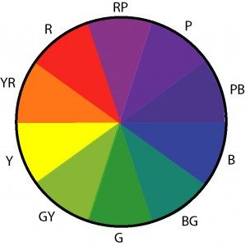
Hue is what most people think of when using the term ‘color.’ It corresponds to its position in the spectrum. Examples of hues are: red, orange, yellow, green, blue, violet.
In scientific terms, hue is the spectral wavelength composition of a color that produces the perception of being red, yellow, blue, and so on.

Value
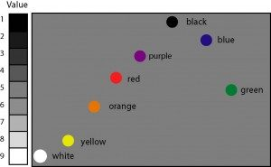
Value is the relative lightness or darkness of a color. This is what you see when you take a black and white photograph. Each tube color has a different value as shown in this chart.

Saturation
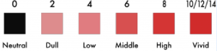
The saturation of a color is its degree of richness, intensity, purity, or grayness. Other commonly used terms for saturation are intensity or chroma.
For example, cadmium orange and burnt sienna are the same hue (orange), but cadmium orange has a high saturation whereas burnt sienna has a low saturation.
1bii) Primary colors
Primary colors include red, blue and yellow. Primary colors cannot be mixed from other colors. They are the source of all other colors.
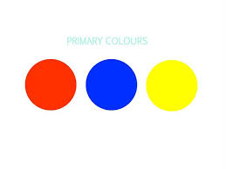

1biii) Secondary colors
The Secondary Colors are green, orange and purple, which are created by mixing two primary colors.
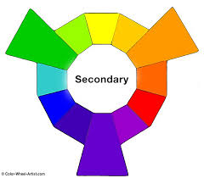

1biv) Tertiary Colors
Tertiary colors are red-purple, red-orange, blue-green, blue-purple, yellow-green, and yellow-orange. There are six tertiary colors and they are the result from mixing equal parts of a primary color with a secondary color.
