NAME: AGBATO OLAOLUWA
MATRIC NO: 17/MHS01/031 (CARRYOVER)
DEPARTMENT: PHYSIOLOGY
COURSE CODE: BIO 102

1) The majority of grasses and trees require a mycorrhizal relationship with fungi to survive.
Yeasts have been used for thousands of years in the production of beer, wine, and bread.
Fungi not only directly produce substances that humans use as medicine, but they are also versatile tools in the vast field of medical research.
Some fungi attack insects and, therefore, can be used as natural pesticides

2)
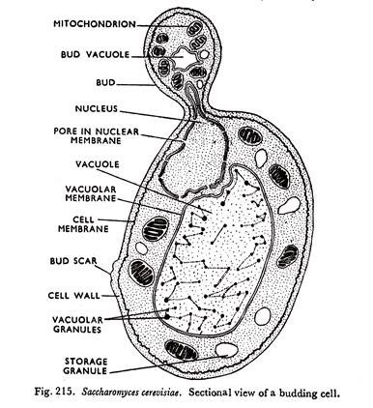

DIAGRAM OF THE CELL STRUCTURE OF A UNICELLULAR FUNGUS
3) 1.It takes place by the fusion of multinucleate gametangia. Species are dioecious or heterothallic.
2.Two fusing gametangia (male and famale, or + and -) are morphologically similar but physiologically different.
3. Developing gametangia are known as progametangia. These are filled with cytoplasm and nuclei in their swollen tip.
4. At the time of their fusion each gametangium is separated from the ‘suspensor’ with the help of a septum.
5. The multinucleate protoplasm of each gametangium is known as coenogamete.
6. Fusion of two gametangia takes place. The nuclei of + gametangium fuse with those of -, and thus many diploid nuclei are formed. Around this fusion product, a thick, spiny wall develops, and now it is called zygospore.
7. Zygospore germinates meiotically by producing a long sporangiophore bearing a sporangium at the tip.

4) Mosses have developed leaf-, stem-, and root-like structures, apart from the thallus of algae. They develop specialized structures for a particular function. Generally, leaves are specialized for photosynthesis; stems are specialized for support as well as transport; roots are specialized for support and absorption of water. The leaf-like structures of mosses are simple and one-cell thick. The stems hold the plant against the ground. The root-like structures of mosses are called rhizoids and they attach the plant to the substrate.
Each cell of the moss is surrounded by a thick cell wall, providing support to the plant as in higher plants.
The absorption of water mainly occurs through the body surface of the plant. Water diffuses from cell to cell. However, they have developed special storage areas for both water and nutrients. Some mosses have developed primitive types of vascular systems, allowing the efficient transfer of water and nutrients throughout the plant.
Mosses have chlorophyll for photosynthesis. Hence, they produce their own food.
Mosses asexually reproduce through spores. A spore consists of a single reproductive cell covered by a protective, hard, and watertight covering. It is transmitted through the air. The production of this type of spores by mosses is an adaptation for the life on land

5)Eustele: a stele typical of dicotyledonous plants that consists of vascular bundles of xylem and phloem strands with parenchymal cells between the bundles
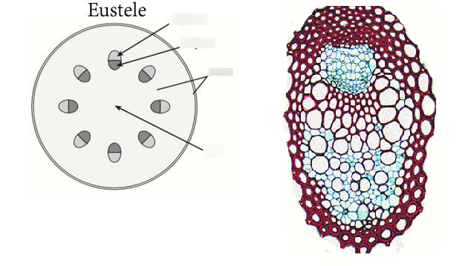
Atactostele: A type of eustele, found in monocots, in which the vascular tissue in the stem exists as scattered bundles.
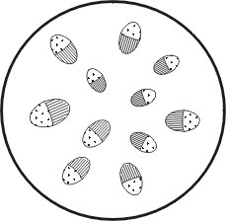
Siphonostele: a stele consisting of a core of pith surrounded by concentric layers of xylem and phloem.
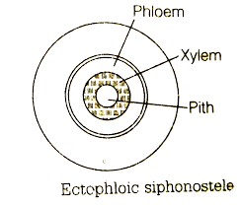
Dictyostele: a stele in which the vascular cylinder is broken up into a longitudinal series or network of vascular strands around a central pith (as in many ferns)
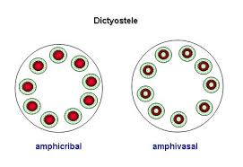
6)