Odukoya Treasure
18/MHS05/010
Physiology
ANA 204
Question: Describe the microanatomy of small and large intestine. Note: you are expected to state the functions, segment, layers, general features and epithelium of each part of the small and large intestine.
SMALL INTESTINE
The histological structure of the small intestine is similar to the other organs in the digestive tract. There are four main layers:
- Mucosa (Innermost layer) – Contains the epithelium, lamina propria and muscularis mucosae.
- Submucosa – Connective tissue layer, which contains blood vessels, lymphatics and the submucosal plexus.
- Muscularis externa – Consists of two smooth muscle layers; the outer longitudinal layer and inner circular layer. The myenteric plexus lies between them.
- Adventitia (Outermost layer) – Comprised of loosely arranged fibroblasts and collagen, with the vessels and nerves passing through it. The majority of the small intestine adventitia is covered by mesothelium and is commonly called the serosa.
The small intestine is the major absorptive site in the gastrointestinal tract, and therefore has a number of modifications to aid its function. The mucosa and submucosa form large numbers of folds (or plicae) arranged in a circular fashion in the lumen (therefore called plicae circulares). Additionally, the plicae contain microvilli to further increase the surface area, which increases absorption.
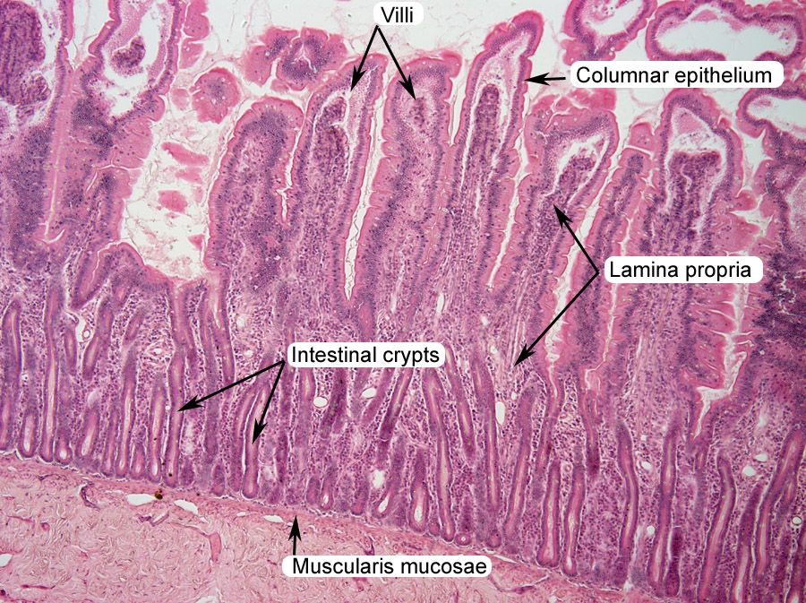
Epithelium
The mucosa of the small intestine is lined by a simple columnar epithelium which consists primarily of absorptive cells (enterocytes), with scattered goblet cells and occasional enteroendocrine cells. In crypts, the epithelium also includes Paneth cells and stem cells
Cells of the Epithelium
The epithelium of the small intestine lines the luminal surface. There are a number of components to the epithelium:
- Enterocytes – Tall columnar cells, which have an absorptive function. They contain brush border enzymes on the surface which have an important digestive function.
- Goblet cells – Exocrine glands which secrete mucin.
- Crypts of Lieberkuhn – The Crypts of Lieberkuhn are glands found in the epithelial lining. They contain numerous cells such as stem cells to produce new cells to replenish the cells lost due to abrasion, as well as enteroendocrine cells to synthesise and secrete hormones.
To protect from pathogens, there are Paneth cells which secrete protective agents (such as defensins and lyzozymes) and Peyer’s patches which are only found in the ilium. Peyer’s patches contain mucosal-associated lymphatic tissue (MALT) which house white blood cells and lymphocytes. These cells can produce antibodies to further protect the small intestine from infection.
Enteroendocrine Cells
The enteroendocrine cells are located within the Crypts of Lieberkuhn. They secrete hormones in response to various stimuli. There are four main classes of enteroendocrine cell, each with a different secretory product. These are I cells, S cells, K cells and enterochromaffin cells.
LARGE INTESTINE
The large intestine has the same 4 layers found in most parts of the GI tract. They are as follows:
- Mucosa - Includes a columnar epithelium with large number of mucus-secreting goblet cells (villi; present in small intestine; absent in colon), lamina propria, and muscularis mucosa; the appendix is rich in mucosa-associated lymphoid tissue (MALT)
- Submucosa - Contains the blood vessels and Meissner nerve plexus
- Muscularis propria - Contains continuous inner circular and outer longitudinal muscles arranged in bands and myenteric (Auerbach) nerve plexus; tenia coli are formed by bands of the outer longitudinal muscles (tinea are present in the colon only and are not present in the rectum, where the outer longitudinal muscle is continuous)
- Serosa - Visceral peritoneum
Key point of the large intestine
- The longitudinal layer of the muscularis of the large intestine is reduced to three, strap-like structures known as the taeniae coli—bands of longitudinal muscle fibers, each about 1/5 in wide.
- The bands of longitudinal muscle fibers start at the base of the appendix and extend from the cecum to the rectum.
- The wall of the large intestine is lined with simple columnar epithelium.
- Both the small intestine and the large intestine have goblet cells, but they are abundant in the large intestine.
The large intestine, or large bowel, is the last part of the digestive system in vertebrate animals. Its function is to absorb water from the remaining indigestible food matter, and then to pass the useless waste material from the body. The large intestine consists of the cecum, colon, rectum, and anal canal.
It starts in the right iliac region of the pelvis, just at or below the right waist, where it is joined to the bottom end of the small intestine. From here it continues up the abdomen, across the width of the abdominal cavity, and then it turns downward, continuing to its endpoint at the anus.
The large intestine differs in physical form from the small intestine in being much wider. The longitudinal layer of the muscularis is reduced to three strap-like structures known as the taeniae coli—bands of longitudinal muscle fibers, each about 1/5 in wide. These three bands start at the base of the appendix and extend from the cecum to the rectum.
Along the sides of the taeniae are tags of peritoneum filled with fat; these are called epiploic appendages, or appendices epiploicae. The wall of the large intestine is lined with simple columnar epithelium.
Instead of having the evaginations of the small intestine ( villi ), the large intestine has invaginations (the intestinal glands). While both the small intestine and the large intestine have goblet cells that secrete mucin to form mucus in water, they are abundant in the large intestine.
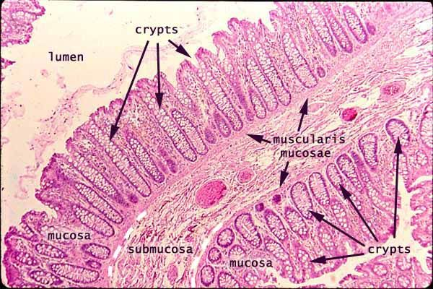
In histology, an intestinal crypt—called the crypt of Lieberkühn—is a gland found in the epithelial lining of the small intestine and colon. The crypts and intestinal villi are covered by epithelium that contains two types of cells: goblet cells that secrete mucus and enterocytes that secrete water and electrolytes.
The enterocytes in the mucosa contain digestive enzymes that digest specific food while they are being absorbed through the epithelium. These enzymes include peptidases, sucrase, maltase, lactase and intestinal lipase. This is in contrast to the stomach, where the chief cells secrete pepsinogen. In the intestine, the digestive enzymes are not secreted by the cells of the intestine.
Also, new epithelium is formed here, which is important because the cells at this site are continuously worn away by the passing food. The basal portion of the crypt, further from the intestinal lumen, contains multipotent stem cells.
During each mitosis, one of the two daughter cells remains in the crypt as a stem cell, while the other differentiates and migrates up the side of the crypt and eventually into the villus. Goblet cells are among the cells produced in this fashion. Many genes have been shown to be important for the differentiation of intestinal stem cells.
The loss of proliferation control in the crypts is thought to lead to colorectal cancer.

