NAME: OTUBELA PRINCESS OLUWAPAMILERIN
COURSE CODE: BIO 102
DEPARTMENT : MEDICINE AND SURGERY
MATRIC NO: 19/MHS01/366
ASSIGNMENT
- How are fungi important to mankind?
Some fungi are parasite to some horrible pests e.g grasshopper, flies and so on. Therefore, they can serve as biological control agents.
Certain fungi e.g Mushroom serve as food to man
Some fungi e.g yeast (Saccharomyces cerevisiae)are important in the food industry
Some fungi e.g Penicillium notatum can be used to produce antibiotics
Fungi help to regulate the various cycle by mediating the decay of organic matter causing elements in them to escape.
- Illustrate the cell structure of a unicellular fungus with a well labelled diagram.
The cell structure is very simple though the organisation is one of the more advanced fungal forms from the point of view of its spore producing structure. Cells exists in diploid / haploid states. They multiply rapidly by simple mitotic cell divisions(budding) this is nuclear division and division of the cytoplasm in such a way that one segment of the constricted cytoplasm is smaller than the others. Diploid cell arise from haploid cells by the process of plasmogamy and karyogamy. The diploid cell may under meiosis under certain conditions to produce 4 haploid spores (ascospores)
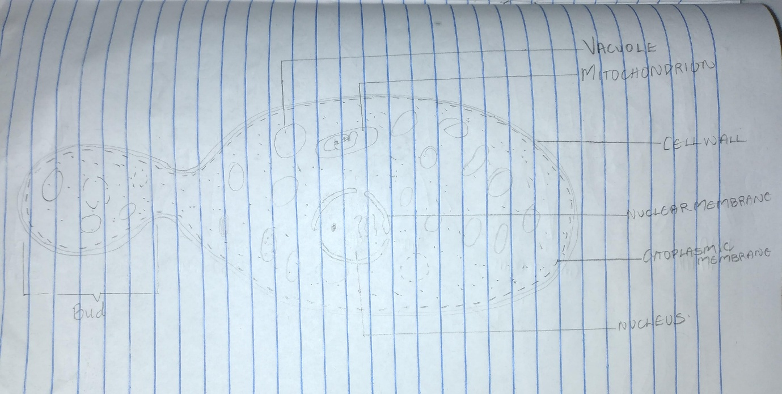
- Outline the sexual reproduction in a typical filamentous form of fungi.
The sexual reproduction in a filamentous fungus occurs when two mating types of hyphen grow in the same medium. The two mating types of hyphae undergo a chemical reaction which induces a perpendicular growth in opposite directions. These growths are delimited by a wall such that many nuclei are isolated in a gamentangium. Two gamentangium fuse (plasmogamy) and a zygote is formed which may undergo prolonged dormancy (resting stage). The nuclei in the zygote fuse in twos and undergo meiosis independently. The Zygote germinates under favourable conditions to produce a fruiting which at maturity liberates with haploid spores.
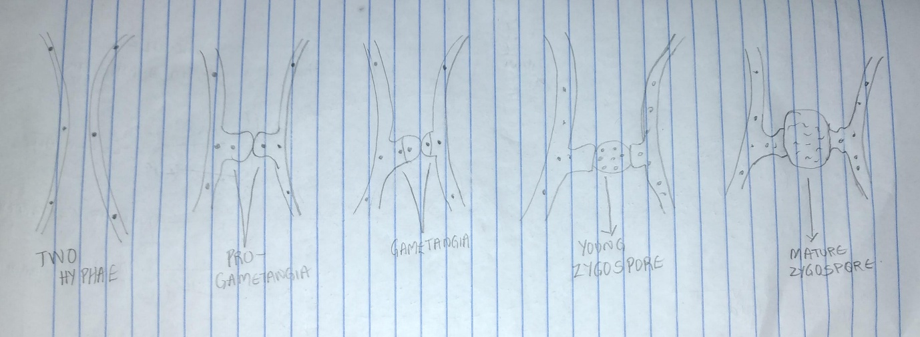
- How do Bryophytes adapt to their environment?
Bryophytes live on land and they adapt to the land environment with various modifications.
They have definite structures for water and nutrient absorption from the soil. The plant body is divided into two : an aerial portion and a subterranean portion( this is the rhizoid which is not a true root as the case of advanced land plants)
The aerial portion ( the portion exposed to the atmosphere) demands some modifications that prevents excessive loss of water through the body surface(desiccation)
The bryophytes possess other modifications that permit the elimination of excess water from the plant body and not only exchange of gasses between internal parts of the plant and the atmosphere therefore openings are available on the aerial parts of the plant.
- Describe with illustration the following terminologies: (a) eusteles (b) atactostele (c) siphonostele (d) dictyostele.
Eustele : This is a conducting tissue in which the vascular bundles are discrete, concentric collateral bundles of xylem and phloem. It occurs in herbaceous dicotyledonous plants
Actactostele : it occurs in grasses and many monocotyledonous plants. Here, the vascular bundles are scattered
Siphonostele : it occurs in more advanced vascular systems. E.g ferns and higher vascular plants. It is a cylinder enclosing a parenchymatous pith . Eustele and dictyostele are types of siphonostele.
Dictyostele : Here, vascular supply to leaves is associated with leaf gaps and the conducting cylinder is dissected.
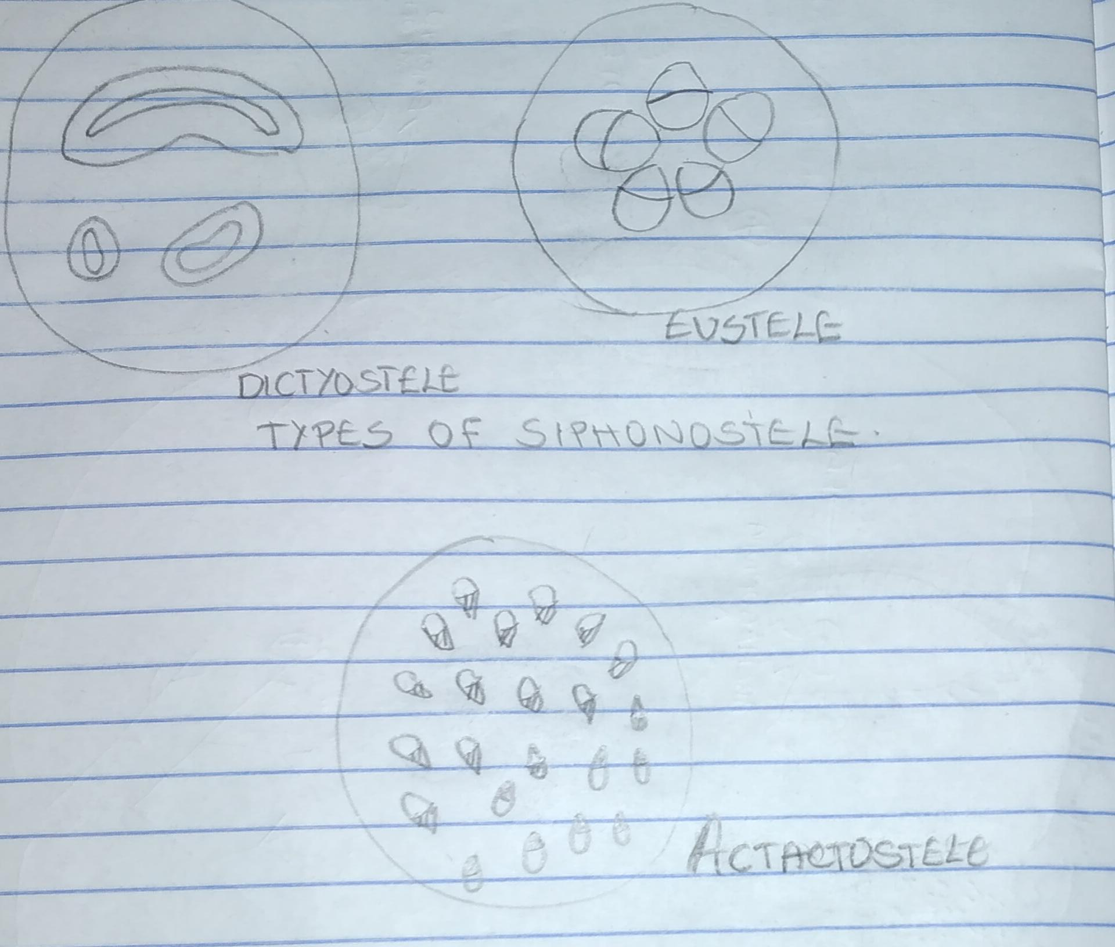

6.Illustrate the life cycle of a primitive vascular plant.
Sporangium develops into a globose structure inside which sporongenous cells undergo meiosis to produce haploid spores. The plant is homosporous. After liberation, spores germinate into cylindrical dichotomously branched gametophytes. The gametophytes are saprophytic. At maturity, the terminal ends of the cylindrical branches bear archegonia while the antheridia are borne protuberance lower down the branches. Flagellated sperm are released when antheridia are ripe which swims into the archegonia and the resulting zygote subsequently develops into a sporophyte.

