NAME: OLUSOLA IFEDAYO
MATRIC NO: 16/MHS06/057
COURSE TITLE: BIOMEDICAL ENGINEERING
COURSE CODE: MLS 410
Light Microscopy
Introduction
Light microscopes play an important role in many research laboratories, including electron microscopy facilities. They can be used as a primary visualization tool or in support of electron microscopy. Samples for light microscopy are prepared in an ever-increasing number of techniques, and can range from sliced biological organisms and tissue cultures to materials science and geological samples. Light and electron microscopes share many similarities in their optical principles. Understanding how a light microscope works is not only critical for obtaining optimum light images, but also for understanding electron microscopy.
Principles of Light, Electrons, & Microscopy
In microscopy we take advantage of waveform properties of light. These waves when produced at a particular source vibrate at right angles to the line of propagation. Each wave has a peak and trough. The distance traveled forward by the light ray is one wavelength (lambda). Wavelength varies with the color and intensity of the source.
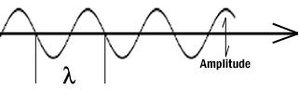
How the image is formed
The structures the light microscope is called upon to resolve exert only a small influence on the light they transmit. What is changed is the phase of momentary vibration. Conventional brightfield illumination will lack contrast and the details of the sample remain invisible. When the emerging waves have acquired a larger phase difference due to changes in refractive index, greater contrast is produced. This manifests itself by an edge effect (diffraction, refraction, and reflection). Sample details may be resolved in a number of ways. When a light passes through stained structures intensity is reduced selectively depending on the color and density of the sample as the light is absorbed. Selective absorption of wavelengths of white light produces colored light. Refraction changes the direction of a light ray as it passes from one medium to another. The shorter the wavelength, the greater the refractive angle. Diffraction is the bending of light rays around objects with sharp edges. A new wave front is created at this edge. Diffraction can be useful, but can also reduce resolution. When light is dispersed it is separated into its constituent wavelengths as a result of refraction on entering a transparent medium. Contrast can be defined as a steep slope between bright and dark image points. Adequate contrast MUST be achieved before the specimen can be resolved.
Two terms that are often confused, but are central to microscopy are magnification and resolution. Magnification is the degree by which dimensions in an image are, or appear to be, enlarged with respect to the corresponding dimensions in the object. Resolution is the act or result of displaying fine detail in an image. Magnification without resolution would be meaningless.
The theoretical resolution of the light microscope was first defined by Abbe in the following equation.
Abbe's equation for theoretical resolution of the light microscope:
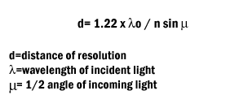

The actual resolution achievable with a light microscope is not as great. We will discuss the reasons for this later.

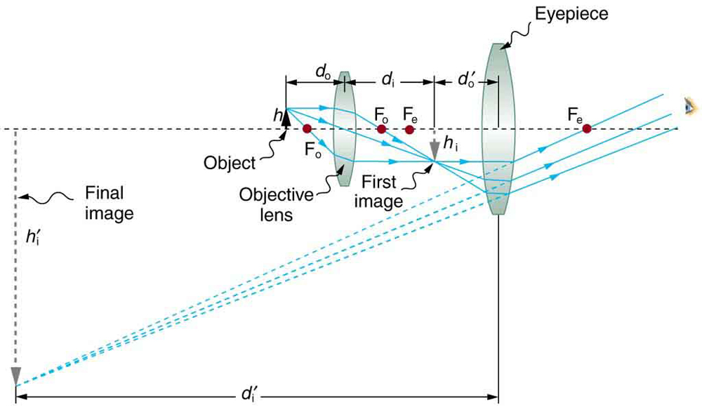

CENTRIFUGE
PRINCIPLE
- In a solution, particles whose density is higher than that of the solvent sink (sediment), and particles that are lighter than it floats to the top.
- The greater the difference in density, the faster they move. If there is no difference in density (isopycnic conditions), the particles stay steady.
- To take advantage of even tiny differences in density to separate various particles in a solution, gravity can be replaced with the much more powerful “centrifugal force” provided by a centrifuge.
- A centrifuge is a piece of equipment that puts an object in rotation around a fixed axis (spins it in a circle), applying a potentially strong force perpendicular to the axis of spin (outward).
- The centrifuge works using the sedimentation principle, where the centripetal acceleration causes denser substances and particles to move outward in the radial direction.
- At the same time, objects that are less dense are displaced and move to the center.
- In a laboratory centrifuge that uses sample tubes, the radial acceleration causes denser particles to settle to the bottom of the tube, while low- density substances rise to the top.
COST
A Centrifuge costs about $1,000 to $5,000

CARE/MAINTENANCE
- Clean the centrifuge daily, or at least weekly
- Remove the rotor and any sample or container holders
Interior cleaning
- Before and after use, check the rotor and lid

