FIDE-AKWUOBI ANTHONY CHIZALU
17/ENG06/037
MECHANICAL ENGINEERING
ENG 342

- Benefits of filters in Engineering Systems
A filter is a circuit capable of passing (or amplifying) certain frequencies while attenuating other frequencies. Thus, a filter can extract important frequencies from signals that also contain undesirable or irrelevant frequencies. The four primary types of filters are the Low-pass filter, the high-pass filter, the band-pass and the notch filter. There are many practical applications for filters. Examples include:
- Radio Communications: Filters enable radio receivers to only "see" the desired signal while rejecting all other signals (assuming the other signals have different frequency content).
- DC power supplies: Filters are used to eliminate undesired high frequencies (i.e., noise) that are present on AC input lines. Additionally, filters are used on a power supply's output to reduce ripple.
- Audio electronics: A crossover network is a network of filters used to channel low-frequency audio to woofers, mid-range frequencies to midrange speakers, and high-frequency sounds to tweeters.
- Analog-to-digital conversion: Filters are placed in front of an ADC input to minimize aliasing.
- High-pass and low-pass filters are also used in digital image processing to perform image modifications, enhancements, noise reduction, etc.
- Used in Audio Applications for Equalization purposes.
- Used in Receivers such as Superheterodyne etc for efficient reception of the baseband signals.

- Designing a Low-Pass Filter with 0.005Ω resistor and 0.01F capacitor
A 50V Amplitude was selected with a frequency of 10Hz for the Ac Voltage source.
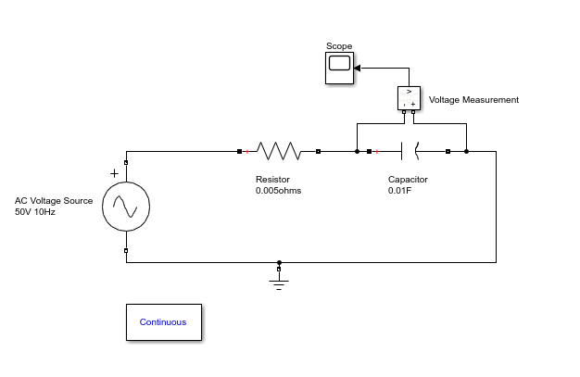
Low-Pass Filter Design

- Determining the Cut-off frequency
Theoretically, the cut-off frequency can be determined by F= ½*(pi*R*C)
Where R= 0.005Ω and C= 0.01F
F= 0.5*pi*0.005*0.01=3189.099 Hz

- Design Ouput
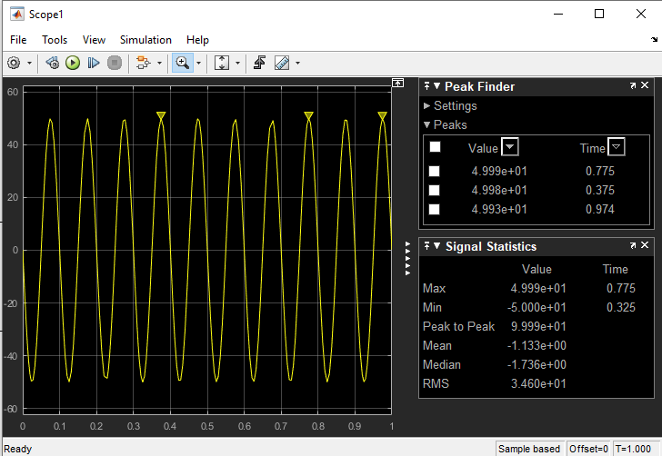
The sinusoidal curve is shown above with the peak value 49.999 approximately 50 which is the input voltage.

- If two signals of 5 KΩ and 2 KΩ are pass through the filter at different intervals. Discuss your observation
When the signal of 5 KΩ is passed through the filter, the following result is obtained:
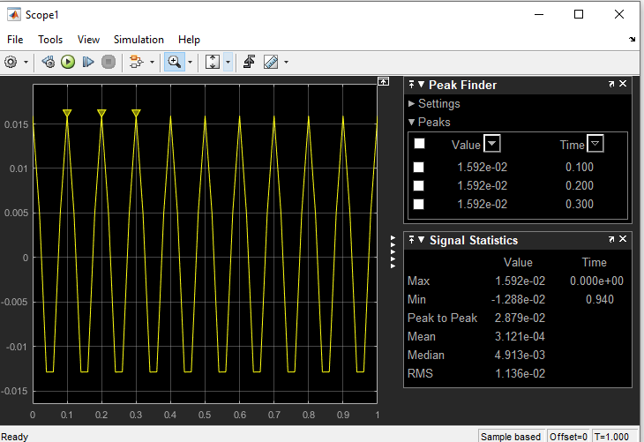
Observations: It is noticed that when the signal of 5K ohms is passed through the filter, the signal is attenuated. The high frequency signal is blocked out while the low frequency signal passes through. This can be seen from the peak values of amplitude which dropped to 0.01592

When the signal of 2K ohms is passed through the filter the following results are obtained:

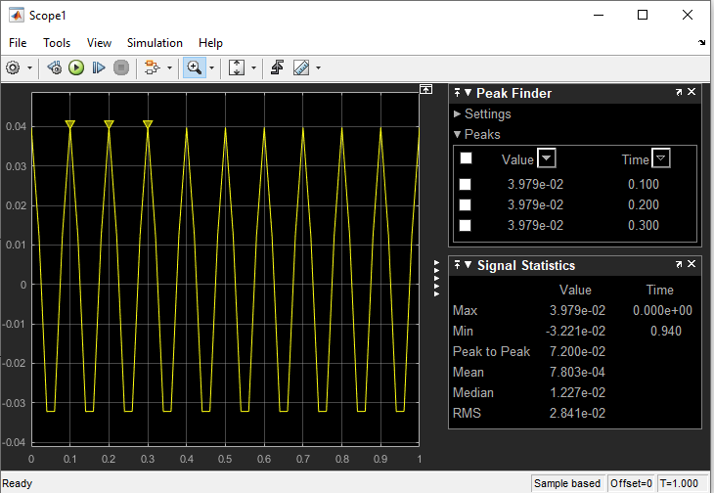

Observations: : It is also seen that when the signal of 2K ohms is passed through the filter, the signal is attenuated. The high frequency signal is blocked out while the low frequency signal passes through. This can be seen from the peak values of amplitude which dropped to 0.03979

