- The ten sectors composed in the Francis Rowell model used for financial planning sales forecasting are
1) Industry sales
2) Production sector
3) Fixed capital stock requirements
4) Pricing
5) Production costs
6) Income
7) New financing required
8) Risks
9) Costs of financing and
10) Common stock valuation
2. Macro forecasting is concerned with forecasting markets in total. This is about determining the existing level of market demand and considering what will happen to market demand in the future.
Micro forecasting is concerned with detailed unit sales forecasts. This is about determining a product’s market share in a particular industry and considering what will happen to that market share in the future.
3. i) Time horizon
ii) Data availability
iii) Type of product
iv) The time horizon that the sales forecast is intended to cover
v) The position of the product in its life cycle
4. i) The first stage in creating the sales forecast is to estimate market demand for a product that is estimating the total volume that would be bought by a defined customer group, in a defined geographical area, in a defined time period, in a given marketing environment.
ii) The second stage in the forecast is to estimate company demand.
iii) The third stage is then to develop the Sales Forecast.
5. Sales forecasting is the process of estimating future sales.
6. Demand is the various quantities of a given commodity or service which consumers would buy in one market in a given period of time at various prices, or at various incomes, or at various prices of related goods.
7. Market demand analysis helps the manager to make decisions regarding: (a) sales forecasting with a sound basis and greater accuracy: (b) guidelines for demand manipulation through advertising and sales promotion programmes; (c) production planning and product improvement: (d) pricing
policy; (e) determination of sales quotas and performance appraisal of personnel in the sales department; and (f) size of market for a given product and corresponding market share.
8. Law of Demand
Law of Demand states that people will buy more at lower prices and buy less at higher prices, if other things remaining the same.
Characteristics of law of demand
• Inverse relationship between price and demand.
• Price is independent variable
• Demand is dependent variable on price of goods.
9. i) Individual demand
Ii) Market demand
iii) Derived demand
10. i) Giffen goods
ii) Commodities which are used as status symbols
iii) Expectations regarding future prices
iv) Emergency
v) Quality-price relationship
11. Fixed Cost
The much we produce the goods, fixed cost will not change, it will be constant (not change). If we close the production also fixed cost must be faced by the firm.
eg: (Rent, salaries, Interest on capital) these are to paid by the firm, if there is production are not.
Illustration:-
Cost schedule table
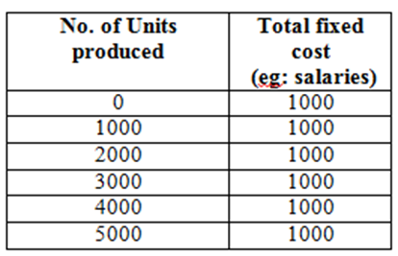
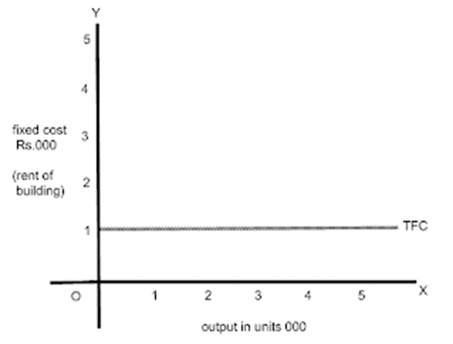
Ii) Average fixed cost
Fixed cost spends towards single unit of output or production is called Average fixed cost.
Total fixed cost (Rent) TFC = 1000/-
No. of units produced TQ = 1000
The more he produces, per unit cost will be decreased {per unit cost of fixed cost is average fixed cost}
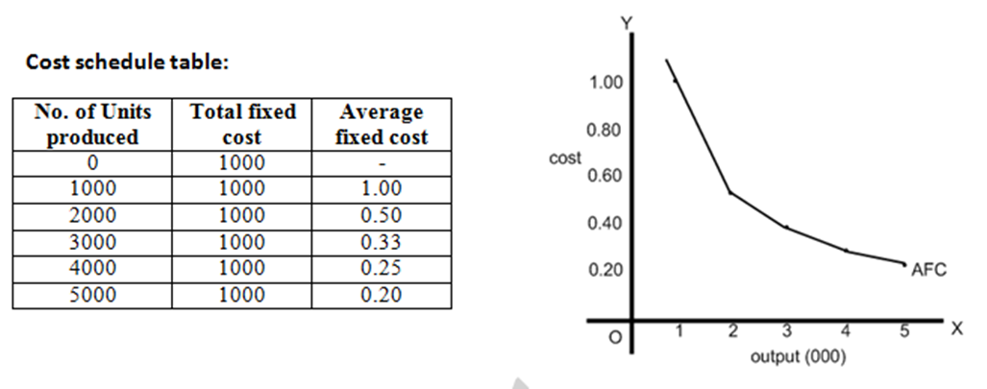
iii) Variable Cost
The cost which rises with increase in production and decreases with fall in production is called variable cost. Variable cost incur for total goods produced is called total variable cost.Eg: Raw materials, power, fuel and labour. The more the firm produces the goods the firm should incur more.
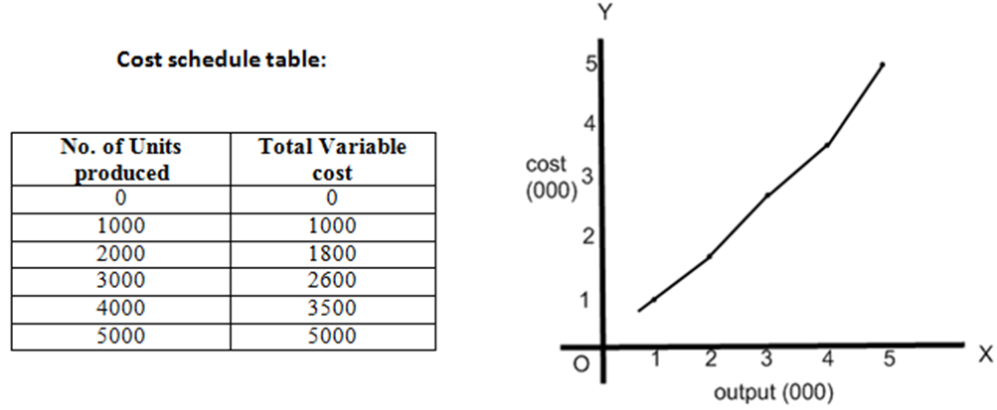
12. I) Land: Land is that factor of production which is freely available from nature. In it, not only on the surface of soil is included, but also all other free gifts of the nature below the surface and above the surface are included; for example, forests, minerals, fertility of soil, water, etc. According to Marshall, "Land means the material and the forces which nature gives freely for man's aid, in land and water, in air, light and heat." Land is also called a natural resource.
ii) Labour: Labour is a human factor of production. In it all those mental and physical activities of man are included which are performed in order to earn money. The services of a carpenter, black-smith, weaver, teacher, lawyer and doctor, etc., are called labour.
iii) Capital: Capital is that man-made factor of production which is used for more production. Factors like machines, tools, raw materials, buildings, railways, factories, etc., are called capital. The saving of a man when invested to earn will also be called capital
iv) Organization and enterprise : Entrepreneurs usually invest their own capital in a business and take on risks. Their main reward is the profit made from running the business.

