**300 LEVEL**

**ENG 342**

* They are used to eliminate noise
* **They are used in radio tuning to a specific frequency:**

An example of filter used is the radio frequency filter. They are used so that only the right kind of frequencies can be entertained while filtering out other unwanted bands of frequencies. it is most frequently used in equipment’s such as radio, wireless communications, and televisions etc.

* **They are used in pre-amplification, equalization, tone control in audio systems:**

This is the adjusting of the balance between frequency components within an electronic signal.

* **They are extensively used in medical electronic systems:**

Medical devices are increasingly using sensitive analogue electronics, wireless technologies and microprocessors. When medical devices receive strong electromagnetic waves, unwanted electric currents can be induced in the circuits and cause unintended operations and most circuits often operate at lower voltages and are easily affected by noise and this is where electromagnetic interference filters are introduced

* **They are used in signal processing circuits and data processing:**

Filters are used to separate signals that have been combined and also restoration of signals that have been distorted in some way and it helps to analyze data better.

b) 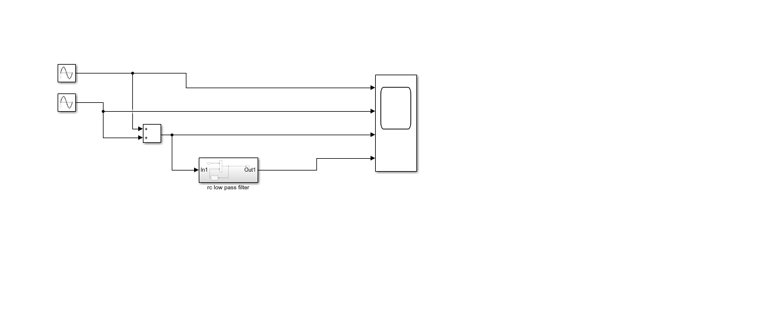

**Figure 1: low pass filter design**

c) Cut off frequency

Fc = ½ pi* R*C

R=0.005ohms

C=0.01F

Fc = `1/2*pi*0.005*0.01

Fc = 3183.098Hz

D) amplitude-50

Step size – 0.00005

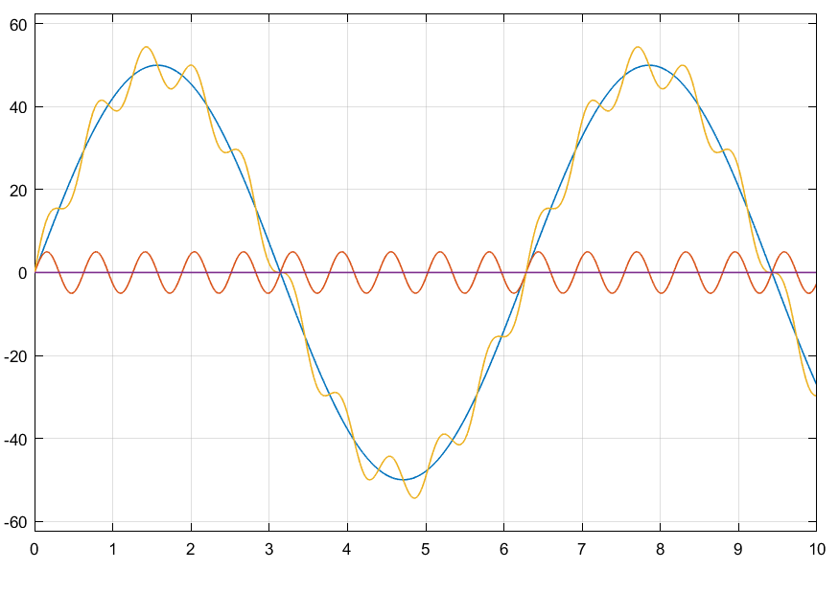

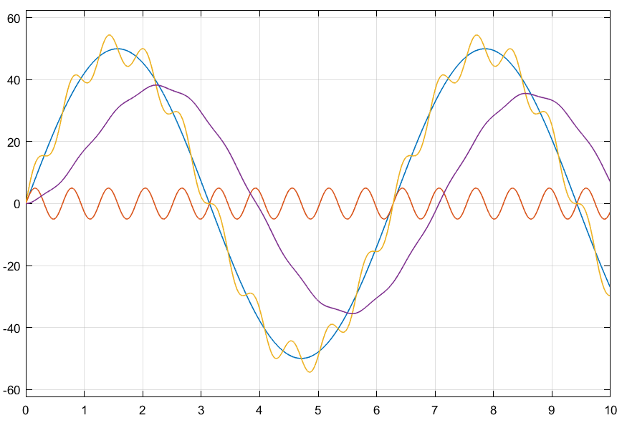

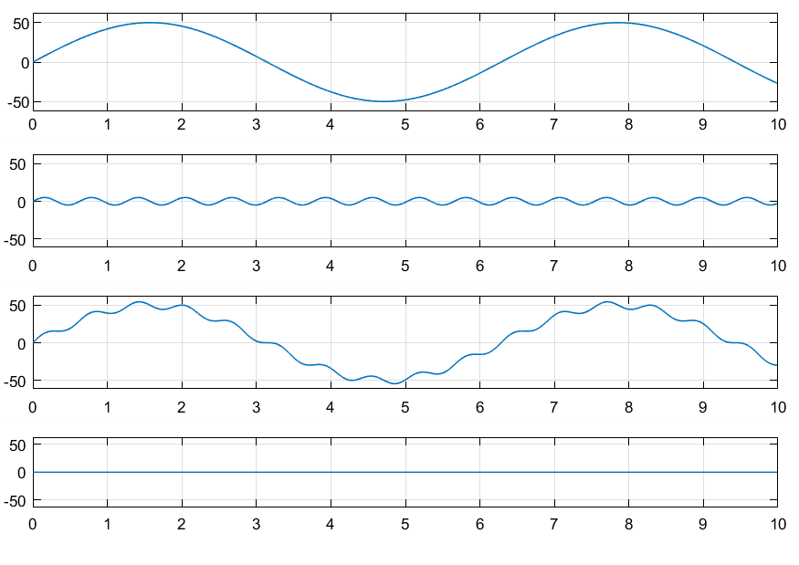

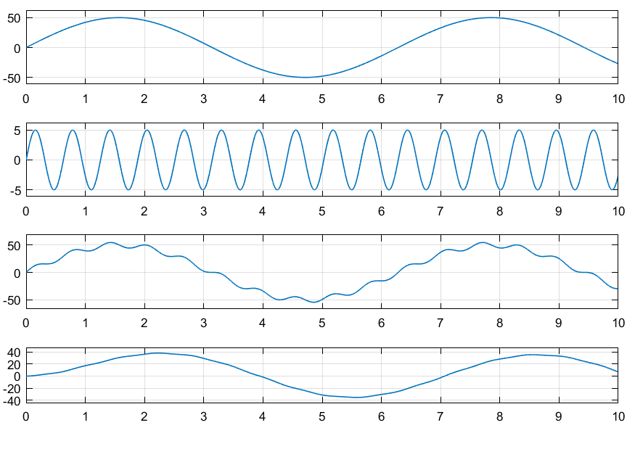

**Figure 2: output**