NAME: EZEOBIDI CLEMENTINA ONYINYECHUKWU
MATRIC NUMBER : 17/ ENG04/027
DEPARTMENT : ELECTRICAL AND ELECTRONICS ENGINEERING
COURSE : SOFT WARE DEVELOPMENT AND APPLICATION ( EEE 342)
Class work

QUESTION A

- Noise suppression: They are used in communication systems for noise removal from the received signals.
- Radio communications : in communication, Filters enable radio receivers to only "see" the desired signal while rejecting all other signals (assuming that the other signals have different frequency content).
- DC power supplies: Filters are used to eliminate undesired high frequencies (i.e., noise) that are present on AC input lines. Additionally, filters are used on a power supply's output to reduce ripple.

- Audio electronics: A crossover network is a network of filters used to channel low-frequency audio to woofers, mid-range frequencies to midrange speakers, and high-frequency sounds to tweeters

- Analog-to-digital conversion: Filters are placed in front of an ADC input to minimize aliasing.

QUESTION B
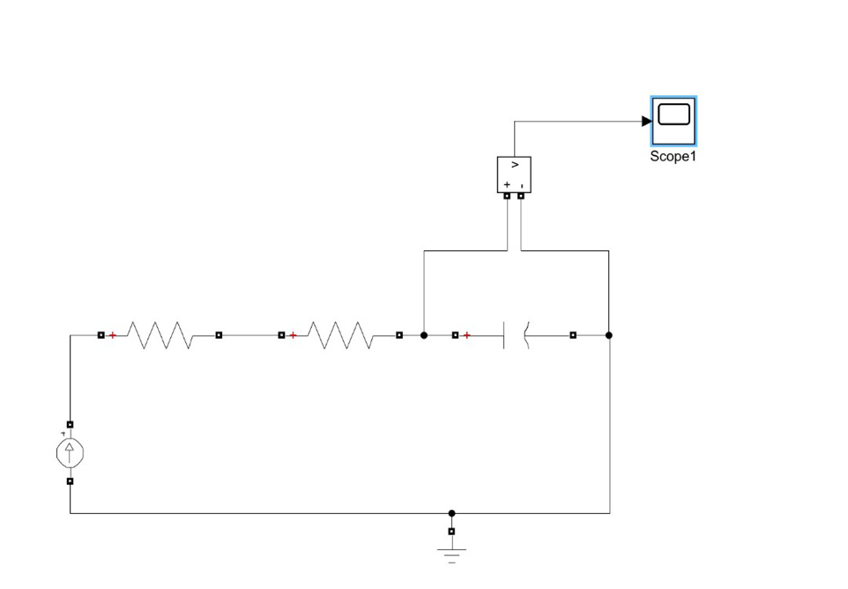

QUESTION C
Given that : R = 0.005 ohms , C =0.01F
Using : 1/ (2* pi* R*C) Recall: pi = 3.1415
Hence W_{c} = 1/(2*3.1415*0.005*0.01)
W_{c} = 3183.098 Hz

QUESTION D
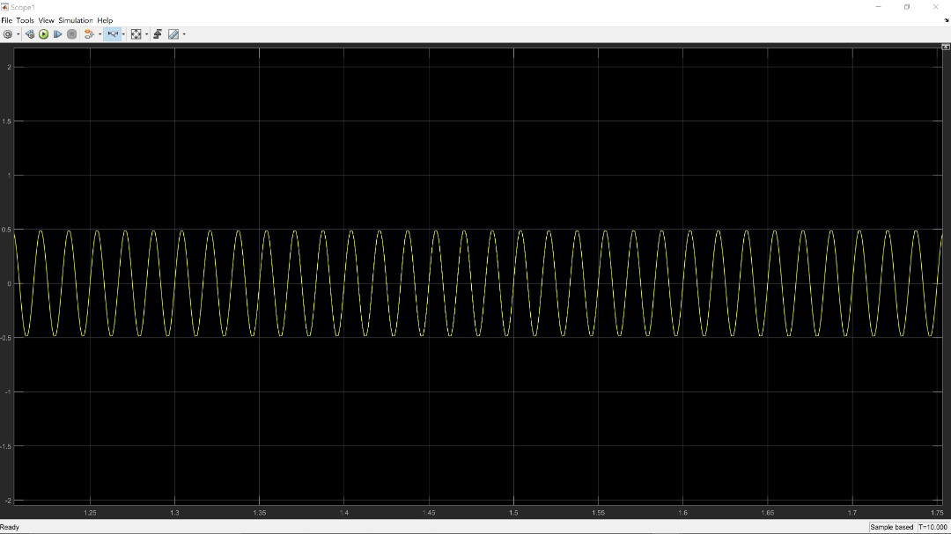

QUESTION E
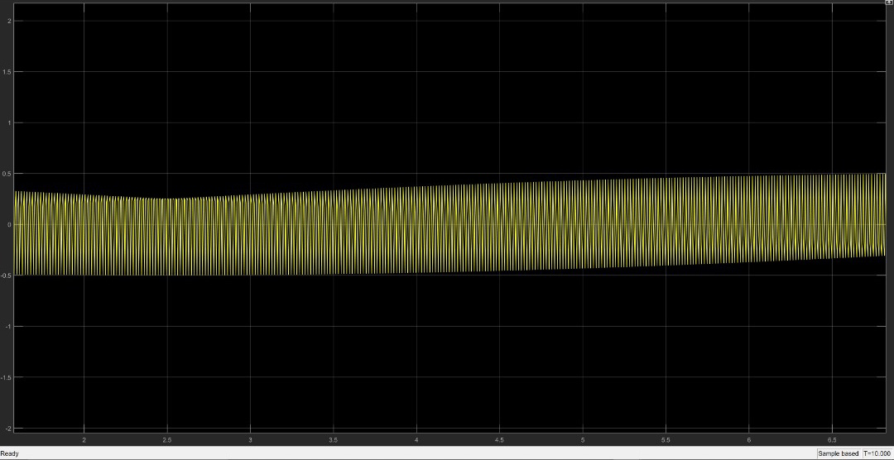
i

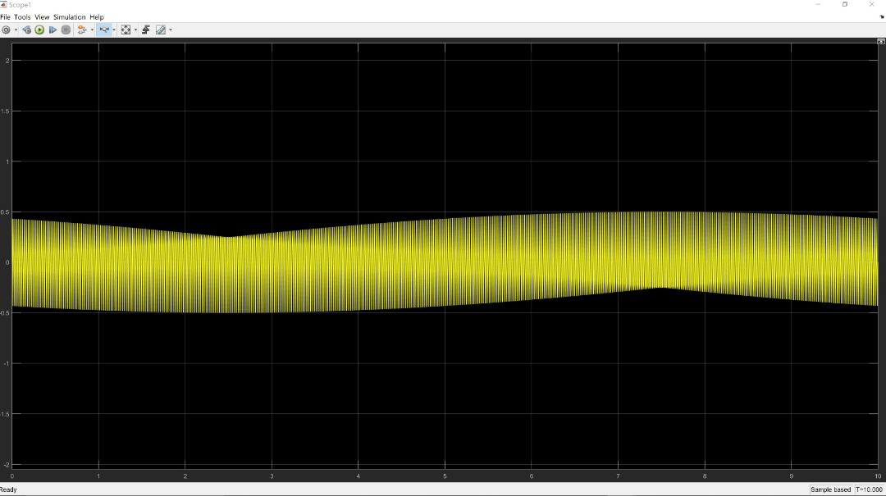
ii

Observation :
- It was observed in figure i, the waveform tends to be constant at 0.5 voltage within the time of 6 to 6.6 seconds and the waveform tends to be constants at -0.5 within the time of 0 to 3.5 seconds
ii. The peak of the sign wave is at its lowest at time = 2.5 seconds In figure I ( signal of 5k ohms )

iii. In figure ii, the peak is at its lowest at time = 25 and the negative peak is at its highest at time = 7.5

