Didam lorreta ZUGWAI
17/eng06/021
Mechanical Engineering
A.What is the Role of a Mechanical Fitter?
A mechanical Fitter is responsible for fitting and assembling parts made from metal and other materials to make production machinery. They can work in various industries, for example, the Auto industry.

Mechanical fitting

Is a field of mechanical engineering that deals with the maintenance of machines, a key aspect is to understand the interchangeability of mechanical parts

Fitters & Turners maintain and repair many different kinds of machines. Fitters and Turners are highly skilled craftspeople who manufacture, construct, assemble and fit components for machinery. If you consider yourself good with metal and repairing parts, then a career as a Fitting & Turner may be just for you!

Pipefitters attach pipes to walls, structures, and fixtures, such as radiators or tanks, using brackets, clamps, tools or welding equipment. This trade is also used in mining and also in construction

B. Designing a Low-Pass Filter with 0.005Ω resistor and 0.01F capacitor
A 100V Amplitude was selected with a frequency of 1Hz for the Sine Wave Source.
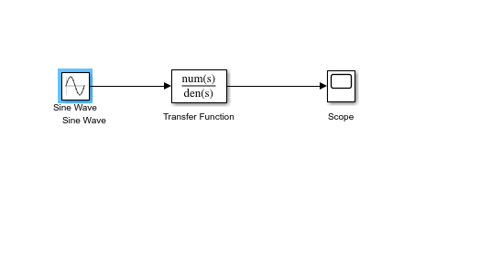

C. Determining the Cut-off frequency
The cut-off frequency is calculated by F= ½*(pi*R*C)
When R= 0.005Ω and C= 0.01F
F= 0.5*pi*0.005*0.01=3189.099 Hz

D. Design Output
The transfer function equation for the circuit is given as
(1/RC)/(S + 1/RC)
When R= 0.005Ω and C= 0.01F
Transfer Fcn=(1/0.005*0.01)/(S + (0.005*0.01))= (20000)/(s+ 20000)

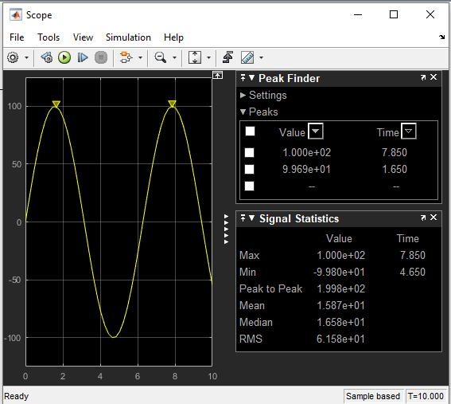

- If two signals of 5 KΩ and 2 KΩ are pass through the filter at different intervals. Discuss your observation
When the signal of 5 KΩ is passed through the filter, the following result is obtained:
The transfer function equation for the circuit is given as
(1/RC)/(S + 1/RC)
When R= 5000Ω and C= 0.01F
Transfer Fcn=(1/5000*0.01)/(S + (5000*0.01))= (0.02)/(s+ 0.02)

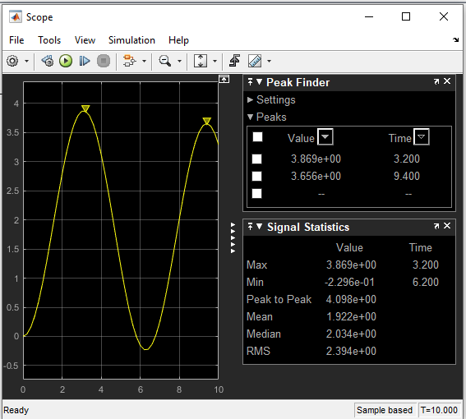
Observations: The signal is attenuated to 3.869 ohms

When the signal of 2K ohms is passed through the filter the following results are obtained: The transfer function equation for the circuit is given as
(1/RC)/(S + 1/RC)
When R= 2000Ω and C= 0.01F
Transfer Fcn=(1/2000*0.01)/(S + (2000*0.01))= (0.05)/(s+ 0.05)

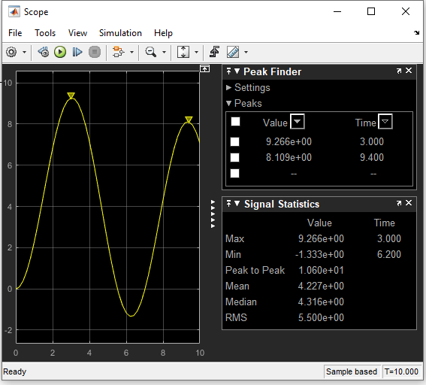

Observations: The signal is attenuated to 9.266 ohms

