- Radio Communication
Filters enable radio receivers to only "see" the desired signal while rejecting all other signals (assuming the other signals have different frequency content).

- DC power supplies
Filters are used to eliminate undesired high frequencies (i.e., noise) that are present on AC input lines. Additionally, filters are used on a power supply's output to reduce ripple.

- Audio electronics
A crossover network is a network of filters used to channel low-frequency audio to woofers, mid-range frequencies to midrange speakers, and high-frequency sounds to tweeters.
- Used in Audio Applications for Equalization purposes.

- Used in Receivers such as Super-heterodyne etc for efficient reception of the baseband signals.

- Designing a Low-Pass Filter with 0.005Ω resistor and 0.01F capacitor
A 100V Amplitude was selected with a frequency of 1Hz for the Sine Wave Source.

- Determining the Cut-off frequency
The cut-off frequency is calculated by F= ½*(pi*R*C)
When R= 0.005Ω and C= 0.01F
F= 0.5*pi*0.005*0.01=3189.099 Hz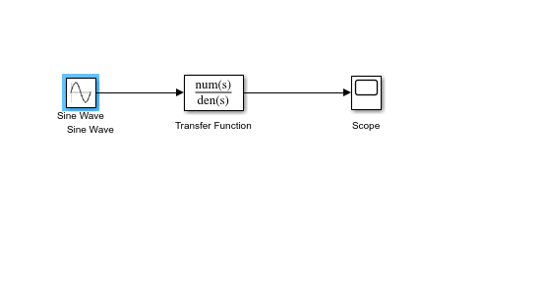

- Design Output
The transfer function equation for the circuit is given as
(1/RC)/(S + 1/RC)
When R= 0.005Ω and C= 0.01F
Transfer Fcn = (1/0.005*0.01)/ (S + (0.005*0.01))= (20000)/(s+ 20000)

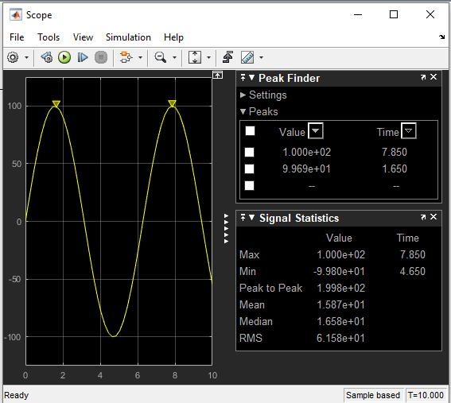

- If two signals of 5 KΩ and 2 KΩ are pass through the filter at different intervals. Discuss your observation
When the signal of 5 KΩ is passed through the filter, the following result is obtained:
The transfer function equation for the circuit is given as
(1/RC)/ (S + 1/RC)
When R= 5000Ω and C= 0.01F
Transfer Fcn= (1/5000*0.01)/ (S + (5000*0.01)) = (0.02)/ (s+ 0.02)

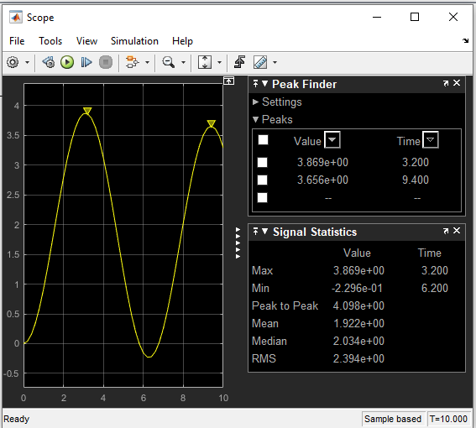
Observation: The signal is attenuated to 3.869 ohms

When the signal of 2K ohms is passed through the filter the following are obtained results: The transfer function equation for the circuit is given as
(1/RC)/ (S + 1/RC)
When R= 2000Ω and C= 0.01F
Transfer Fcn= (1/2000*0.01)/ (S + (2000*0.01)) = (0.05)/ (s+ 0.05)

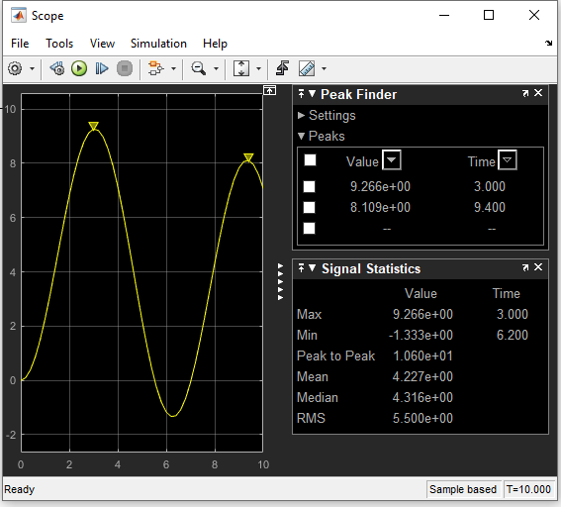

Observation: The signal is attenuated to 9.266 ohms

