NAME: UGAH UCHE CHUKWUNENYE
MATRIC NO: 17/ENG04/071
DEPARTMENT:ELECTRICAL ELECTRONICS
ENG 342

- Active filters are used in communication systems for suppressing noise, to isolate a communication of signal from various channels to improve the unique message signal from a modulated signal
- These filters are used in instrumentation systems by the designers to choose a required frequency apparatus and detach unwanted ones.
- These filters can be used to limit the analog signal’s bandwidth before altering them to digital signals.
- Analog filters are used in audio systems by engineers to send various frequencies to various speakers. For example, in the music industry, record & playback applications are needed to control the frequency components.
- Active filters are used in biomedical instruments to interface psychological Sensors with diagnostic equipments & data logging.
- They are used in signal processing circuits and data processing:
Filters are used to separate signals that have been combined and also restoration of signals that have been distorted in some way and it helps to analyze data better.
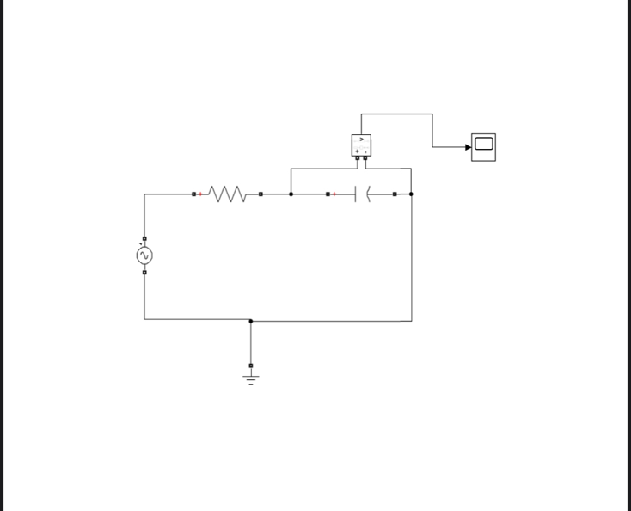
b) 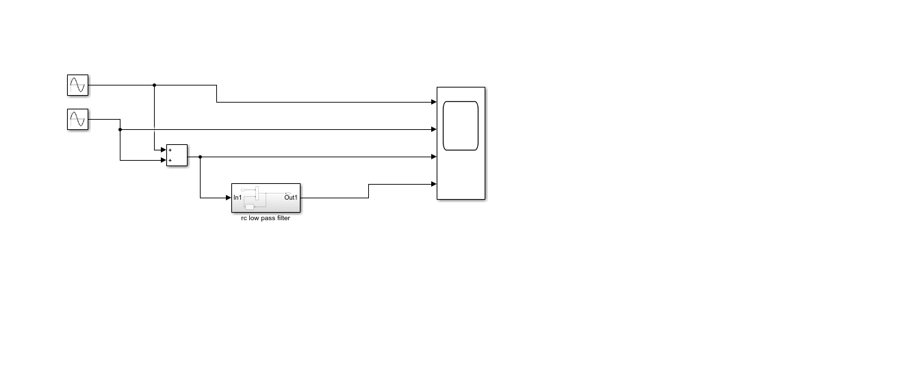

The low pass filter design

c) Cut off frequency
Fc = ½ pi* R*C
R=0.005ohms
C=0.01F
Fc = `1/2*pi*0.005*0.01
Fc = 3183.098Hz

D) amplitude-50
Step size – 0.00005

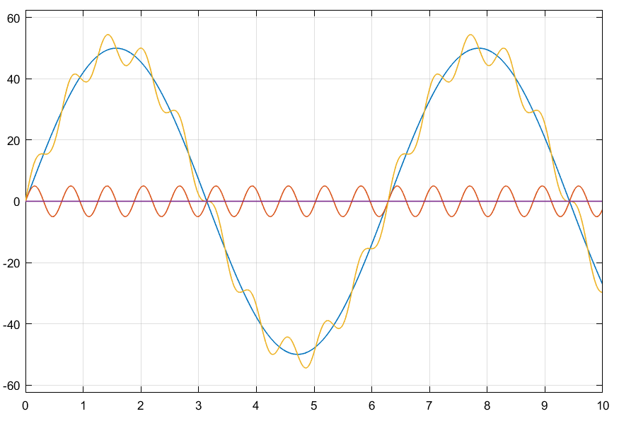

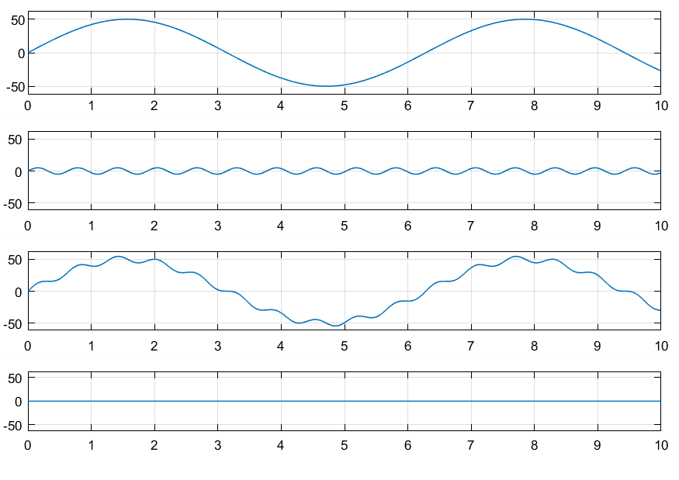
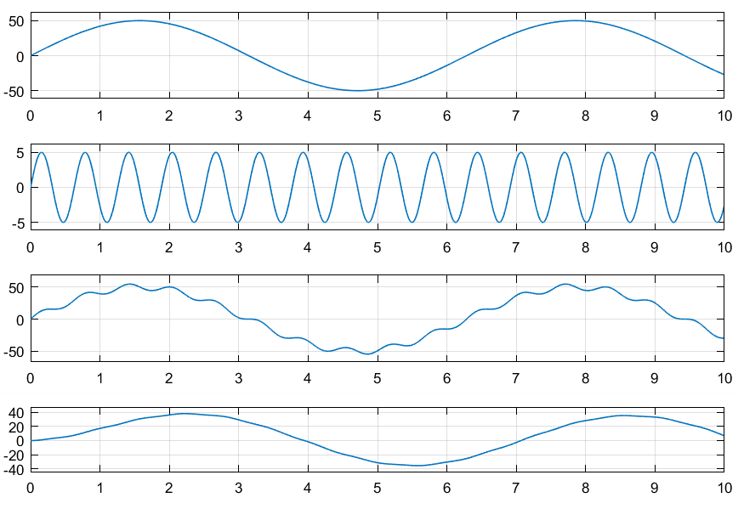
The output

E) When the signal of 5 KΩ is passed through the filter, the following result is obtained:
The transfer function equation for the circuit is given as
(1/RC)/(S + 1/RC)
When R= 5000Ω and C= 0.01F
Transfer Fcn=(1/5000*0.01)/(S + (5000*0.01))= (0.02)/(s+ 0.02)
It was observed that the signal attenuated to 3.869ohms

When the signal of 2K ohms is passed through the filter the following results are obtained: The transfer function equation for the circuit is given as
(1/RC)/(S + 1/RC)
When R= 2000Ω and C= 0.01F
Transfer Fcn=(1/2000*0.01)/(S + (2000*0.01))= (0.05)/(s+ 0.05)
It was observed that the Signal attenuated to 9.266ohms

