NAME: Iyamah Osemudiamen Nathaniel
MATRIC NO: 17/eng06/048
DEPARTMENT: Mechanical Engineering

A.
- DC power supplies: Filters are used to eliminate undesired high frequencies (i.e., noise) that are present on AC input lines. Additionally, filters are used on a power supply's output to reduce ripple.

- Radio Communications: Filters enable radio receivers to only "see" the desired signal while rejecting all other signals (assuming the other signals have different frequency content).

- Audio electronics: A crossover network is a network of filters used to channel low-frequency audio to woofers, mid-range frequencies to midrange speakers, and high-frequency sounds to tweeters.
- Used for Equalizing in Audio Application.

- Used in Receivers for efficient reception of the baseband signals.

B. Designing a Low-Pass Filter with 0.005Ω resistor and 0.01F capacitor
A 100V Amplitude was selected with a frequency of 1Hz for the Sine Wave Source.
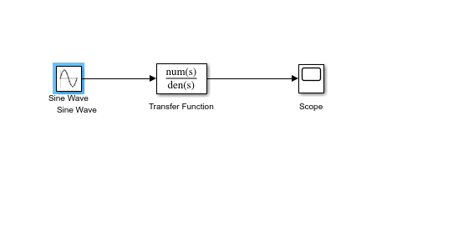

C. Determining the Cut-off frequency
The cut-off frequency is; F= ½*(pi*R*C)
When R= 0.005Ω and
C= 0.01F
F= 0.5*pi*0.005*0.01=3189.099 Hz

D. Design Output
The transfer function equation for the circuit is given as
(1/RC)/(S + 1/RC)
When R= 0.005Ω and
C= 0.01F
Transfer Fcn=(1/0.005*0.01)/(S + (0.005*0.01))
= (20000)/(s+ 20000)

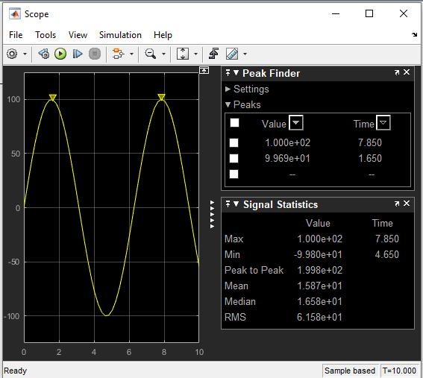

- If two signals of 5 KΩ and 2 KΩ are pass through the filter at different intervals. Discuss your observation
When the signal of 5 KΩ is passed through the filter, the following result is obtained:
The transfer function equation for the circuit is given as
(1/RC)/(S + 1/RC)
When R= 5000Ω and C= 0.01F
Transfer Fcn=(1/5000*0.01)/(S + (5000*0.01))= (0.02)/(s+ 0.02)

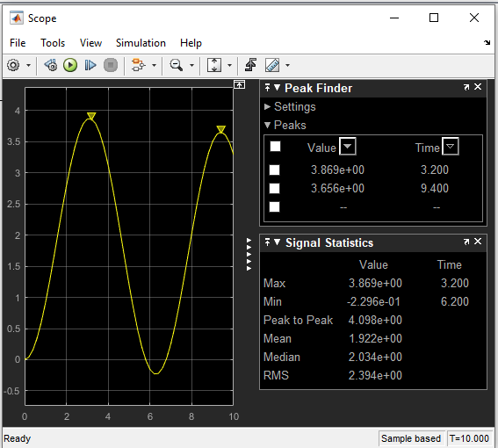
Observations: The signal is attenuated to 3.869 ohms

When the signal of 2K ohms is passed through the filter the following results are obtained: The transfer function equation for the circuit is given as
(1/RC)/(S + 1/RC)
When R= 2000Ω and
C= 0.01F
Transfer Fcn=(1/2000*0.01)/(S + (2000*0.01))= (0.05)/(s+ 0.05)

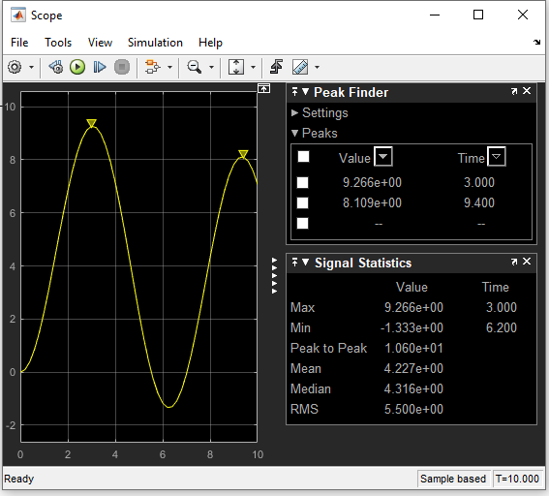

Observations: The signal is attenuated to 9.266 ohms

