Questions 10marks
Filters are important components in electronics system as seen in communication devices, speech and signal processing.
- Discuss the benefits of filters in engineering system.
- Design a low pass filter of 0.005Ω and 0.01F using building blocks only; you are free to determine your amplitude value.
- Determine the cut-off frequency
- Simulate the design and show the output using a display unit
- If two signals of 5 KΩ and 2 KΩ are pass through the filter at different intervals. Discuss your observation(s).
Deliverables:
PDF report of the solutions showing in details the step by step of your design, results and observations
Deadline: 11.59pm (7th May, 2020)
Answers
1. Audio electronics: Audio electronics is the implementation of electronic circuit designs to perform conversions of sound/pressure wave signals to electrical signals, or vice versa.
- The audio filters are the electronic circuits which are designed to amplify or attenuate certain range of frequency components. Which helps in eliminating the unwanted noise from the audio signal and improving the tone of the output audio.
- DC power supplies: Filters are used to eliminate undesired high frequencies (i.e., noise) that are present on AC input lines. Additionally, filters are used on a power supply's output to reduce ripple.
- Radio Communications: RF filters are used to remove or accept signals that fall in certain areas of the radio spectrum. There are many different instances where they can be used .They are used within transmitters to ensure that unwanted signals are not transmitted
- Used in Receivers for efficient reception of the baseband signals
- .Used in Audio Applications for Equalization purposes.

B Designing a Low-Pass Filter with 0.005Ω resistor and 0.01F capacitor
A 100V Amplitude was selected with a frequency of 1Hz for the Sine Wave Source.
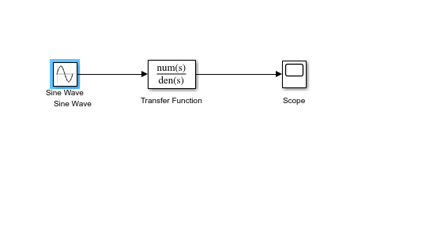

C. Determining the Cut-off frequency
The cut-off frequency is calculated by F= ½*(pi*R*C)
When R= 0.005Ω and C= 0.01F
F= 0.5*pi*0.005*0.01=3189.099 Hz

D. Design Output
The transfer function is:
(1/RC)/(S + 1/RC)
When R= 0.005Ω and C= 0.01F
Transfer Fcn=(1/0.005*0.01)/(S + (0.005*0.01))= (20000)/(s+ 20000)

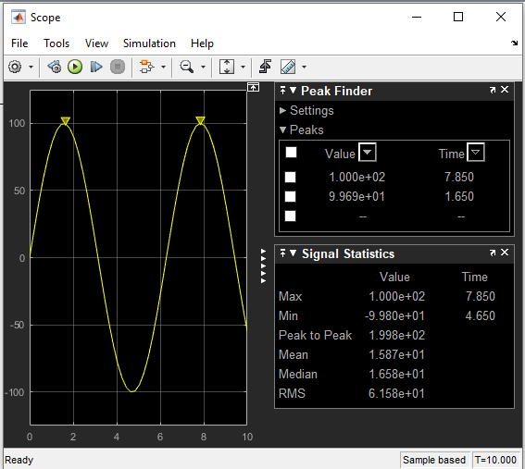

- If two signals of 5 KΩ and 2 KΩ are pass through the filter at different intervals. Discuss your observation
When the signal of 5 KΩ is passed through the filter, the following result is obtained:
The transfer function equation for the circuit is given as
(1/RC)/(S + 1/RC)
When R= 5000Ω and C= 0.01F
Transfer Fcn=(1/5000*0.01)/(S + (5000*0.01))= (0.02)/(s+ 0.02)

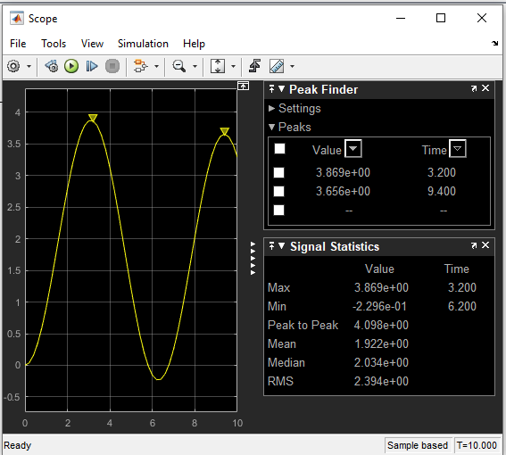
Observations: The signal is attenuated to 3.869 ohms

When the signal of 2K ohms is passed through the filter the following results are obtained: The transfer function equation for the circuit is given as
(1/RC)/(S + 1/RC)
When R= 2000Ω and C= 0.01F
Transfer Fcn=(1/2000*0.01)/(S + (2000*0.01))= (0.05)/(s+ 0.05)

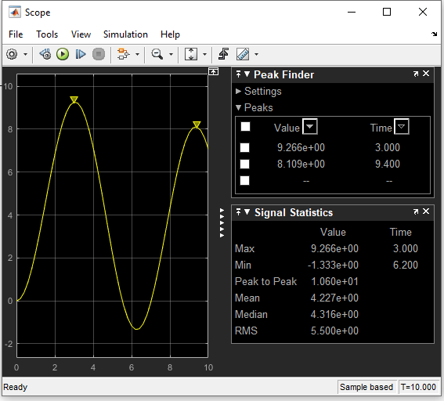

Observations: The signal is attenuated to 9.266 ohms

