NAME: NWAGWUAGWUTOCHUKWU DAISY
MATRIC NUMBER: 17/ENG04/043
DEPARTMENT: ELECTRICAL ELCTRONICS ENGINEERING
COURSE: EEE 342

A. Filters have been an important cpomponent of electrical engineering evolution. They rae instrumental to various technological advancement and thus its important to study their theory ,construction and design. A filter is a circuit designed to pass signals pr allow signals within dsome desired frequency range and reject attenuate others.
Some appliocations of filters in the engineering systems are:
- Filter Circuits are used to eliminate background Noise
- They are used in Radio tuning to a specific frequency
- Used in Pre-amplification, Equalization, Tone Control in Audio Systems
- They are also used in Signal Processing Circuits and Data Conversion
- Filter Circuits are extensively used in Medical Electronic Systems

B. Using a capacitor of 0.01F, resistor of 0.005ohms ,frequency of 60hz and amplitude of 100v

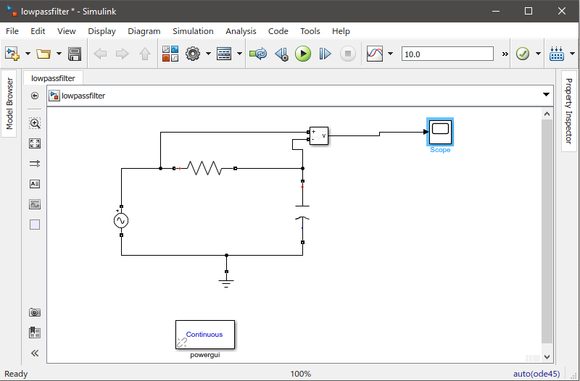

C. cut off frequency
Cut off frequency, F=$1/2$*(PI*R*C)
WHEN R=0.005ohms and C=0.01F
F=0.5*pi*0.005*0.01= 3189.099Hz

D. The ouput after simulation

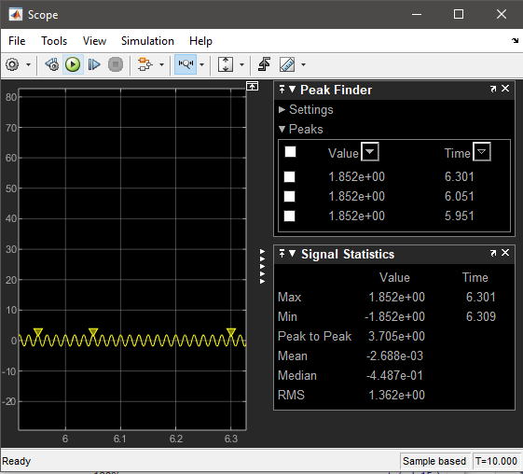

E. If signal 5kiloohms pass through
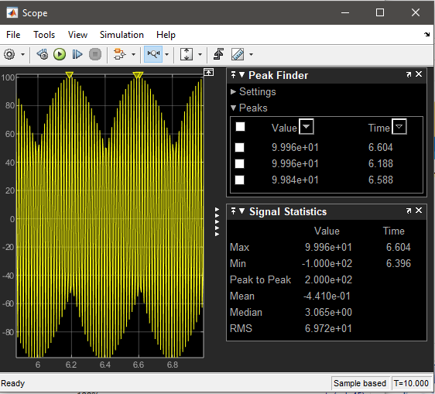
Observation:the signal is attenuated to 9.996e+01 ohms

If signal 2kiloohms is passed through
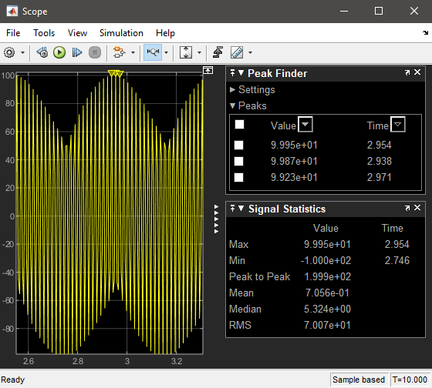
OBSERVATION: A signal of 9.995e+01 ohms was attenuated.

