NAME: AKUMA SUNNY
MATRIC NO: 17/ENG04/009
DEPARTMENT: ELECTRICAL/ELECTRONICS ENGINEERING
COURSE CODE: ENG 342
Classwork
A.) Discuss the benefits of filters in engineering system
Answer: Some benefits of filters in engineering systems include;
The tuner in radio: The bandpass filter in the tuner of the radio allows a fixed frequency to the output speaker.
Treble & bass of the speaker: The bass has lower frequencies & treble has higher frequencies. They are separated using high pass & low pass filter and are separately routed to corresponding bass speaker & treble speaker for clear music.
Anti-Aliasing: it is a low pass filter that filters out the high-frequency components from a signal before sampling. It prevents the aliasing component form being sampled.
Notch Filter: they are band rejects filters with a narrow bandwidth that filter out any interfering signal.
Power Supply Smoothing: The output of the power supply which is a rectifier has an AC ripple in it. These frequencies are filtered out using a low pass filter which results in smoothing the output signal.
Noise suppression: They are used in communication systems for noise removal from the received signals.

B.) Design a low pass filter of 0.005Ω and 0.01F using building blocks only; you are free to determine your amplitude value.
Answer: A 100V Amplitude was selected with a frequency of 1Hz for the Sine Wave Source.
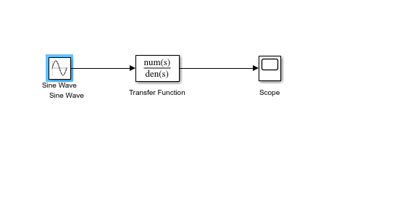

C.) Determine the cut-off frequency
Answer: The cut-off frequency is calculated by F= ½*(pi*R*C)
When R= 0.005Ω and C= 0.01F
F= 0.5*pi*0.005*0.01=3189.099 Hz

D.) Determine the cut-off frequency
Answer: The transfer function equation for the circuit is given as
(1/RC)/(S + 1/RC)
When R= 0.005Ω and C= 0.01F
Transfer Fcn=(1/0.005*0.01)/(S + (0.005*0.01))= (20000)/(s+ 20000)

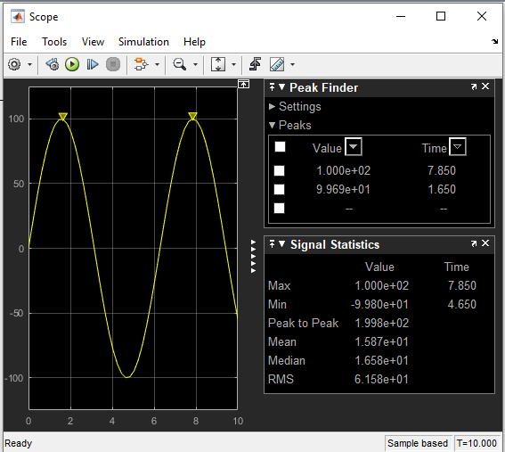
E.) If two signals of 5 KΩ and 2 KΩ are pass through the filter at different intervals. Discuss your observation(s
Answer: When the signal of 5 KΩ is passed through the filter, the following result is obtained:
The transfer function equation for the circuit is given as
(1/RC)/(S + 1/RC)
When R= 5000Ω and C= 0.01F
Transfer Fcn=(1/5000*0.01)/(S + (5000*0.01))= (0.02)/(s+ 0.02)

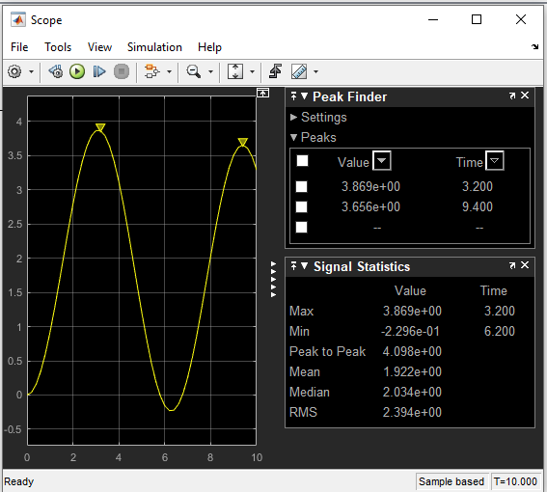
Observations: The signal is attenuated to 3.869 ohms

When the signal of 2K ohms is passed through the filter the following results are obtained: The transfer function equation for the circuit is given as
(1/RC)/(S + 1/RC)
When R= 2000Ω and C= 0.01F
Transfer Fcn=(1/2000*0.01)/(S + (2000*0.01))= (0.05)/(s+ 0.05)

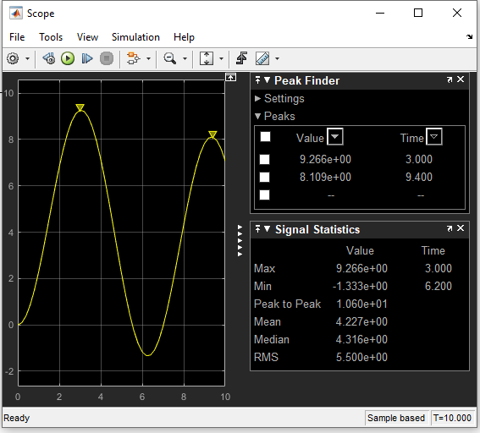

Observations: The signal is attenuated to 9.266 ohms

