NAME: YAKUBU NATHAN BALA
MATRIC. NO: 17/ENG04/076
DEPARTMENT: ELECT/ELECT
CLASSWORK 1

- Benefits of filters in engineering systems:
Filters are the essential building blocks of any Electronic and Communication Systems that alter the amplitude or phase characteristics of a signal with respect to frequency.
- Filters are basically linear circuits that help to remove unwanted components such as Noise, Interference and Distortion from the input signal.
- They are economical or cost-effective Unlike passive filter circuits.
- They are used to separate signals that have been combined and also restoration of signals that have been distorted in some way and it helps to analyze data better.
- Also, they are used so that only the right kind of frequencies can be entertained while filtering out other unwanted bands of frequencies. It is most frequently used in equipment’s such as radio, wireless communications, and televisions etc.

- Design of a low pass filter with 0.005Ω and 0.1F with building blocks only:

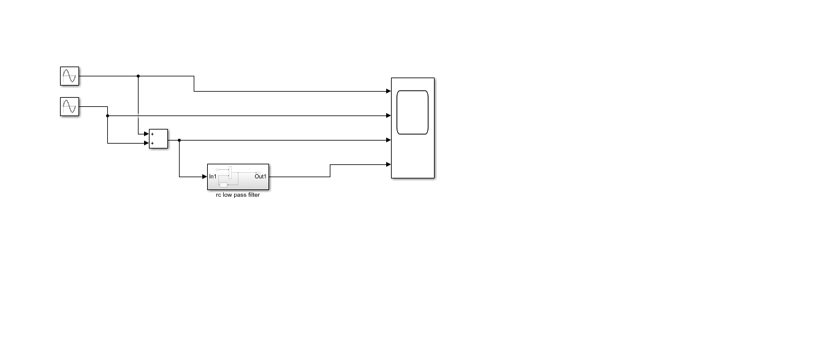
- The cut-off frequency:
Fc = ½ pi* R*C
R=0.005ohms
C=0.01F
Fc = `1/2*pi*0.005*0.01
Fc = 3183.098Hz
- The simulated design output:
With amplitude=50
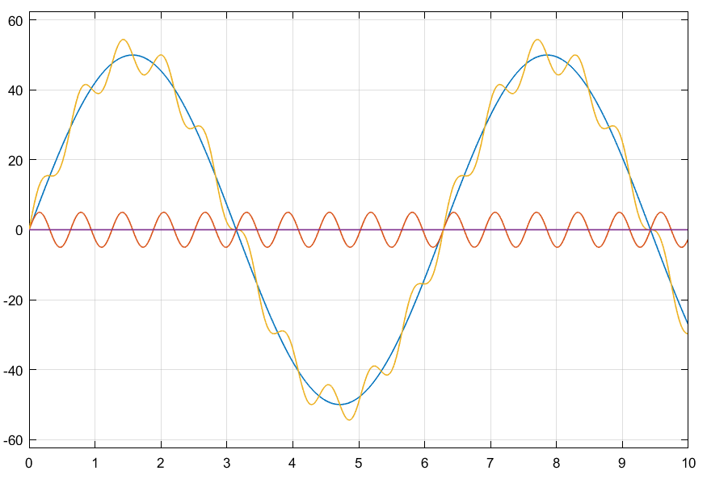
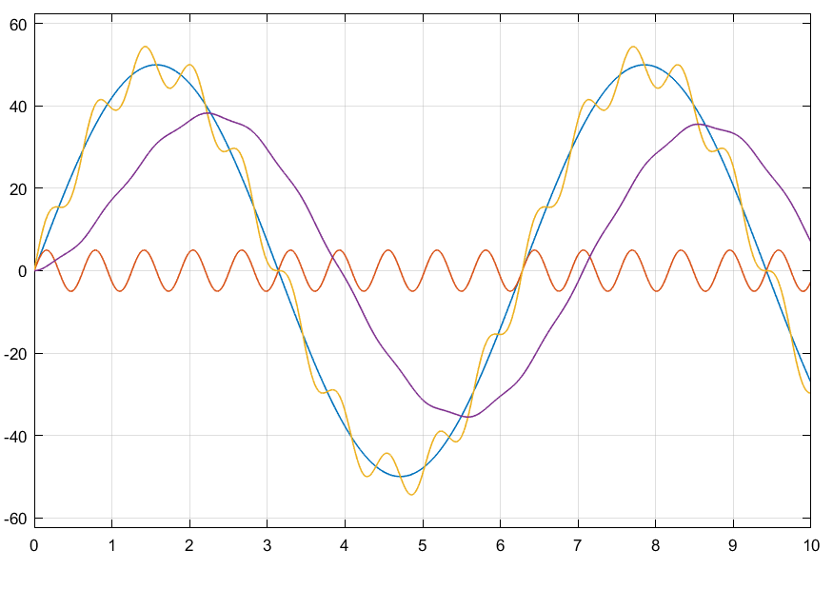
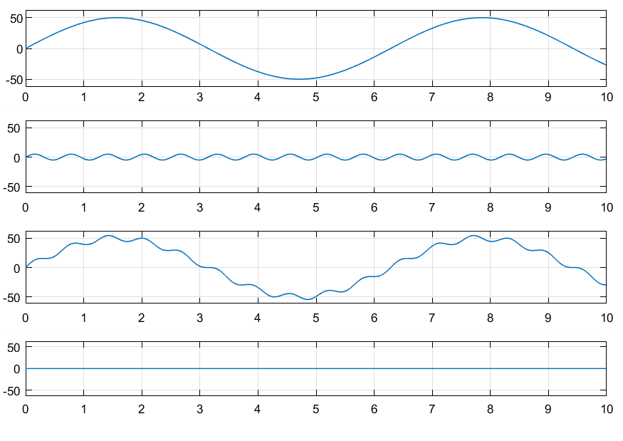
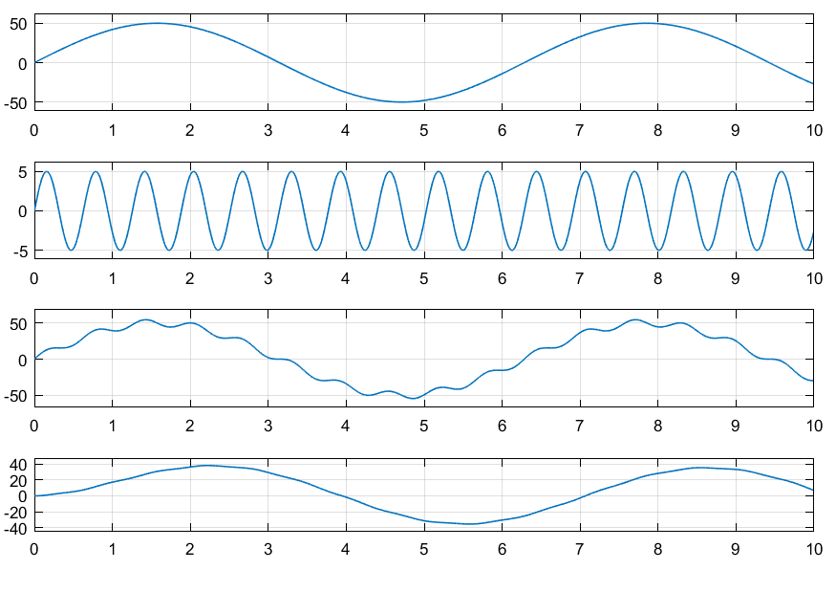
- Observations:

