NAME: USMAN MUSTAPHA A.
DEPT: MECHANICAL
MATRIC NO: 17/ENG06/087
ASSIGNMENT NO 1

Question:
- Discuss the benefits of filters in engineering system.
Ans:
- Electronic filters remove unwanted frequency components from the applied signal enhance wanted ones, or both.
- They are used to eliminate noise.
- They are used in pre-amplification, equalization, tone control in audio systems:
This is the adjusting of the balance between frequency components within an electronic signal.
- They are extensively used in medical electronic systems:
Medical devices are increasingly using sensitive analogue electronics, wireless technologies and microprocessors. When medical devices receive strong electromagnetic waves, unwanted electric currents can be induced in the circuits and cause unintended operations and most circuits often operate at lower voltages and are easily affected by noise and this is where electromagnetic interference filters are introduced
- They are used in signal processing circuits and data processing:
Filters are used to separate signals that have been combined and also restoration of signals that have been distorted in some way and it helps to analyze data better.

Question:
- Design a low pass filter of 0.005Ω and 0.01F using building blocks only; you are free to determine your amplitude value.
Ans:
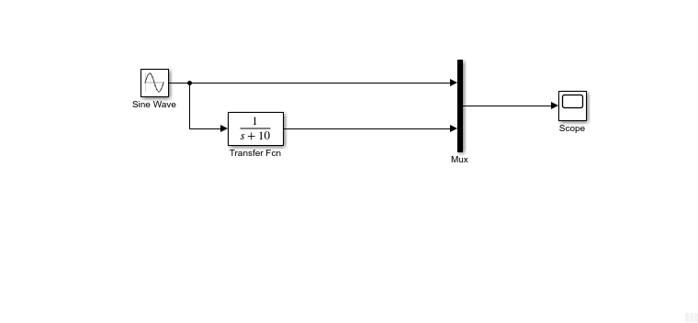
Figure 1: SIMULINK BLOCKS

Question:
- Determine the cut-off frequency
Ans:
Cut off frequency
Fc = ½ pi* R*C
R=0.005ohms
C=0.01F
Fc = `1/2*pi*0.005*0.01
Fc = 3183.098Hz
Question:
- Simulate the design and show the output using a display unit
Ans: Amplitude = 20
