NAME: MBA CHIAMAKA ABALI
MATRIC NO: 18/MHS01/209
DEPARTMENT: MEDICINE and SURGERY
COLLEGE: MEDICINE AND HEALTH SCIENCE
COURSE: GENERAL EMBRYOLOGY 1
ASSIGNMENT

DISCUSS THE SECOND WEEK OF DEVELOPMENT
Events that take place during the second week of development are:
- Completion of implantation of the blastocyst
- Formation of bilaminar embryonic disc( epiblast and hypoblast)
- Formation of extraembryonic structures( amniotic cavity, amnion, umbilical vesicle( yolk sac), connecting stalk

DAY 8 :
At the 8th day of development, the blastocyst is partially(slowly) embedded in the endometrium. The syncytiotrophoblast continues its invasion of the endometrium, thereby avoiding endometrial blood vessels and endometrial glands. More cells in the cytotrophoblast divide and migrate into the syncytiotrophoblast where they fuse and lose their individual cell membrane.
CELLS OF THE INNER CELL MASS OR EMBRYOBLAST ALSO DIFFERENTIATE INTO 2;
- The hypoblast layer, which is made up of small cuboidal cells and it is adjacent(nearer) to the blastocyst cavity
- The epiblast layer which is made up of high columnar cells and it adjacent to the amniotic cavity
The hypoblast and epiblast layers together form a flat ovoid shaped disc called the BILAMINAR EMBRYONIC DISC

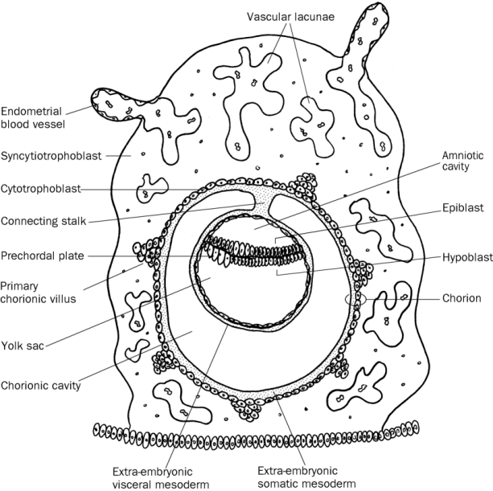
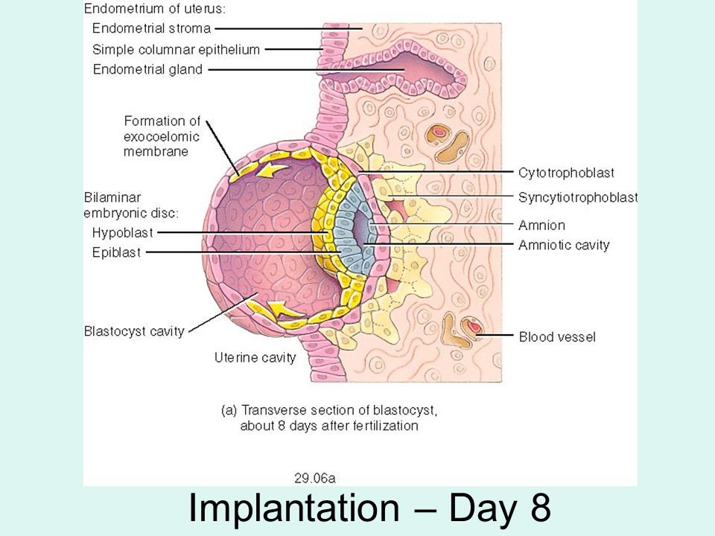

DAY 9:
The blastocyst is more deeply embedded in the endometrium and the penetration defect in the surface epithelium is closed by a coagulum called FIBRIN. Vacuoles appear at the region of the trophpoblast and they fuse to form layer lacunae. This phase of trophoblast development is known as the LACUNAR STAGE.
The cells of the hypoblast adjacent to the cytotrophoblast form a thin membrane called the EXOCOELOMIC(Heuser’s) membrane which lines the inner surface of the cytotrophoblast. The EXOCOELOMIC (Heuser’s) membrane together with the hypoblast forms the lining of the exocoelomic cavity or primitive yolk sac or primary umbilical vesicle.
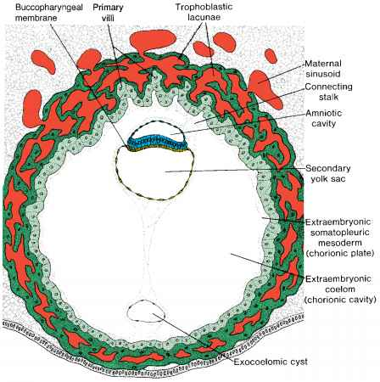

Day 11-12:
- The blastocyst is completely embedded in the endometrium and the surface epithelium almost covers the original defect in the uterine wall.
- The blastocyst now produces a sight protrusion into the lumen of the uterus.
- Cells of the syncytiotrophoblast penetrate deeper into the stroma{tissue} and erode the endothelial lining of the endometrial capillaries.
- Sinusoids are ruptured endometrial capillaries.
- The lacunae then begin to communicate with the sinusoids and maternal blood enters the lacunar system.
- The communication of the sinusoids with the lacunae establishes the primordial uteroplacental circulation.
- When material blood flows into the lacunae, oxygen and nutritive substances are available to the embryo.
- A new population of cells appears between the inner surface of the cytotrophoblastand the outer surface of the exocoe lomic cavity.
- These cells with are derived from yolk sac cells from fine, loose connective tissue called the extra embryonic mesoderm.
- Large cavities row develop in the extraembryonic mesoderm, and when these become confluent, they form a new spice known as the extraembryonic cavity or chronic cavity or extraembryonic coelom.
- The chronic cavity or extraembryonic coelom surrounds the primitive yolk sac and amniotic cavity except where the germ disc is connected to the trophoblast by the connecting stalk {which develops into the umbilical cord}.
- The extraembryonic mesoderm lining the cytotrophoblast and amnion is called the extraembryonic somatic mesoderm which also forms the connecting stalk.
- Extraembryonic splanchnic mesoderm is the lining covering the yolk sac.
- As the conceptus implants, the endometrial connective tissue cells undergo a transformation called decidual reaction.
- Decidualcells are the cells of the endometrium that swell because of the accumulation of glycogen and lipid in their cytoplasm.
- The primary function of the decidual reaction is to provide nutrition for the early embryo and an immunologically privileged site for the concepts.

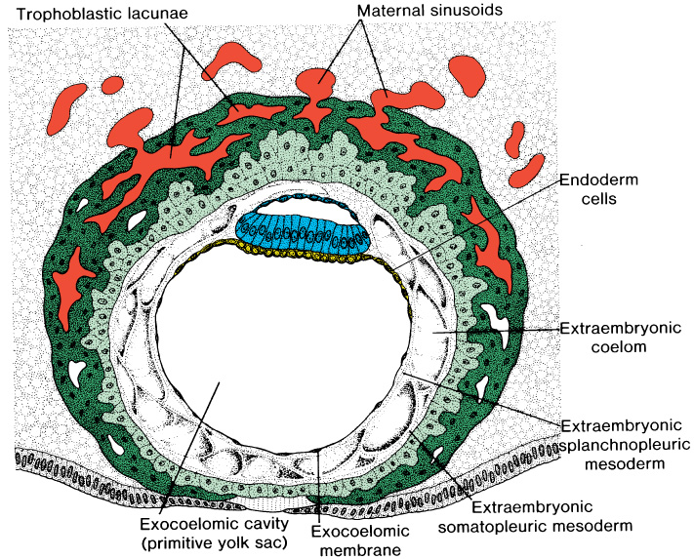

DAY 13:
- The surface defect on the endometrium has been completely covered by the surface epithelium.
- Occasionally bleeding occurs at the implantation site as a result of increased blood flow into the lacunar spaces.
- Cells of the cytotrophoblast proliferate locally and penetrate into syncytiotrophoblast, forming cellular columns surrounded by syncytium.
- Cellular columns with the syncytial covering are known as primary will.
- Secondary yolk sac occur when the primary yok sac reduces in size.
- It is known as secondary yolk sac or definitive yolk sac or secondary umbilical vesicle.
- In humans the yolk sac contains no yolk but it is important for the transfer of nutrients between the fetus and mother.
- During the formation of the yolk sac large portions of the exocoelomic cavity are pinched off to form exocoelomic cysts.
- This yolk sac is much smaller than the original exocoelomic cavity or primitive yolk sac.
- Exocoelomic cysts are often found in theextraembryonic cavity or chronic cavity or extraembryonic coelom.
- Meanwhile, the extraembryonic coelom expands and form a large cavity called the chronic cavity.
- The extraembryonic mesoderm lining the inside of the cytotrophoblast is then known as the chorionic plate.
- The only place where extrembryonic mesoderm traverses the chorionic cavity is in the connecting stalk.
- With development of blood vessels, the connecting stalk becomes, the umbilical cord.

