NAME: BOLA-MATANMI AJIBOLA HASIAT
MATRIC NUMBER: 19/MHS01/121
DEPARTMENT: MBBS
COURSE: BIO102
- Importance of fungi to mankind:
-serve as food
-fungi are responsible for mediation of decay of of organic matter
-preparation of medicines
-for synthesis of enzymes
-serve as important biological control agents to some pests
2.
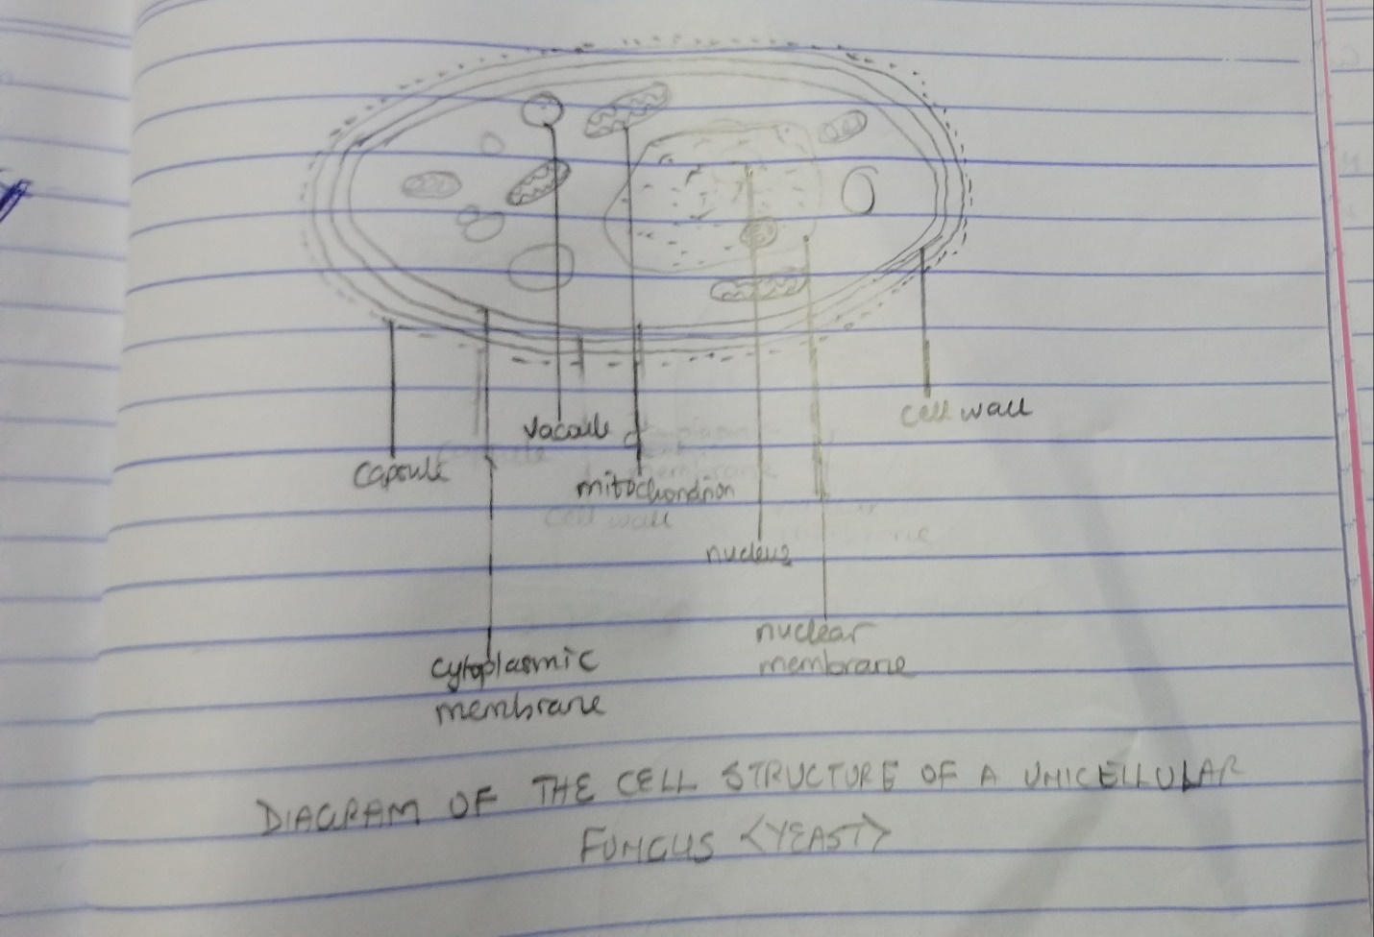
- Sexual Reproduction in a typical filamentous form of fungi:
Sexual reproduction in filamentous fungi occurs when two mating types of hyphae grow in the same medium. Chemical interaction in the two mating types of hyphae induces growths perpendicular to the hyphae in opposite directions. These growths are delimited by a wall such that many nuclei are isolated in a gametangium. The two gamentagia fuse in plasmogamy and a zygote is formed which may undergo prolonged dormancy. The nuclei in the zygotes fuse in twos and undergo meiosis independently. The zygote germinates under favourable conditions to produce a fruiting which at maturity liberates the haploid spores.
- Adaptation of Bryophytes to their environments:
- They have definite structures for water and nutrient absorption from the soil, therefore their body is divided into two (an aerial portion and a subterranean portion). The subterranean portion is the rhizoid and is not a true root.
- The aerial portion being exposed to the atmosphere demands some modifications that prevents excessive loss of water through the body surface.
- There are some other modifications that permit elimination of excess water from the plant body and not only exchange of gases between the internal parts of the plant and the atmosphere therefore openings are available on the aerial parts of the plant.
- Eusteles: a stele in which the vascular bundles are discrete, concentric collateral bundles of xylem and phloem.
Atactosteles: a stele in which the vascular bundles are scattered.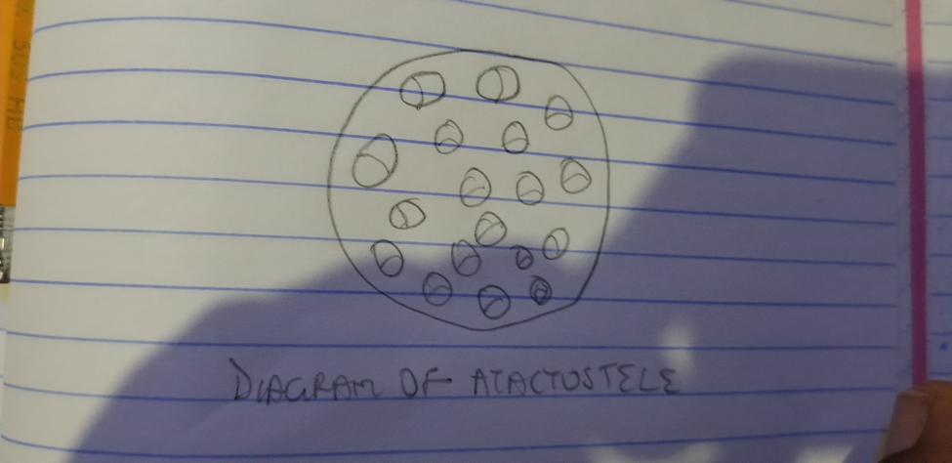

Siphonostele: a stele which is cylindrical enclosing a parenchymous pith.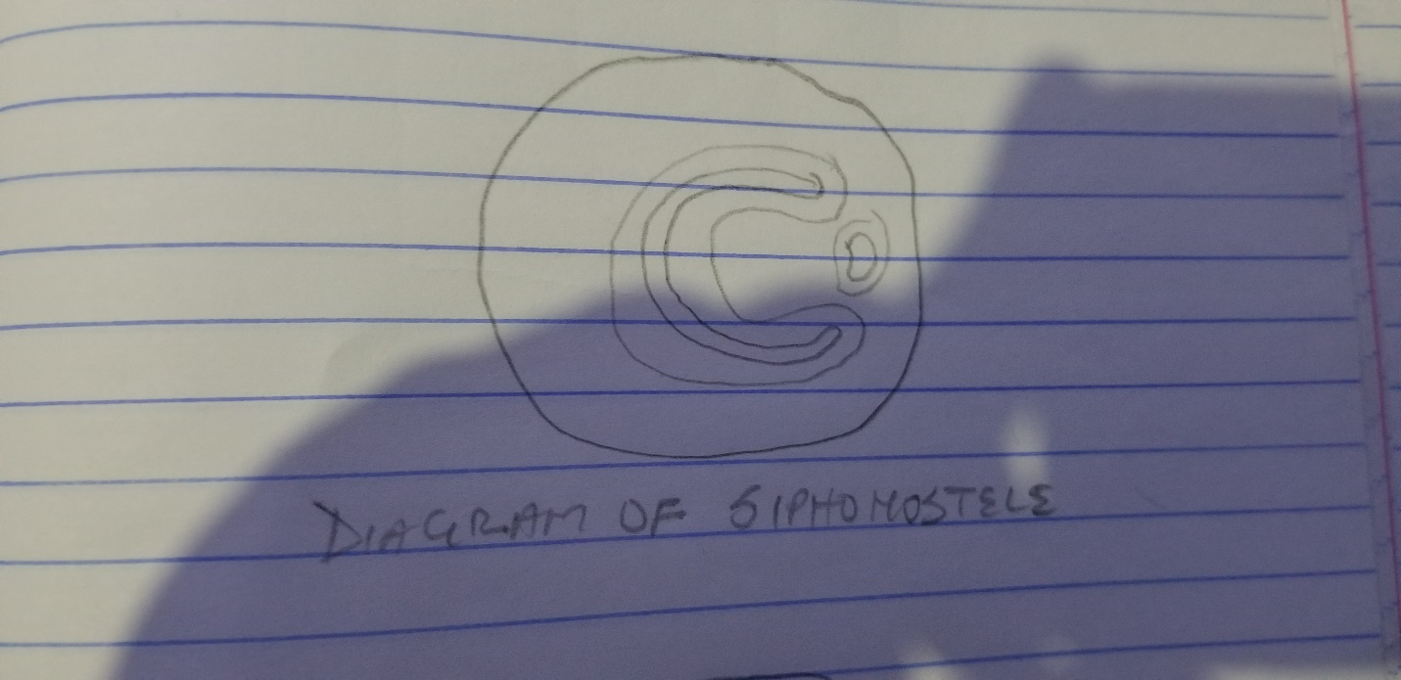
Dictyostele: a stele in which vascular supply to leaves is associated with leaf gaps and the conducting cylinder is a dissected one.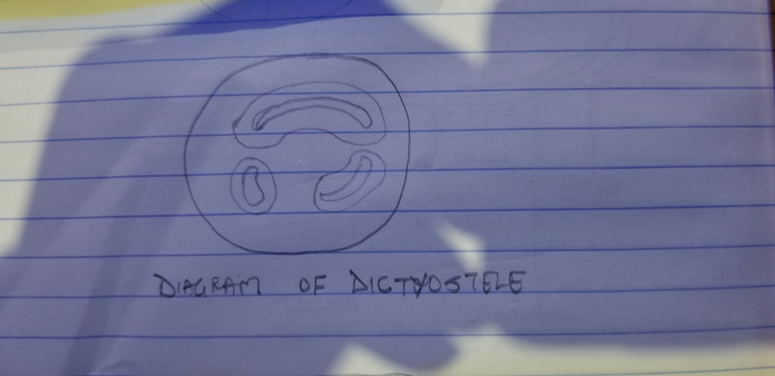
- Life cycle of a primitive vascular plant:
Psilotum is a very primitive vascular plant. The plant body has horizontal and vertical axes. It uses rhizoids to absorb water and mineral salts from the soil. In psilotum, three-lobed sporangia each subtended by two scales are borne on the vertical axis. The sporangium contains haploid spores and originates from diploid cells of the stem. Sporangium develops into a globose structure inside which sporangenous cells undergo meiosis to produce haploid spores. The short stalk of the sporangium has a trace connected to the stele of the vertical axis. After liberation, the spores germinate into cylindrical,dichotomously-branched gametophytes. At maturity, the terminal ends of the cylindrical branches bear the archegonia while the antheridia are borne as protuberances lower down on the branches. Sperms having many flagellates are released when antheridia are ripe which swim into the archegonia and the resulting zygote subsequently develops into a sporophyte.