NAME: TIAMIYU AISHA BOLAJI
COLLEGE: MHS
DEPARTMENT: PHARMACY
MATRIC NUMBER: 19/MHS11/136
COURSE CODE: BIO 102
- Fungi influence the well-being of human populations on a large scale because they are part of the nutrient cycle in ecosystem.
- Cell structure of a unicellulat fungus(yeast)
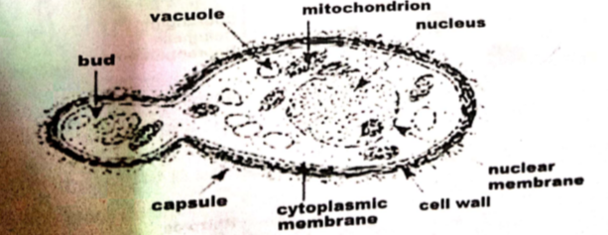
- Sexual reproduction occurs when two mating types of hyphae grow in the same medium. These growths are delimited by a wall such that many nuclei are isolated in a gametangium. The two gametangia fuse (plasmogamy) and a zygote is formed which may undergo prolonged dormancy or resting stage. The nuclei in the zygotes fuse in twos and undergo meiosis independently.
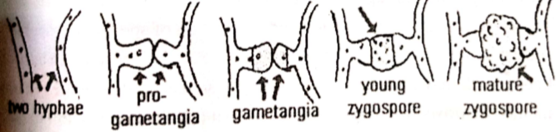
- a) They have definite structures for water and nutrient absorption from the soil.
b) The aerial portion being exposed to the atmosphere demands some modifications that prevent excessive loss of water through the body surface.
c) Some other modification that permit elimination of excess water from the plant body.
- a) Eusteles:

- Atactostele:Scaterred vascular bundles 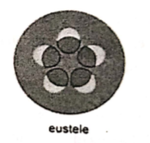
- Siphonostelle:
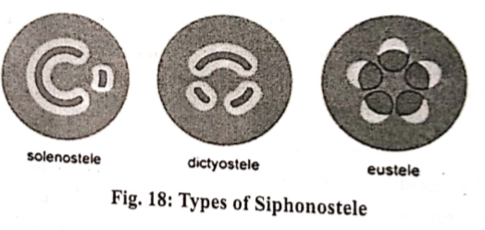
- Dictostele:
- LIFECYCLE OF A PRIMITIVE VASCULAR PLANT
