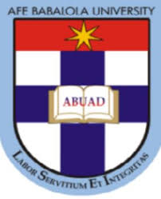
NAME : BELLO MOYONINUOLUWA ESTHER

MAT.NO : 19/MHS02/035

DEPT : NURSING

COURSE: CHM 102 [GENERAL CHEMISTRY II]

ASSIGNMENT: NEW ASSIGNMENT

1] CLASSIFICATION OF ALCOHOL

Primary alcohols
In a primary (1°) alcohol, the carbon atom that carries the -OH group is only attached to one alkyl group. Some examples of primary alcohols are shown below:
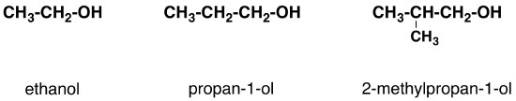
Notice that the complexity of the attached alkyl group is irrelevant. In each case there is only one linkage to an alkyl group from the CH₂ group holding the -OH group. There is an exception to this. Methanol, CH₃OH, is counted as a primary alcohol even though there are no alkyl groups attached to the the -OH carbon atom.

Secondary alcohols
In a secondary (2°) alcohol, the carbon atom with the -OH group attached is joined directly to two alkyl groups, which may be the same or different. Examples include the following:
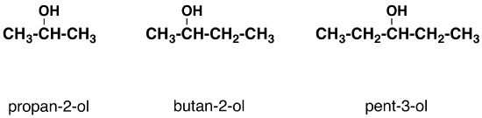

Tertiary alcohols
In a tertiary (3°) alcohol, the carbon atom holding the -OH group is attached directly to three alkyl groups, which may be any combination of the same or different groups. Examples of tertiary alcohols are given below:
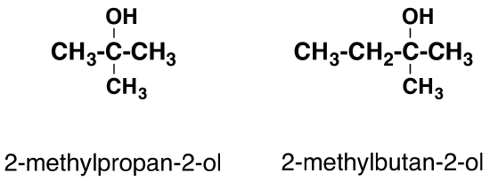
2] SOLUBILITY OF ALCOHOL IN WATER
At the molecular level, solubility is controlled by the energy balance of intermolecular forces between solute-solute, solvent-solvent and solute-solvent molecules. Recall from general chemistry that intermolecular forces come in different strengths ranging from very weak induced dipole – induced dipole interactions to much stronger dipole-dipole forces (including the important special case, hydrogen bonding). However there is a simple, very useful and practical empirical rule that is quite reliable. That simple rule is “like dissolves like” and it is based on the polarity of the systems i.e. polar molecules dissolve in polar solvents (e.g. water, alcohols) and non-polar molecules in non-polar solvents (e.g. the hydrocarbon hexane). This is why ionic compounds like table salt (sodium chloride) or compounds like sugar, dissolve in water but do not dissolve to any great extent in most organic solvents. It also applies to the separation of oil and water (e.g. in salad dressings). The polarity of organic molecules is determined by the presence of polar bonds1 due to electronegative atoms (e.g. N, O) in polar functional groups such as amines (-NH2) and alcohols (-OH).
3] THREE STEPS OF MANUFACTURING ETHANOL
There are essentially three methods used to produce ethanol;
-Manufacture from ethane using steam (the synthetic route)
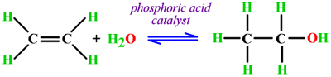
-Production from sugars and starches by fermentation, using yeasts
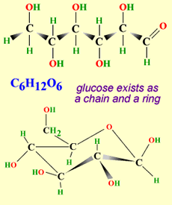
-Production from biomass waste, using bacteria.
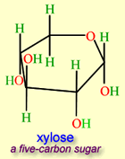

4] THE REACTION BETWEEN 2-METHYLPROPANAL AND BUTYL MAGNESIUM CHLORIDE
BUTYLMAGNESIUM CHLORIDE +2-METHYLPROPANAL
2C4CLMGH9 + 4C4H8O = 3C8H16O+2MGCL+H2O
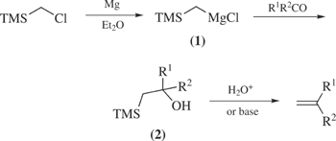
5] THE REACTION BETWEEN 2-METHYL PROPANONE AND BUTYLMAGNESIUMCHLORIDE
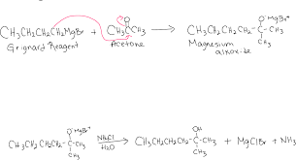
6] THE REDUCTION REACTION OF 2-METHYLPROPANONE

2 C₄H₁₀ + 13 O₂ → 10 H₂O + 8 CO₂
26 O⁰ + 52 e⁻ → 26 O^{-II} (reduction)
C₄H₁₀ is a reducing agent, O₂ is an oxidizing agent.

7] THE REDUCTION OF 2 METHYLPROPANAL

2 C₄H₈O (aq) + 11 O₂ (g) → 8 H₂O (l) + 8 CO₂ (g)
This is an oxidation-reduction (redox) reaction:
8 C^{-3/2} - 44 e⁻ → 8 C^{IV} (oxidation)
22 O⁰ + 44 e⁻ → 22 O^{-II} (reduction)
C₄H₈O is a reducing agent, O₂ is an oxidizing agent.
8] CONVERSION OF PROPAN-1-OL TO PROPAN-2-OL
