ADESINA OBAFEMI OLUWAFIKAYOMI
COMPUTER SCIENCE
19/SCI01/008
MAT 102 ASSIGNMENT

QUESTION 1
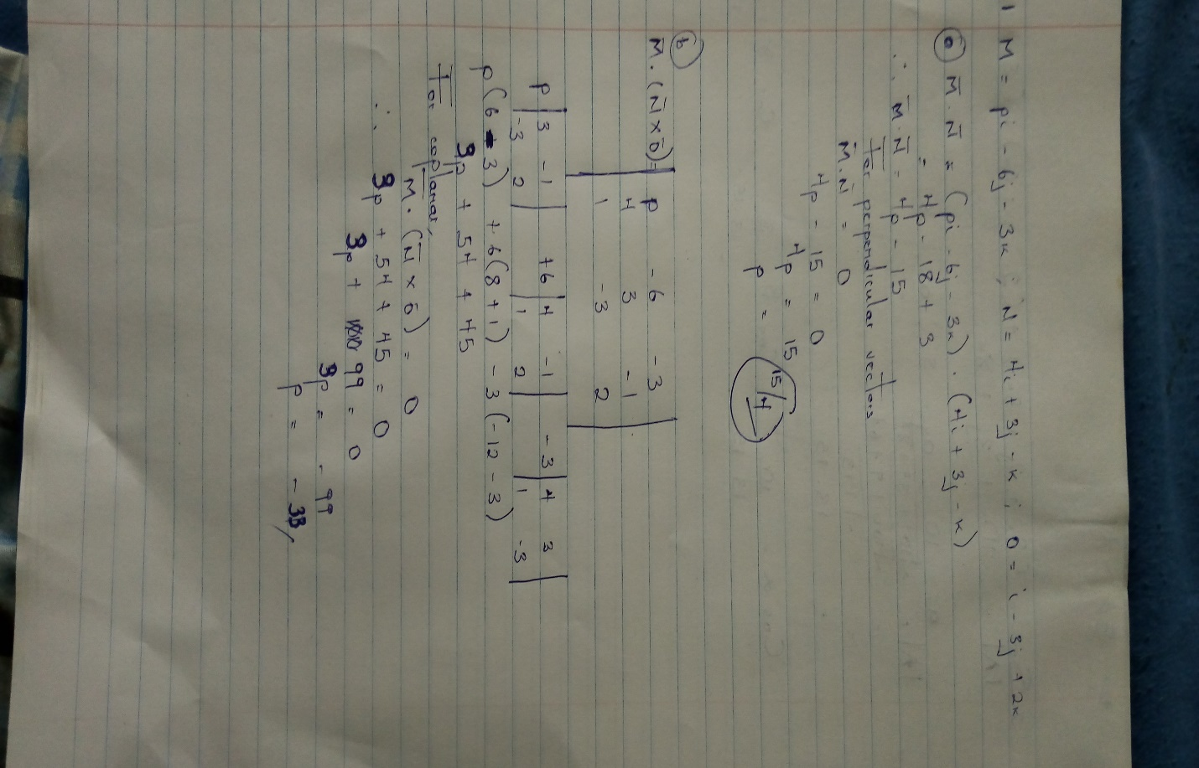

QUESTION 2
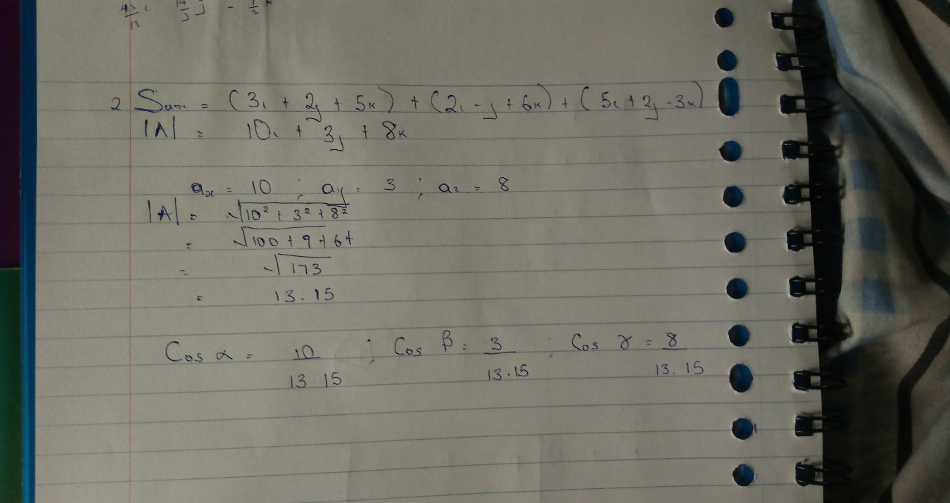

QUESTION 3
