NAME: KOLAPO OLAJUMOKE JANET
DEPARTMENT: PHYSIOLOGY
COURSE CODE: BIO 102
MATRIC NO: 19/MHS05/001
- How are fungi important to mankind?
Some fungi are useful in the food industry
They are parasites to some certain unbearable pests e.g. grasshopper, houseflies and therefore serve as important biological control to such pests.
They are important to the terrestrial ecosystem in material cycling and to man.
- Illustrate the cell structure of a unicellular fungus with a well labeled diagram
according to the state of activity of the cell.
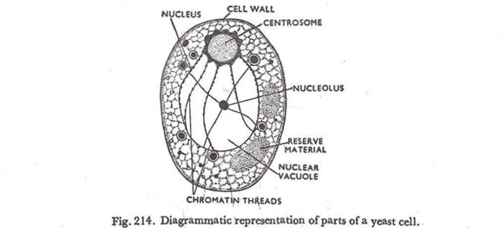

The yeasts are unicellular fungi. Cells may remain attached in short chains forming a pseudomycelium, but they do not produce true mycelium. The cells are extremely variable in shape being globose, oval, elongated, or rectangular.
The yeast cells are very polymorphic and are capable of assuming different forms depending upon the medium in which they grow and their age. Individually yeast cells are hyaline but in colonies they appear white, cream-coloured or slightly brownish.
- Outline the sexual reproduction in a typical filamentous form of fungi
Reproduction in rhizopus stolonifer
In sexual reproduction, resistant spherical spores are formed, called zygospores. Zygospores are thick-walled, which make them highly resistant to environmental hardships. The zygospores are the only diploid phase of Rhizopus stolonifer reproduction. They are composed of two suspensor cells, which are the former gametangia or hyphae. There is a suspensor cell on either side of a large, rough, dark brown spore. The suspensor cells are present to provide support. The zygospore forms from two special haploid hyphae of opposite mating types that touch due to hormones and being in close proximity of each other. The two cytoplasms intermingle, also known as plasmogamy. As this occurs the nuclei of both parents enter the conjunction, causing the resting spore to develop. Karyogamy is the term used to describe the fusion of the two nuclei. After the zygospore has fully formed, meiosis occurs and haploid spores are formed and dispersed. The zygospore can become dormant for several months at a time. Meiosis still occurs and a sporangium similar to the asexually produced sporangium is created when the zygospore finally cracks open.

- How do bryophytes adapt to their environment?
- They have structures for water and nutrient absorption from the soil. The body is divided into the subterranean portion which is made up of rhizoids and an aerial portion.
- The aerial portion being exposed to the atmosphere has modifications that prevents excessive loss of water through the surface.
- And it also has modifications like openings for exchange of gases between the plant and the atmosphere and prevents excessive water loss from plant body.
- Describe with illustration the following terminologies:
- Eusteles : here the vascular bundles are in one or two rings around the pith. The vascular bundles can be collateral( with phloem on only one side of the xylem).

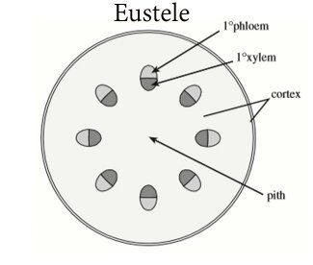

- Atactostele: A type of eustele, found in monocots, in which the vascular tissue in the stem exists as scattered bundles.
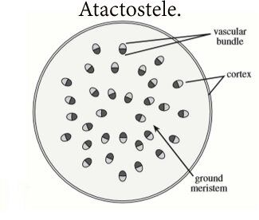

- Siphonostele: they have a region of ground tissue called pith which is internal to the xylem.
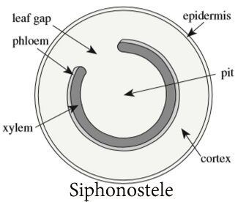

- Dictyostele: consisting of vascular strands interconnected in such a manner that, in any given cross section of stem, several distinct bundles can be observed. These are separated by regions filled with parenchyma cells known as leaf gaps. They have multiple gaps in the vascular cylinder.

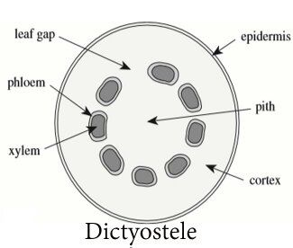
- Illustrate the life cycle of a primitive vascular plant
In seedless vascular plants, such as ferns and horsetails, the plants reproduce using haploid, unicellular spores instead of seeds. The spores are very lightweight (unlike many seeds), which allows for their easy dispersion in the wind and for the plants to spread to new habitats. Although seedless vascular plants have evolved to spread to all types of habitats, they still depend on water during fertilization, as the sperm must swim on a layer of moisture to reach the egg. This step in reproduction explains why ferns and their relatives are more abundant in damp environments, including marshes and rainforests. The life cycle of seedless vascular plants is an alternation of generations, where the diploid sporophyte alternates with the haploid gametophyte phase. The diploid sporophyte is the dominant phase of the life cycle, while the gametophyte is an inconspicuous, but still-independent, organism. Throughout plant evolution, there is a clear reversal of roles in the dominant phase of the life cycle.
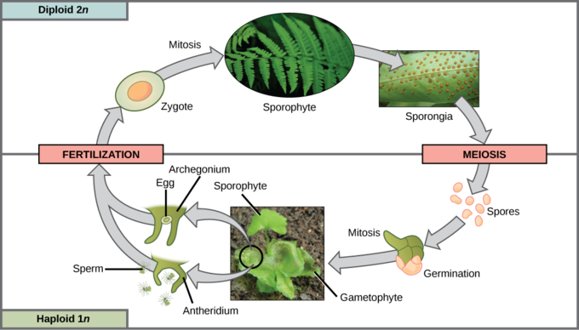Life cycle of a fern: This life cycle of a fern shows alternation of generations with a dominant sporophyte stag

